Vale Ray Johnstone (1943-2012)

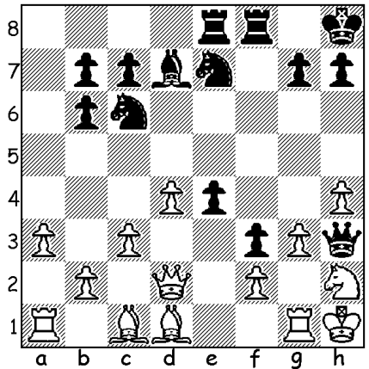

Diagram 463:
Richard Lilly – Ray Johnstone
(WA Champ.1978): Black to play and win:
White’s planned attempt to break Black’s
attack by Qe1 / Qf1 is brilliantly thwarted
(4 moves).

I am sure I speak on behalf of all the chess playing public in WA when I say
how saddened we were to read Ray Johnstone’s obituary on December 5 in the West, ‘Fearless Analyst, the Smoking Scientist.’ To all Ray’s family may I extend our deepest sympathy. Malcolm Smith’s article comprehensibly covered Ray’s life so well that I need only confine
my comments to writing of Ray the chess player.

My earliest recollections were from the 1975 WA Championship when I saw
Ray defeat ex-champion Paul Foster with the Black pieces (1.e4 e5 2.Nf3 d5) and also crunch
the French Defence with an obscure gambit line. I was so concerned that when we faced each other I switched from the French (1.e4 e6) to the Nimzovitsch Defence (1.e4 Nc6). My respect
for Ray’s attacking prowess was enhanced a year later when he defeated me in a 4 player tournament which enabled Richard Lilly, the 1975 and 1976 WA champion, to win the right
to take on the legendary Mikhael Tal in an Australian-wide telephone simultaneous. Ray
continued to be one of WA’s leading players throughout the 1970s and in 1978 came within a whisker of winning the state title when, after a Rd 1 loss, he won his next seven games in a row
to take the lead only to lose to and be overtaken by the ultimate winner in the final round. His style was uncompromising, built around the desire to attack with material considerations secondary.

Ray was a leading figure, together with Denis McMahon, in the Fremantle Club
and via his bookshop sponsored the Fremantle and City of Fremantle Open tournaments, a generosity which did much to attract participants to these events. He was also, until illness prevented it, a popular and enthusiastic member at the Metropolitan Club in Nedlands.

(below pictures from The West Australian, Wednesday December 5)
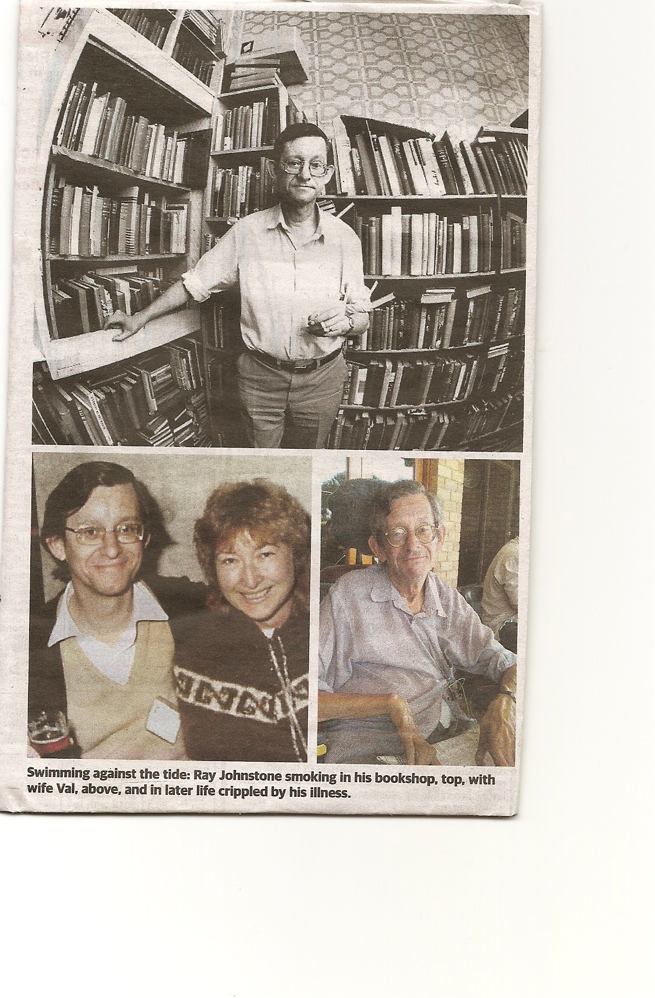

Here is a game perfectly showing Ray’s romantically attacking style in which piece after
piece is sacrificed leaving the whole game balanced on a knife edge:

Dr Ray Johnstone - Richard Lilly
Fremantle Championship 1998
Sicilian Scheveningen
1.e4 c5 2.Nf3 d6
3.d4 cxd 4.Nxd4 Nf6
5.Nc3 e6 6.Be3 Be7
7.f4 Nc6 8.Qf3 Qc7
9.0-0-0 a6 10.g4 0-0
11.g5 Nd7 12.f5 Nde5
13.Qg3 Nxd4 14.f6 Ndc6
15.Be2 Rd8 16.h4 Bf8
17.h5 b5 18.Rdf1 d5
19.Bf4 d4 20.Nd5 exd5
21.g6 Nb4 22.c3 dxc
23.b3 Qa5 24.a4 Nbd3+
25.Bxd3 Nxd3+ 26.Qxd3 dxe
27.Qxe4 bxa 28.Bd6 axb
29.gxf+ Kh8 30.fxg+ Bxg7
31.Qe8+ Bf8 32.Be5+ resigns

(The problem & game were first published in the West on June 6, 1998)

THE TEAMS LIGHTNING CHAMPIONSHIP Sunday 16 December 1pm. 3 players
per team (not restricted to clubs). Information cawa.org.au & enquiries DOP Gordon Dunlop 93686412. All CAWA members are invited to the Awards Presentation and Xmas social
which follow the Lightning.

SOLUTION: 1…Ng8!! (this undeveloping move is the start of a wonderful attacking combination) 2.Qe1 Nf6 3.Qf1 Ng4! White resigns (4.Qxh3 Nxf2#).

