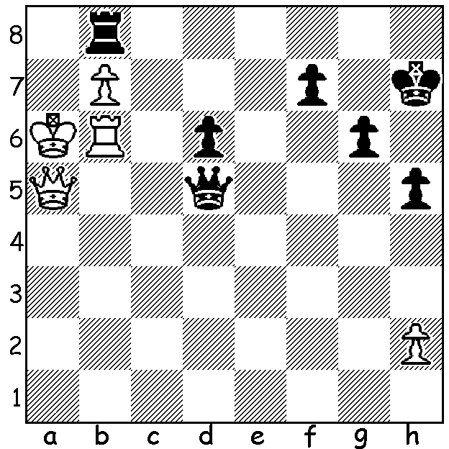

Diagram 464:
Gawain Jones failed to win a game
in the 2012 London Classic but he did
produce the move of the tournament in
Judit Polgar - Jones:
Black to play and draw:

The recently completed London Classic featured five of the world’s top players, the world’s leading woman player and three of the best British players. Winner was Magnus Carlsen with 18 pts (+5 =3 -0) closely followed by ex-world champion Vladimir Kramnik with 16 (+4 =4 -0). England’s number 1 Michael Adams and US champion Hikaru Nakamura came equal 3rd (+3 =4 -1) while World champion Vishwanathan Anand (+1 =6 -1), Levon Aronian, Judit Polgar, Luke Mc Shane and Gawain Jones all had a disappointing tournament. Not only did Carlsen win but in the process gained a rating of 2861, 10 pts more than Gary Kasparov’s record rating of 13 years ago. Here is a game of ex-world champion Vladimir Kramnik whose performance will enable him to overtake Levon Aronian as the second highest in world ratings. Kramnik employs a Catalan set-up, one that has won him countless games in the past and makes two exchange sacrifices (giving up rook for knight or bishop) which give him a completely dominating position:

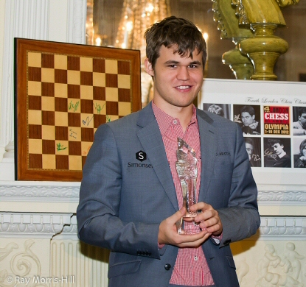
Vladimir Kramnik - Luke McShane
2012 London Classic, Rd 5
Slav Defence
1.d4 d5 2.c4 c6
3.Nf3 Nf6 4.Nc3 a6
5.g3 dxc 6.a4 e6
7.Bg2 c5 8.0-0 cxd
9.Nxd4 Nbd7 10.Nc2 Qc7
11.Bf4(a) e5 12.Bd2 Nc5
13.Bg5 Be6 14.Bxf6 gxf6(b)
15.Nd5 Qd8 16.Nce3 Nb3
17.a5! Rc8(c) 18.Ra4 Nd4 London Winner Magnus Carlsen
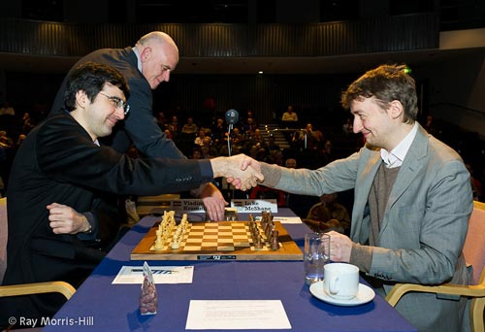
19.Nb6 Rc7 20.Rxc4!(d) Bxc4
21.Nexc4 Nb5 22.Qb1 Qd4
23.Rd1 Qc5 24.e3 Be7
25.Qf5 Kf8 26.Bd5 Kg7
27.Qg4+ Kh6(e) 28.e4 Nd4
29.Ne3 f5(f) 30.Qh3+ Kg7
31.Rxd4! exd4 32.Nxf5+ Kf8
33.Qh6+ Ke8 34.Bxf7+! Kd8
35.Qg7 Rf8 36.Nxd4 Rc6(g) Kramnik v McShane
37.Nxc6+ bxc6 38.Qg4 Kc7
39.Qd7+ Kb8 40.Qd2(h) Kc7
41.Qd7+ Kb8 42.Kg2 Bd6(i)
43.b4! Qd4 44.Qxc6 Ka7
45.Kh3 Qd1 46.Nc8+ Rxc8
47.Qxc8 Qf1+ 48.Kg4 h5
49.Kxh5 resigns

a) Enticing …e5 which enables the White knights to occupy d5.
b) Black’s two bishops will not compensate for the broken kingside.
c) If 17…Nxa1 18.Qa4+ Bd7 and White might try 19.Qxc4! Rc8 20.Qh4. Also if 18…Nxa5 19.Rxa5! Qxa5 20.Nxf6+.
d) An excellent exchange sacrifice giving White a dominating position and control of the white squares.
e) 27…Kf8 allows 28.Nd7+.
f) The only move to stop 30.Rxd4 / 31.Nf5#
g) Not 36…Rxf7? 37.Qxf7 Qxd4 38.Qg8+ Kc7 39.Qxc8+ Kd6 40.Qd7+ winning.
h) A cheapie, threatening 41.Nd7+
i) 42…Rxf7?? 43.Qc8+ Ka7 44.Qa8#.

SOLUTION: 1…Ra8+!! 2.bxa=Q Qxa8+ 3.Kb5 Qd5+ with a perpetual check (if now 3.Kb4 Qd2+ 4.Ka4 Qa2+ or 3.Ka3 Qa8+).

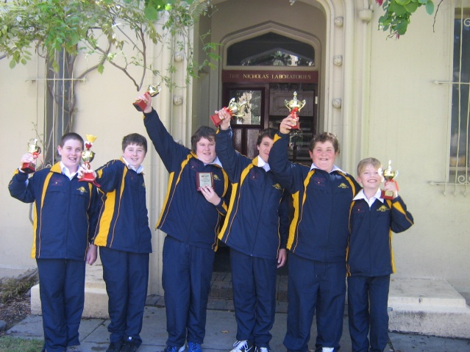
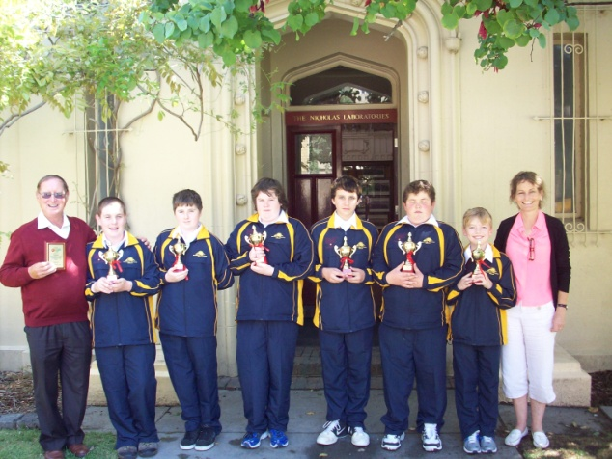

Kendenup Primary celebrating their Primary Schools 2nd place in the Australian/NZ
ChessKids Championships with coach Bill Sandilands, Sebastian Gavisson, Alex Bolton, Jayden Williams, Izaak Bateman, James Gray, Ethan Palfrey and teacher Heather Fergie
(see column for December 7th)

