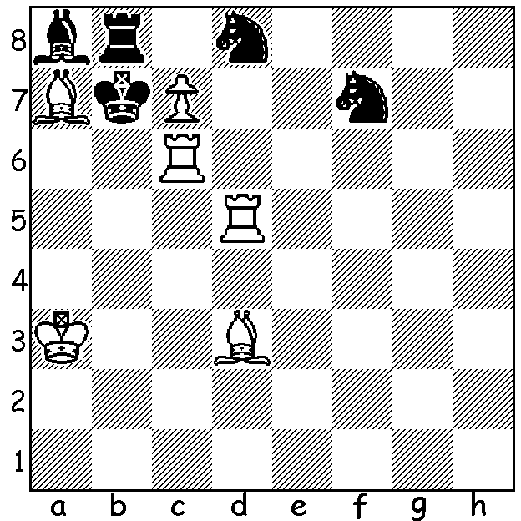

Here’s my Mystery of Christmas teaser:
(Diagram 465: Bettmann 1923)
White to play and mate in 2:

And now some festive chess riddles (answers below):
a) Why shouldn’t you ever buy a house from a chess player?
b) Why is Gary Kasparov not keen on golf?
c) Why can’t you buy a chess set from Cash Converters?
d) What should you do when your computer consistently beats you at chess?
e) How did the Slovak describe his wife?
f) Why was the passed pawn on the 7th so happy (see puzzle above)?

The AUSTRALIAN OPEN CHAMPIONSHIP will be played in Sydney 2 – 13 January (the Open and the Closed Championship are played on alternating years). German GM Igor Khenkin is at present the top rated entrant while leading Australian players include 5 times Australian champion Darrryl Johansen, defending Open champion George Xie (winner of the 2012 WA Foundation Day weekender), 2010 Australian champion Zong-Yuan Zhoa and Olympiad players Stephen Solomon and Mouthun Ly. WA will have six representatives, the state’s top-rated player, Tristan Boyd, WA champion Yita Choong, Akef Saleh, Ganesh Viswanath, two times WA champion Richard Lilly and Robin Shaw. Here is a win by Tristan from a previous Australian (Closed) Championship. He methodically prepares a central pawn push, avoids exchanges, sacrifices queenside pawns, creates pressure against Black’s king, leading to an unstoppable advance by his united passed central pawns.

Tristan Boyd - Romeo Capilita
2008 Australian Championship, Rd 1
Nimzo-Indian Defence, Rubinstein Variation
1.d4 Nf6 2.c4 e6
3.Nc3 Bb4 4.e3 0-0
5.Bd3 d5 6.Ne2 c5
7.0-0 Nbd7 8.a3 Ba4
9.cxd exd 10.Nf4 c4
11.Bc2 Bxc3 12.bxc3 Re8
13.f3 Nf8 14.Qe1 Ng6
15.Ne2 Bd7 16.Ng3 Bc6
17.Bd2 Qd7 18.Qf2 b5
19.Rae1 a5 20.e4 dxe
21.fxe Rf8 22.Nf5 Ne8
23.Qg3 f6 24.Bd1 Ne7
25.Bg4 Nxf5 26.Bxf5 Qe7
27.Qh3 g6 28.Be6+ Kh8
29.d5 Ng7 30.Bg4 Bb7
31.Qh4 Qe5 32.Qf2 Bc8
33.Bd1 Bd7 34.Be3! Qxc3
35.Bd4 Qxa3 36.Bxf6 Qd6
37.Qd4 Rg8 38.e5 Qb4
39.e6 Be8 40.d6 & wins

SOLUTION: 1.Rd7! with the triple threats of 2.cxb8=N#, c8=Q# & cxd8=N#. If 1…Kxc3 2.cxb8+N#: if 1…Nxc6 2.cxb8=Q#: if 1…Kxa7 2.c8=N#: if 1…Rc8 2.cxd8=N#. A problem showing the power of a double check.

RIDDLES: a) Because he takes forever to move.
b) Because he doesn’t like Putin.
c) Because it’s only a pawn shop.
d) Take it on at Kick-Boxing.
e) As his czech mate.
f) Because it was about to be promoted.

