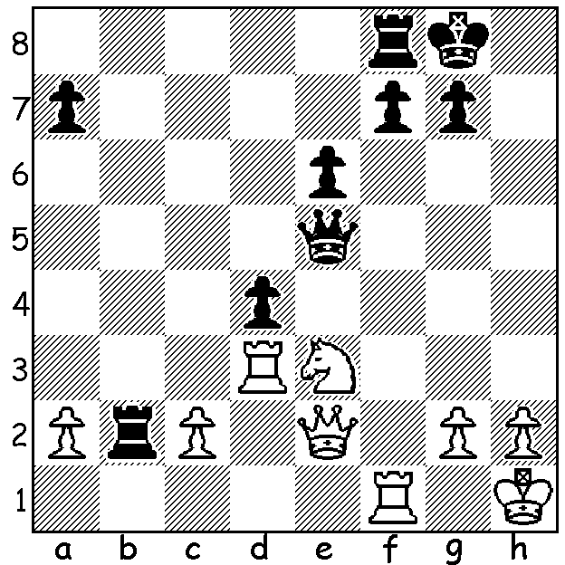

Diagram 466:
John Fedec – Ganesh Viswanath:
Ganesh needed to win this game to win the
2012 Respini Tournament at the Metro Club.
Can you see how White could have ruined
his chance (4 moves)?

The AUSTRALIAN OPEN CHAMPIONSHIP in Sydney has now started. WA has six representatives, the state’s top-rated player, Tristan Boyd, WA champion Yita Choong, Akef, Ganesh Viswanath, two times WA champion Richard Lilly and Robin Shaw. Last week we saw a win by Tristan from a previous Australian (Closed) and today we feature games by other WA players. Below a win by Yita defeating one of his main rivals in the 2012 Metro Championship which he won:

Ihsan Ferozkohi - Yita Choong
2012 Metro Championship
Sicilian Najdorf
1.e4 c5 2.Nf3 d6
3.d4 cxd 4.Nxd4 Nf6
5.Nc3 a6 6.Bg5 e6
7.f4 Qc7 8.Qf3 b5
9.a3 Nbd7 10.Be2 Rb8
11.f5 Ne5 12.Qh3 b4
13.axb Rxb4 14.Bxf6 gxf6
15.Rd1 Qb6 16.Qe3?(a) d5?(b)
17.fxe fxe 18.Bh5+ Ng6
19.e5 Bc5 20.Qh6(c) Bxd4
21.Bxg6+ Kd8 22.Qg7?(d) Bxc3+

a) A blunder, 16.Nb3 should be played.
b) Black should follow the maxim, ‘Attack pinned pieces.’ After 16…Nc6 17.fxe6 Nxd4 18.exf+ Kxf7 19.Bh5+ Kg8 20.Qg3+ Bg7 White does not have enough compensation for the piece.
c) 20.Nce2 fxe 21.Qxe5 0-0 22.Bxg6 hxg6 23.Rf1 Rxf1+ 24.Kxf1 Qd6 is better for Black.
d) A decisive mistake; White should play 22.Ne2 when 22…Bxe5 23.Qg7 hxg6 24.Qxh8+ Kc7 25.b3 White is to be preferred. The game concluded – 22…Bxc3+ 23.Ke2 (23.bxc3? Qe3+ mating) 23…hxg6 24.Qxh8+ Kc7 25.Rd3 Re4+ 26.Kf3 Bxe5 27.Qh7+ Kd6 28.Qxg6 Rf4+ 29.Ke2 Bd7 30.g3 Qf2+ 31.Kd1 Ra4 32.Ra3 Rxa3 33.bxa3 Qf3+ White resigns.

Akeh Saleh - John Fedec
2012 WA Championship
Sicilian Dragon
1.e4 c5 2.Nf3 d6
3.d4 cxd 4.Nxd4 Nf6
5.Nc3 g6 6.f4 Nc6
7.Nxc6 bxc6 8.e5 dxe
9.Qxd8+ Kxd8 10.fxe Ng4(a)
11.Bf4 Bg7 12.0-0-0+ Ke8?(b)
13.Nb5! Bd7 14.Nc7+ Kd8
15.Nxa8 Nf2 16.Bc4 Nxh1
17.e6 fxe 18.Bxe6 resigns

a) 10…Nd5 is considered better.
b) The wrong side; Black should play 12…Kc7 and if 13.e6+ Be5 holds.

SOLUTION: 1.Nf5!! Qxe2 2.Ne7+ Kh7/8 3.Rh3+ Qh5 4.Qxh5#. Ganesh breathed a sigh of relief when White failed to see the winning sacrifice and went on to win the game and the tournament with 7/9, a half point ahead of Ihsan Ferozkohi.

