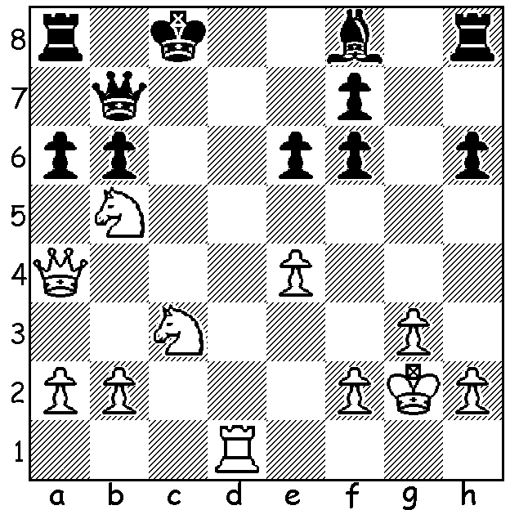

Diagram 468:
Frank Low – Akef Saleh
(2013 Aus Open, Rd 3):
White has sacrificed the exchange
to attack Black’s uncastled king:
how does he now win in 3 moves?

Over 170 players are competing in the Australian Open Championships in Sydney with 112 in the Australian Open. After 7 rounds WA’s top two entrants, WA champion Yita Choong and ex WA champion Tristan Boyd have 5pts, one point behind the three joint leaders. Yita’s only loss has been to one of the leaders, the top rated German GM Igor Khenkin, while he has drawn with five times Australian champion Darryl Johansen and also with Tristan. Other WA scores: Akef Saleh and Ganesh Viswanath 4, Richard Lilly and Robin Shaw 3. Yita got off to a good start dominating all over the board to defeat WFM (Womens FIDE Master) Megan Setiabudi in the first round:

Megan Setiabudi – Yita Choong
2013 Australian Open, Rd 1
Sicilian Closed
1.e4 c5 2.Nc3 a6
3.f4(a) b5 4.Nf3 Bb7
5.d3 e6 6.Be2 d5
7.exd(b) exd 8.0-0 Nf6
9.Qe1 Be7 10.Ne5 Nc6
11.Nxc6 Bxc6 12.Bf3 b4
13.Ne2 0-0 14.Bd2 Re8
15.Qf2 Ne4! 16.Qe1 Nxd2(c)
17.Qxd2 Bf6 18.Rab1 Qb6
19.Kh1 Rad8 20.Rfd1 a5
21.d4? cxd 22.Rg1(d) Bb5
23.Rbd1 d3! 24.cxd Re3
25.Nc1 Qd4 26.f5?(e) Bg5
27.Nb3 Qh4(f) 28.Qc2 a4
29.Nc1 Qf4 30.Qc5?(g) Rxf3!
31.Qxb5 Rh3!(h) 32.gxh3 Qf3+
33.Rg2 Qxd1+ 34.Rg1 Qf3+
35.Rg2 Bxc1 White resigns

a) I would prefer 3.g3 as White’s two bishops now become very ineffectively placed.
b) An unnecessary surrender of the centre; 7.0-0 d4 8.Nb1 is perfectly playable as the loss of time is of no great significance in a blocked position.
c) This foreshadows control of the e3 square.
d) 22.Nxd4? loses – 22…Bxd4 23.Qxd4 Re1+! winning the queen.
e) Making his kingside more vulnerable. White should play 26.Ne2! when 26…Qxd3?! is met by 27.Qc1 (27…Rxf3 28.Rxd3 =).
f) After attacking on the queenside and the centre Black is able to switch the attack to the kingside.
g) 30.Ne2 had to be played.
h) This clever deflection sacrifice decides the game.

SOLUTION: 1.Na7+! (a brilliant clearance sacrifice) 1…Kb8 (1…Q/Rxa7 loses quickly to 2.Qe8+) 2.Rd8+ Kxa7 3.Nb5#.

