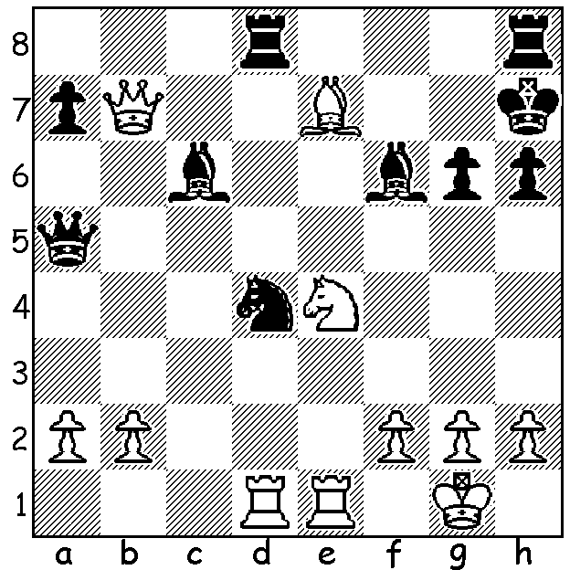

Diagram 469:
Yita Choong – Mark Choong
(2013 Aus Open): White wins comfortably
with 1.Nxf6+ Kg7 2.Bxd8+ and Black resigns
but he could have mated in 2. Can you see how?

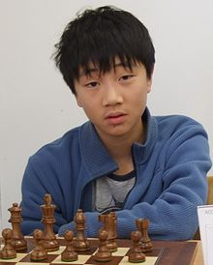
The 2013 Australian Open Championship has been
won in convincing style by New Zealand born Bobby
Cheng (Vic) at the age of only 15. Bobby was undefeated
with 9.5/11, a clear point ahead of Max Illingworth
(NSW), Zhoa Zong-Yuan (NSW) and Moulthun Li (Qld). .
WA’s top scorer was WA champion Yita Choong on 7.5
(+5 =5 -1), coming =7th with tournament favourite
Igor Kherkin (Germany), 5 times Australian champion
Darryl Johansen (Vic) and another ex- Australian
champion Trevor Tao (SA). Other WA scores:
Tristan Boyd 6.5, Ganesh Viswanath 6, Richard Lilly 5,
Akef Saleh 4.5, Robin Shaw 4.
Here is Yita’s exciting Rd 10 game. A thematic Ruy
Lopez kingside attack with a knight offer, a rook sacrifice
and concluding with masterly endgame play all showcase Bobby Cheng
Yita’s talent.


Yita Choong – Luke Li Zuhao
2013 Australian Open, Rd 10
Ruy Lopez, Breyer Defence
1.e4 e5 2.Nf3 Nc6
3.Bb5 a6 4.Ba4 Nf6
5.0-0 Be7 6.Re1 b5
7.Bb3 d6 8.c3 0-0
9.h3 Nb8 10.d4 Nbd7
11.Nbd2 Bb7 12.a4 c5
13.Bc2 Re8 14.Nf1 Bf8
15.d5 c4 16.Kh2 Qc7
17.g4 g6 18.Ng3 Nc5
19.Rg1 Reb8 20.g5 Nfd7
21.Nh4 Bg7 22.Ngf5!?(a) Bf8 Yita Choong
23.Nh6+ Bxh6 24.gxh6 Bc8
25.Qf3 b4 26.Nf5 Kf8(b)
27.Rxg6!! fxg6(c) 28.Nxd6+ Ke7
29.Qf7+! Kxd6 30.Bg5 Nf6(d)
31.Qxf6+ Be6 32.f4 b3
33.Bd1 Re8(e) 34.Qxe5+ Kd7
35.dxe6+ Nxe6 36.Qd5+ Qd6
37.Bg4! Kc7 38.Qxc4+ Qc6
39.Qxc6+ Kxc6 40.Bxe6(f) Rxe6
41.e5 Ra7 42.Kg3 Rd7
43.Ra3 Rb7 44.Kf3 Kd5
45.Ra1 Rc6 46.Rd1+ Ke6
47.Ke4 Rc4+ 48.Rd4 Rxd4+?(g)
49.cxd4 Rb4(h) 50.h4 Rxa4
51.h5! gxh 52.f5+ Kd7
53.e6+ Kd6 54.Bf4+ Ke7
55.Ke5 Rb4 56.f6+ Kf8
57.f7 resigns

a) A thematic but speculative offer. White would undoubtedly gain a strong attack after 22…gxf5 23.Nxf5 with most of White’s pieces trained against a sparsely defended Black king.
b) The alternative 26…Nf6 leads to an amazingly complex position. The following moves show the kind of possibilities without being a definitive analysis – 27.Bg5 Bxf5 28.exf5 Ne8 29.fxg fxg 30.Bxg6!? hxg6 31.Be3 Qf7 32.Rxg6+! Qxg6 33.Rg1 Qxg1+ 34.Kxg1 bxc 35.bxc Nxa4 36.Qh5 Nxc3 37.h7+ Kh8 38.Qf7 Ng7 39.Bh6 Nh5 40.Qxh5 Ra7 41.Qg6 Nb5 42.Bg5 Rg7 43.Bf6 Rb7 44.Kh2 c3 45.h4 c2 46.Qxc2 Rf7 47.Bxg7+ winning.
c) 27...hxg6?? 28.h7 and queens.
d) Black must return material to avoid mate.
e) If 33…Kd7 34.dxe6+ Kc6 35.e7+ Kb7 36.Be2 is good for White.
f) 40.h4 also appears good.
g) Planning to attack White’s pawns with his other rook but giving White united passed pawns is suicidal. Better was 48…Rbc7 although all the chances lie with White after 49.h4 planning h5!
h) After 49.Rc7 50.d5+ Kd7 51.f5! gxf5+ 52.Kd4 winning.

SOLUTION: 1.Bf8+!! Bxb7 2.Nxf6#.

