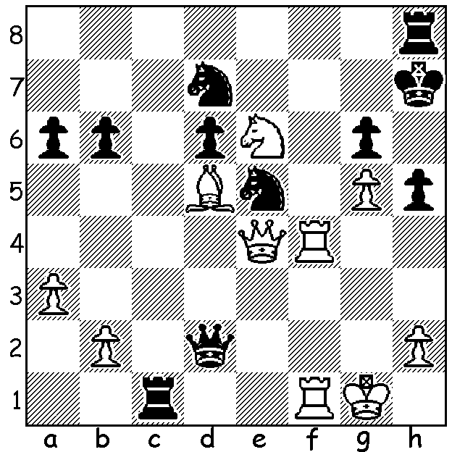
The annual Tata Steel chess tournaments held at
Wijk aan Zee, Netherlands, has 3 Grandmaster
events, each with 14 players. In the A group after
8 rounds world number 1 Magnus Carlsen (Norway)
with 6/8 leads world champion Viswanathan Anand
(India) by a half point with last year’s winner Levon
Aronian (Armenia) and US champion Hikaru
Nakamura a further half point behind. Here is a
sensational finish from the event (Diagram 470)with
Indian Pentala Harikrishna mating local Loek van
Wely in 3 moves Diagram 470

As reported last week the 2013 Australian Open Championship was been won in convincing style by New Zealand born Bobby Cheng (Vic) at the age of only 15. Bobby was undefeated with 9.5/11, a clear point ahead of Max Illingworth (NSW), Zhoa Zong-Yuan (NSW) and Moulthun Li (Qld). Bobby’s family moved to Melbourne in 2007 and Bobby became Victorian champion in 2011. He was Australian junior champion in 2010 & 2011 and world Under 12 champion in 2009. Here is one of his wins from that event:

Michael Steadman– Bobby Cheng
2009 World Under 12 (Turkey)
French Defence: Tarrasch Variation
1.e4 e6 2.d4 d5
3.Nd2 Nf6 4.e5 Nfd7
5.f4 c5 6.c3 Nc6
7.Ndf3 cxd 8.cxd a5(a)
9.Bd3 a4 10.a3 Nb6
11.Ne2 Na5 12.0-0 g6
13.Qc2 Nb3 14.Rb1 Bd7
15.g4 Rc8 16.Nc3 Nc4
17.f5 Nxd4(b) 18.Nxd4 Bc5
19.fxg(c) Bxd4+ 20.Kh1 hxg
21.Bxg6 Nxe5 22.Bh5 Bc6
23.Qe2 Bxc3 24.bxc3(d) d4+
25.Kg1 Qd5 26.cxd Rxh5!
27.gxh5 Nd3! White resigns

a) This variation prepares a general advance on the queenside to gain outposts for his knights with possible play along the open c file to counter White’s advance on the kingside.
b) Enterprising but faulty.
c) White should seek to hold onto the extra piece with 19.Qf2 when it is very difficult for Black to justify the knight sacrifice – eg 19…Nxe5 20.Be2 gxf 21.Be3 Nxg4 22.Bxg4 Rg8 23.h3 Bxd4 24.Bxd4 Qe7.
d) If 24.Bxf7+ Nxf7 25.Qxe6+ Qe7 26.Qxc8+ Nd8 and Black’s attack remains overwhelming.

Here’s another quick French win from the same event:
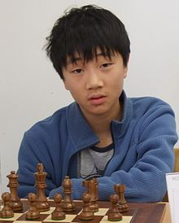
Alexi Terzi - Bobby Cheng
2009 World Under 12
French Advance
1.e4 e6 2.d4 d5
3.e5 c5 4.c3 Nc6
5.Nf3 Qb6 6.a3 Nh6
7.b4 cxd 8.cxd(a) Nf5
9.Be3(b) Bd7 10.Nc3 Nxe3!(c)
11.fxe3 Nxb4! 12.axb4 Bxb4
13.Qb3 Rc8 14.Rc1 Qa5
15.Kd2 0-0 16.Ne1 Ba4
17.Qb2 Rxc3! 18.Rxc3 Rc8
White resigns

(a) If 8.Bxh6 gxh6 9.cxd Bg7 with …f6 to come)
(b) 9.Bb2 is better
(c) White will miss this bishop)

SOLUTION: 1.Rf7+!! (first a deflection sacrifice) Bobby Chen
1…Nxf7 (1…Kg8 2.Rg7#) 2.Qxg6+!! Kxg6 3.Be4#.

