
The annual Tata Steel chess tournaments held at
Wijk aan Zee, Netherlands, had three Grandmaster
events, each with 14 players. The A group, with six
of the world’s top eight players as well as the Women’s
world champion, was won by world number 1 Magnus
Carlsen (Norway) with 10/13 (+7, =6), a point and a
half clear of runner-up Levon Aronian (Armenia) on
8.5. World champion Viswanathan Anand (India)
and Sergey Karjakin (Russia) tied for third place
on 8. Other scores Peter Leko (Hungary) 7.5, Hikaru
Nakamura (US champion) 7, Pentala Harikrishna
(India) 6.5, Wang Hao (China), Anish Giri & Loek
van Wely (both Netherlands) 6, Hou Yifan (Women’s
world champion, China) 5.5, Fabiano Caruana (Italy)
5, Erwin L’Ami 4, Ivan Sokolov 3 (both Netherlands). Carlsen at Tata Steel

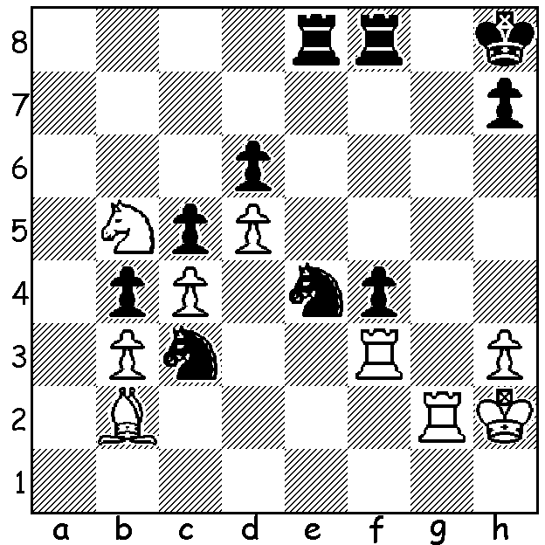

(Diagram 471):
A position from a Group B game,
Naiditsch – Timman
White to play and win (5 moves)

For a number of rounds world champion Viswanathan Anand was vying with Carlsen for top place but gradually fell behind and suffered his only loss in the final round to Wang Hao. However he did produce the game of the tournament with a characteristic brilliant win on the Black side of a Queens Gambit:

Levon Aronian - Viswanathan Anand
2013 Tata Steel, Rd 4
Queens Gambit Declined: Semi-Slav, Meran Variation
1.d4 d5 2.c4 c6
3.Nf3 Nf6 4.Nc3 e6
5.e3 Nbd7 6.Bd3 dxc
7.Bxc4 b5 8.Bd3 Bd6
9.0-0 0-0 10.Qc2 Bb7
11.a3 Rc8 12.Ng5(a) c5!
13.Nxh7(b) Ng4! 14.f4(c) cxd
15.exd(d) Bc5! 16.Be2(e) Nde5!
17.Bxg4(f) Bxd4+ 18.Kh1 Nxg4
19.Nxf8(g) f5!(h) 20.Ng6 Qf6
21.h3 Qxg6 22.Qe2 Qh5
23.Qd3(i) Be3! White resigns (j)

a) We are all taught not to make premature attacks while undeveloped. 12.Rd1 is logical while 12.b4 is met by 12…c5! 13.bxc Bxf3. Black could now play 12…Bxh2+!? – 13.Kxh2 Ng4+ 14.Kg1 Qxg5 but White gains a good position with 15.f3. Instead Black choses a much more aggressive continuation.
b) 13.Bxh7+ was safer but not worrying to Black.
c) 14.Nxf8 loses to 14…Bxh2+ 15.Kh1 Qh4 16.Rd1 Bg6+ etc while if 14.h3 Bh2+ 15.Kh1 Qh4 is good for Black.
d) If 15.Nxf8 Bxf8 retains excellent attacking chances - 16.exd Ndf6 17.h3 Qxd4+ 18.Kh1 Rd8 19.hxg4 Qxd3 20.Qxd3 Rxd3 with all Black’s pieces menacing White’s king and White still undeveloped (…Bc5, …Rh3# is threatened).
e) If 16.dxc5 Nxc5 17.Qe2 (17.Bxb5 Qd4+ 18.Rf2 Ne4 with a winning attack) 17…Qd4+ 18.Kh1 Nxd3 19.Qxg4 Kxh7 20.Qg3 Rfd8 with a strong positional plus to Black.
f) If 17.fxe5 Qxd4+ mates quickly.
g) 19.Ng5 keeps White alive longer – 19…Nf6 20.Qe2 Bxc3 21.bxc3 Rxd3 22.Qxb5 Qc7.
h) Not 19…Qh4? As 20.Qh7+ kills off Black’s attack.
i) White is lost after 23.Rf3 Nf2+! 24.Kh2 Bxf3 25.Qxf3 Qxf3 26.gxf3 Nd3
j) 24.Bxe3 Qxh3+ 25.Kg1 Qxg2#.

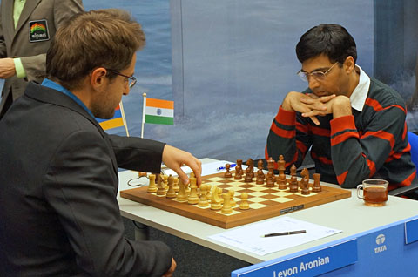

Aronian adjusting his king before his game with Anand.

SOLUTION: 1.Nxd6!! (preventing a possible …Re5 defence) 1…Nxd6 2.Rxc3! wins (2…bxc3 3.Bxc3+ mating or 2…Nf5 3.Rd3+ Nd4 4.Rxd4!): if 1…Re7 2.Nxe4 Rxe4 3.Rxc3! bxc3 4.Bxc3+ Rd4 5.Bxd4+ and the 3 united passed pawns win.

