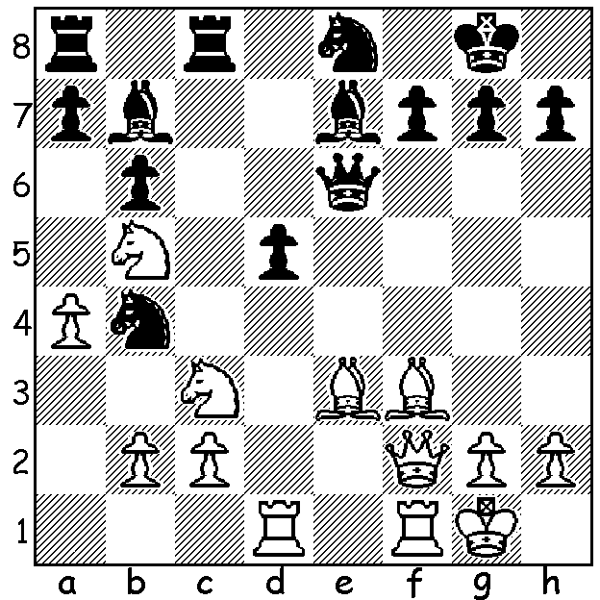

Diagram 471:
Sokolov – Zacrewski 1974:
White to play and win (4 moves):

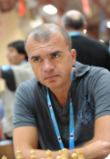
Ivan Sokolov finished in bottom place in the Tata Steel, Wijk aan Zee, tournament in the Netherlands with only 3/13. Born in Bosnia in 1968 and now resident in the Netherlands, his main two tournament successes have been victories at the Vidmar Memorial in Slovenia in 1987 and 1993. The Vidmar Memorial commemorates the life and career of Milan Vidmar (1885 – 1962) and had previously been won by such greats as Anatoly Karpov, Bent Larsen, Jan Timman and Lajos Portisch. However Sokolov is most famous for a win against Gary Kasparov in the 1997 Wijk aan Zee event, being the only player to beat winner Kasparov and finishing 4th with 7/13. Here is that famous game:

Ivan Sokolov - Gary Kasparov
Wijk aan Zee 1997
Nimzoindian Defence: Rubinstein Variation
1.d4 Nf6 2.c4 e6
3.Nc3 Bb4 4.e3 0-0
5. Bd3 d5 6.Nf3 c5
7. 0-0 Nc6 8.a3 Bxc3
9.bxc3 Qc7(a) 10.Qc2 dxc
11. Bxc4 e5 12.Bd3 Re8
13.e4 exd 14.cxd Bg4
15.e5 Bxf3 16.exf6 Nxd4
17.Bxh7+ Kh8 18.fxg+ Kxg7
19.Bb2 Rad8 20.gxf3 Rh8
21.Kh1 Rxh7 22.Rg1+ Kh8
23.Rg3 Qe5(b) 24.Rag1(c) Rh4(d)
25.Qc1 Kh7(e) 26.Qb1+(f) Kh8
27.Qf1(g) Qe6 28.Qg2 resigns(h) Sokolov at Tata Steel 2013

a) These moves have been the main line of the Nimzoindian for over 60 years.
b) Better seems 23.Qe7 – 23…Rag1 f6 25.Bxd4 cxd4 26.Qf5=.
c) Threatening mate with 25.Qxh7+!
d) Better is 24…Qh5 (25.R1g2 f6 26.Qc4=).
e) Black sets a trap, threatening 26…Nxf3!! 27.Bxe5 or Rxf3 Rxh2# but missing White’s reply: 25…Qf5 keeps the game level.
f) Forcing Black’s king back into the pin.
g) Threatening 28.Rh3.
h) If 28…Qe8 29.Rh3 wins.

A strange decision was made by runner-up Fernando Peralta in Group C at Wijk aan Zee
when his final round draw lost him the lead:

Alexander Kovchan - Fernando Peralta
2013 Tata Steel Group C, Rd 13
Pirc Defence
1.e4 d6 2.d4 Nf6
3.Nc3 g6 4. f4 Bg7
5.Nf3 c5 6.Bb5+ Bd7
7.e5 Ng4 8.e6 fxe
9.Ng5 Bxb5 10.Nxe6 Bxd4
11.Nxd8 Bf2+ 12 Kd2 Be3+
13.Ke2 Bf2+ DRAW.

The strange decision? – these moves gave Sax and Seirawan a Best Played Game Prize at a Grand Prix event in Brussels in 1988 and are a well known draw.

SOLUTION: 1.Bg4!! (deflection sacrifice) 1…Qxg4 2.Qxf7+ Kh8 3.Qf8+! Bxf8 4.Rxf8#.

