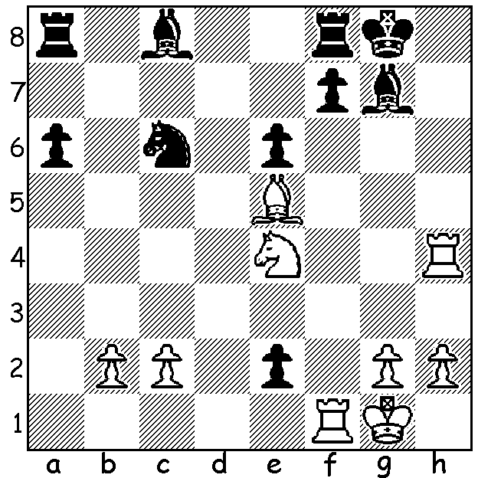

Diagram 473:
Short – Zhukova
(Gibraltar 2006):
White wins in 4 moves:

The 11th Trade Wise Gibraltar Masters (22 – 31 January) had 247 entrants and, not surprisingly, finished with a multiple tie for top place, something that has occurred every year since 2007. In the semi-final playoff (10 mins + 5 sec per move) Nikita Vitiugov (Russia) defeated Chandra Sandipan (India) 1.5 - 0.5 while 3 times winner Nigel Short (England) overcame Maxime Vachier-Lagrave (France) by the same score. In the final Vitiugov, who was born in St Petersburg in 1987, ground down Short in a 104 move marathon and then held on to draw the second game in 70 moves. The closeness at the top was shown with four players on 8/10, nine on 7.5, including Michael Adams (England), Gata Kamsky (USA), previous winner Vassily Ivanchuck (Ukraine) and Women’s title winner Zhao Xue (China), and 12 players on 7.

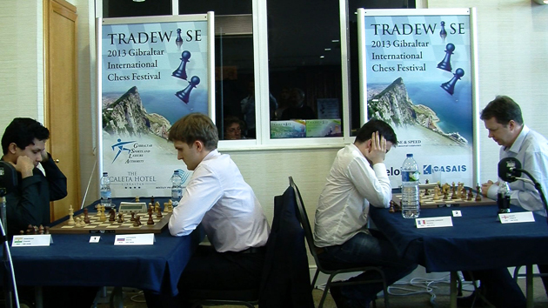

The first of the play-off games: L – R: Sandipan, Vitiugov, Vachier-Lagrave, Short

Sandipan tried an unorthodox defence in his second game against Vitiugov but was worse throughout the entertaining game:

Nikita Vitiugov - Chandra Sandipan
2013 Gibraltar Masters, Playoff Semi Final
Hippopotamus Defence
1.d4 e6 2.e4 b6 3.Bd3 Bb7
4.Nf3 Ne7 5.0-0 g6(a) 6.Nc3 Bg7
7.Re1 d6 8.a4 a6 9.Ne2 Nd7
10.Ng3 c5 11.c3 0-0 12.Be3 e5
13.d5 f5(b) 14.exf gxf 15.Ng5 Qe8
16.c4 e4 17.Bc2 f4?(c) 18.Bxe4 fxe3(d)
19.Rxe3 Bd4 20.Rf3(e) Rxf3 21.Qxf3 Ne5
22.Bxh7+ Kg7 23.Qe4 N7g6(f) 24.Nf5+ Kf6
25.Nxd4 cxd4 26.f4 Bc8 27.Rf1 Ra7
28.fxe5+ Kxg5 28.Bxg6 Qxg6 30.Qxd4 Rg7
31.e6 Kh5 32.Qf2 b5 33.b3 bxc
34.bxc a5 35.h3 Qg5 36.Qe2+ Kh6
37.Kh1 Ba6(g) 38.Rf2(h) Qc1+ 39.Kh2 Bxc4
40.Qe4(i) Qc3 41.Qh4+(j) Kg6 42.Qg4+(k) Kh6
43.Qh4+ Kg6 44.Qg4+ DRAW

a) Black has transposed from a French to Owens Defence (1…b6) to the Hippopotamus which is characterised by the double fianchetto, pawns on e6 & d6 and knights on e7 and d7.
b) Black needs to play 13…h6 first to deprive White’s knight of g5.
c) Going all out to win but leading to a precarious position: better 17…Ne5.
d) Better taking the knight - 18…fxg3 19.Bxh7+ Kh8 20.hxg3 Ne5.
e) Very complicated was 20.Bxh7+ Kh8 21.Qg4 Rxf2!
f) Black should bring the other bishop into play with 23…Bc8.
g) Threatening 38…Bxc4! but the bishop soon is deprived of d7 covering the queening square.
h) 38.Rf8 is very strong.
i) 40.Rf6+ wins – 40…Rg6 41.Rxg6+ Kxg6 42.Qg4+ Kf6 43.Qf3+ Kg5 44.e7 Qe1 45.Qg3+.
j) 41.e7 wins quickly.
k) 42.Qe4+ Kh6 and again e7 wins but a draw is enough for Vitiugov.

The first WA Grand Prix event, the Kingsley Open will be played next weekend, 23-24 Feb.

SOLUTION: 1.Nf6+!! Bxf6 2.Bxf6 exf1=Q+ 3.Kxf1 and 4.Rh8#.

