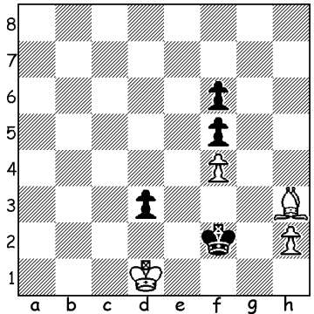
Diagram 474:
Everyone should know that a rook’s pawn
and a bishop which does not control the
queening square cannot defeat a lone king
if the defending king is able to occupy the
queening square. In the problem below
Black aims to capture the f pawn and head
towards h8 drawing. How can White, to
move, prevent Black from achieving this
(7 moves – find the first and the rest come
easily)?

Chess has now restarted in 2013 with the Perth Club’s Allegro and Rapid-Play competitions and the CAWA holding a Valentine Day’s Lightning tournament (16 Feb). The Lightning was won by Ihsan Ferozkohi (9/11) who overtook Lightning specialist Bozidar Mandic who lost 3 of his last 5 games to finish with 8. Other prizewinners: 3rd Open – Rob Maris & Daniel Larsson (7.5): 1st Under 1900 – George Carolin-Uncovich (7): =1st Under 1700 – Ned Tomic & Albert Chin (6): Under 1600 – Patrick Gong (6): Junior – Thomas Pinnock (6).
The Metropolitan Club has also commenced its club championship with 50 players competing in 5 divisions. In the A division 5 of the players are rated over 2000 while the other 5 are between 1898 & 1967. Favourite must be defending Metro and WA champion Yita Choong who recently came =7th in the Australian Open, although he will face strong opposition from Ihsan Ferozkohi, Marc Vliestra and Ganesh Viswanath.
Here is a win from Ganesh at the recent Australian Open in which he scored 6/11

James Laughlan - Ganesh Viswanath
2013 Australian Open
Kings Indian Defence: Classical: Gligoric Variation
1.d4 Nf6 2.c4 g6
3.Nc3 Bg7 4.e4 d6
5.Nf3 0-0 6.Be2 e5
7.Be3(a) Ng4 8.Bg5 f6
9.Bh4 g5 10.Bg3 Nc6
11.d5 Ne7 12.Nd2 Nh6
13.f3 f5 14.b4 Ng6
15.0-0 Nf4 16.c5 Nxe2+
17.Qxe2 f4 18.Bf2 g4
19.fxg(b) Nxg4 20.Nc4 Qg5
21.Qf3 Nxh2!(c) 22.Kxh2 Bg4
23.Qd3 Qh5+ 24.Kg1 Rf6
25.Rfc1(d) Rh6 26.Kf1 Qh1+
27.Bg1 f3 28.gxf Rf8
29.Nd2 Rh2 30.Ne2 Bxf3
31.Nxf3 Rxf3+ 32.Qxf3 Qxf3+
33.Bf2 Qxf2#

a) If White attempts to win a pawn by 7.dxe dxe 8.Qxd8 Rxd8 9.Nxe5 Black regains the pawn with a superior position by 9…Nxe4!
b) This opens up lines for Black’s pieces.
c) Black has built up a thematic kingside attack and confidently sacrifices a piece to expose White’s king.
d) White had to block the advance of Black’s f pawn – eg 25.Be1 Rh6 26.Rf3 although Black retains a strong attack: now White’s position crumbles quickly.

KINGSLEY OPEN (first Grand Prix event of 1013): tomorrow (12.30 – 7.30) and Sunday (10.30 – 6) at Moresby St. Centre, Kensington. Contact Haydn Barber today (hadix@vianet.net.au or 9398 4242) for $10 discount on entry fee.

SOLUTION: 1.Bg2! Ke3 (1…Kxg2 2.h4 and the pawn cannot be stopped) 2.h4 Kxf4 3.Bf3! Ke5 4.h5 Ke6 5.Bd5+! Ke7 6.h6 Kf8 7.Kd2 and White’s king will capture Black’s three pawns and ensure the promotion of the pawn.

