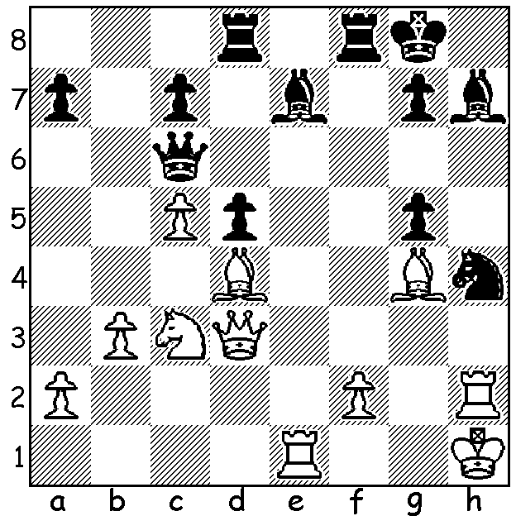
Diagram 475: Kurajica – Hort 1968:
White to play and win (7 moves).
A combination will often incorporate a
number of tactical ideas: the position
below includes discovered check,
exploiting the over-worked piece, pin,
removing the guard and sacrifice
(not in that order):

The KINGSLEY OPEN, the first Grand Prix event of 2013, with an entry of 21 included 6 players of 2000 and above as well as 6 juniors. The tournament proved a struggle between
the top three players WA’s top rated player Tristan Boyd, WA champion Yita Choong and visiting South American Pedro Paiva. Tristan defeated Yita, Pedro beat Tristan and Yita defeated Pedro. However Yita was also defeated brilliantly by Marc Vliestra in the final round while Pedro unexpectedly lost his final round to Daniel Larsson, leaving Tristan with 5/6, a point ahead of Yita, Pedro, Marc, Daniel, Ian Sutton and junior Thomas Pinnock. Considering the time limit of only one hour with 10 second increments each move, the standard was particularly high on the top boards. Here is one of the very fine games from the event:

YITA CHOONG - PEDRO PAIVA
2013 Kingsley Open
Sicilian Defence, Morra Gambit Declined
1.e4 c5 2.d4 cxd
3.c3 d3 4.Bxd3 Nc6
5.c4 Nf6 6.Nf3 d6
7.h3 e6 8.0-0 Be7
9.Nc3 0-0 10.Be3 Bd7
11.Qe2 Qb8 12.Rac1 Rc8
13.Nd2 Be8 14.f4 Nd7
15.Nf3 a6 16.b3 Bf6
17.Bb1 g6 18.f5 Nce5
19.Nd4 Nc6 20.Nxe6?! fxe6
21.fxe6 Nd4(a) 22.Qg4 h5
23.exd7!(b) hxg4 24.dxc8=Q Qxc8
25.Rxf6 Nc6 26.Nd5(c) gxh3
27.e5! Kg7(d) 28.e6(e) Ne5
29.c5 Qc6(f) 30.Be4 Ng4
31.Bd4 h2+ 32.Kh1 Nxf6(g)
33.Nxf6 Qc8 34.Nxe8+ Kh6
35.Rc3?!(h) Qxe6(i) 36.Nxd6 Kh5
37.Kxh2 Kg4 38.Rg3+ Kh4
39.Rxg6(j) resigns

a) This retains the extra piece.
b) The only way to maintain the attack and avoid a serious material deficit.
c) With rook and bishop for queen and with Black’s pieces inactive and an exposed king, the chances lie clearly with White whose pieces dominate.
d) Not 27…dxe? 28.Rxc6! Qg4 29.Be4!
e) Keeping the queen out of the game temporarily.
f) Better was 29…dxc 30.Bxc5 Qd8.
g) This loses material but if 32…Kh6 32.Rf3 keeps up the attack.
h) Better was 35.Nxd6 weaving a mating net – 35…Qxe6 36.Rf1 Re8 37.Nf7+ Kh5 38.Bf3+ Kh4 39.Bf2#.
i) Black could survive into a losing endgame with 35…Qxe8 36.Bf6 Qxe6 37.Rh3+ Qxh3 38.gxh3 dxc5 39.Bxb7 Rf8.
j) Or 39.Be3.

WA OPEN CHAMPIONSHIP: Seven Round Swiss: 9 &10, 16 & 17 March (2 games per day except on last day): time control 60 min + 30 sec. Titles available – WA Open champion, WA Women’s champion, WA Senior champion (over 60). Enter by Thurs 7 March to avoid late fee to Haydn Barber hadix@vianet.net.au or 9398 4242 or 0401473031. Check cawa.org.au for full details.

SOLUTION: 1.Rxe7!! (sacrifice) 1…Bxd3 2.Rxg7+ Kh8 3.Rxg5+ (discovered check and removing the guard) 3…Rf6 4.Rxh4+ resigns (4…Bh7 5.Bf5 – the pin by the other bishop ensures the bishop’s safety – 5.Rd7 6.Bxd7 Qxd7 (relinquishing the defence of the pinned rook) 7.Bxf6+.

