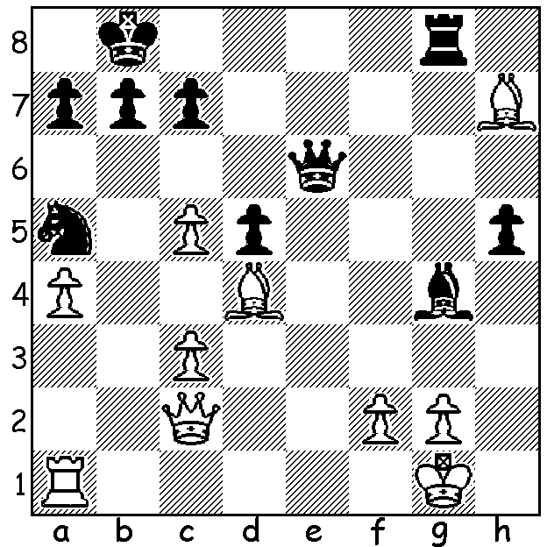

Diagram 476
Looking through some old games of mine
I came across the following position which
I believe came from an Allegro tournament
in 1986 as there is no record of the moves
(Eugene Teh – David Ellis):
Black to play and win (6 moves):

As I wrote last week, the standard among the top players at the recently completed Kingsley Open, won by WA’s top player Tristan Boyd (5/6), was extremely high for a 60 minute tournament. Here is the game which ruined WA champion Yita Choong’s chance of tying for first place:

MARC VLIESTRA - YITA CHHONG
2013 Kingsley Open, Rd 6
Caro-Kann Advance
1.e4 c6 2.d4 d5
3.e5 c5 4.c4 Nc6
5.Nf3 cxd 6.cxd Qxd5
7.Be2(a) Nxe5(b) 8.0-0 Nf6(c)
9.Nxd4 e6(d) 10.Nc3 Qd8
11.Bf4(e) Bd6(f) 12.Bb5+ Ke7(g)
13.Re1 Qc7 14.Rc1 Qb8
15.Ne4 Nxe4 16.Rxe4 a6
17.Ba4(h) Rd8(i) 18.Qh5 h6
19.Bg5+!(j) f6 20.Bxf6+! gxf6
21.Qxh6 Rf8 22.f4 Qa7(k)
23.Kh1 Rf7 24.fxe5 Bxe5
25.Nf5+! exf5 26.Rxe5+! Be6(l)
27.Rxe6! Kxe6 28.Re1+ Kd6(m)
29.Qd2+ resigns(n)

a) A dangerous gambit leaving White ahead in development.
b) 7…Bf5 comes into consideration.
c) 8…Nc6 9.Nc3 Qd8 seems a good alternative – 10.Nb5 Nf6 11.Bf4 Nd5 12.Bg3 e6 13.Bc4 a6 14.Nbxd4 Nb6.
d) Black is concerned with his backward development but circumspect was 9…a6 preventing a White invasion of b5.
e) 11.Nb5 Nc6 12.Qxd8+ Kxd8 13.Rd1+ Bd7 gives White some advantage but White prefers to avoid a queen exchange.
f) The cause of Black’s subsequent problems: better was 11…Ng6 12.Be3 a6.

g) Not 12…Bd7 Nxe6! Black hopes to castle by hand with …Re8, Kf8, (Kg8) but the unattractive 12…Kf8 was safer.
h) Or 17.Qh5! f6 18.Ba4.
i) Now Black is lost: 17…h5 would keep the queen out.
j) 19.Rxe5! is good but White wants the king.
k) Not 22….Nf7 23.Nf5+ winning.
l) If 26…fxe5 27.Rc7+ mates.
m) If 28…Kd5 29.Qd2+ Qd5 30.Bb3+ Kc5 31.Rc1+.
n) Mate is inevitable.

After a most successful Australian Open in January in which he finished =7th with only one defeat in his 7.5 from 11 games, Yita has found it hard going back in WA with two losses in his six games at the Kingsley Open. And defending his title at the Metropolitan Club championship he lost to Ganesh Viswanath, whom I mentioned on February 22 (along with Marc Vliestra) as among the main challengers to Yita at Metro.

MIDSOMER MURDERS: This coming Sunday’s plot revolves around chess with the algebraic move notation providing the clues (ABC1).

WA OPEN CHAMPIONSHIP (7 rounds over three successive weekends – Sat & Sun) starts tomorrow at 12.30. Prizes: 1st, 2nd, 3rd + Rating, Senior & Junior. Details cawa.org.au and entries to Haydn Barber 9398 4242 or 0401473031.

SOLUTION: 1…Bf3! 2.Bxg8 (2.g3 Qh3) Qg4 3.Kf1 (3.g3 Qh3) 3…Qxg2+ 4.Ke1 Qg1+ 5.Kd2 Nc4+ 6.Kd3 Qg6#.

