The West Australian Open Championship has begun and, while few of the state’s top players have entered, the first four rounds have provided some interesting chess. After 4 rounds Marc Vliestra leads with 3.5/4 closely followed by Akef Saleh and two juniors, George Carolin-Unkovich and Ignatius Yap (all on 3/4). Ignatius is the lowest rated player in the tournament but has defeated two players rated 742 and 892 points above him. Here are a few positions which provided players with opportunities or tempting continuations:
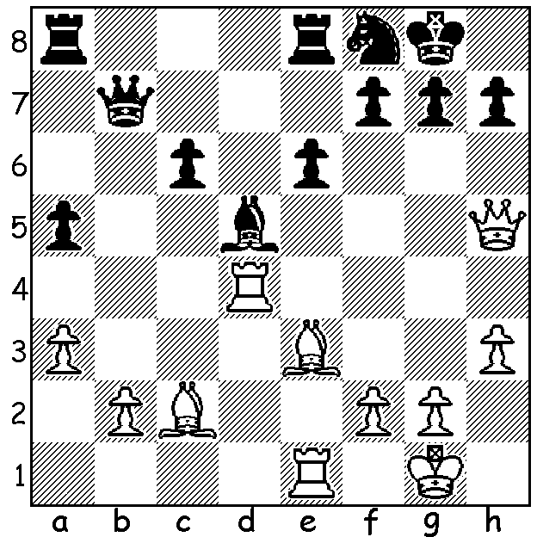

a) Akef Saleh – Gary Donaldson:
White has a strong attack and plans
a quick mate.
Can you see how and is there a
defence (4 moves)?

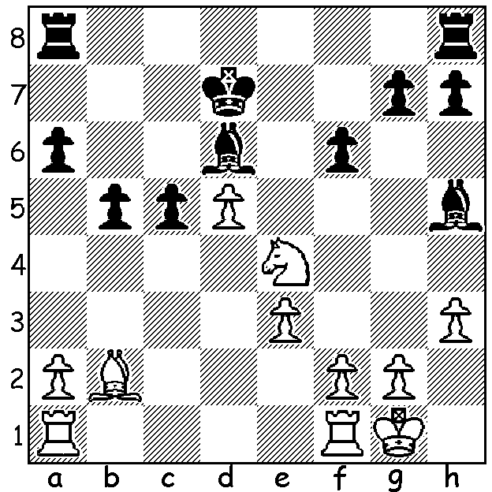

b) Evan Yeung – Peter de Yaak:
White sees a continuation to win
material.

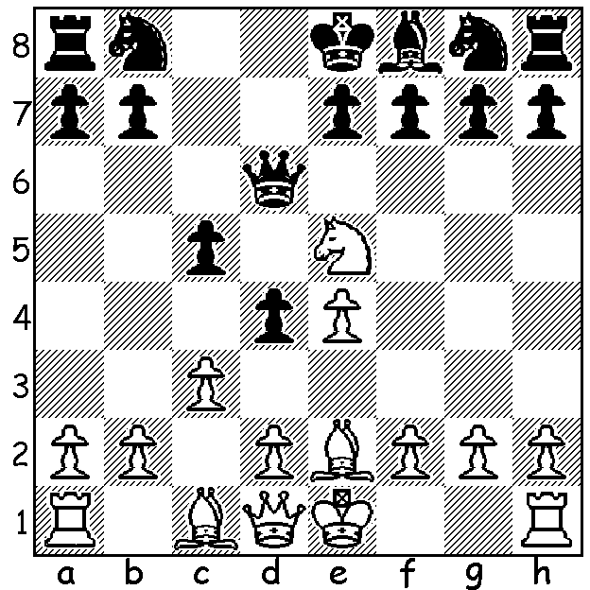

c) Akef Saleh – Gabriel Nhial:
with the game in its early stage
White takes advantage of Black’s
lack of development.

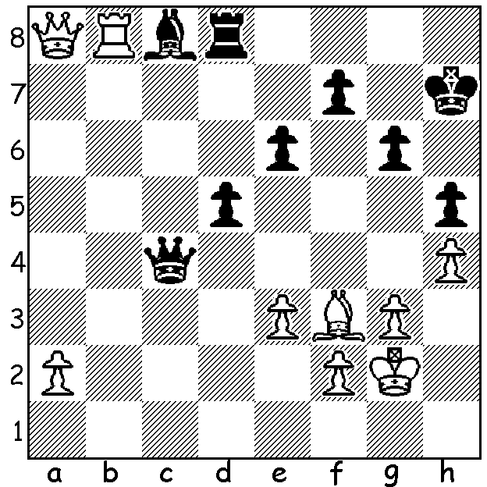

d) David Ellis – Aileen Fisher:
White now plays 1.a4? How does
this allow Black to save the game?
What should he have played?

Junior George Carolin-Unkovich continues to improve and has a quick win with a sharp attack against WA’s second highest ranked female:

George Carolin-Unkovich - Aileen Fisher
2013 WA Open, Rd 3
Sicilan: Morra Gambit Declined
1.e4 c5 2.d4 cxd
3.c3 g6 4.cxd Bg7
5.Nf3 d5 6.exd Nf6
7.Nc3 0-0 8.Bc4 Nbd7(a)
9.0-0 Nb6 10.Bb3 Nbxd5
11.Re1 Ndb6(b) 12.Qe2 e6
13.Bg5 Nbd7 14.Ne5 Qa5
15.Nxf7! Rxf7 16.Qxe6 Qxg5
17.Qxf7+ Kh8 18.Re8+!(c) Bf8
19.Rxf8+ resigns

a) The position now resembles the fianchetto defence in the Caro-Kann against the Botvinnik- Panov Attack.
b) Why move the knight from the perfect blockading square of d5? This and the subsequent move back to d7 are the cause of Black’s coming misfortune.
c) This deflection sacrifice is the move Black missed in her calculations: now if 18…Nxe8 19.Qg8#

SOLUTIONS:

a) 1.Bxh7+ Nxh7 2.Rh4: however Black found the defence 2…Be5! and after 3.Rxe5 won the exchange with 3…Nf6.

b) 1.Bxf6 Rhg8 (1…gxf6 2.Nxf6+ forking king and bishop) 2.Bxg7! Rxg7 3.Nf6+.

Unfortunately neither Gary nor Evan was able to convert his material advantage with both losing to their more highly ranked opponents.

c) 1.Qb3! attacking f7 & b7: after 1…Qxe5 2.Qxb7 wins the rook.

d) After 1.a4? Black plays 1…Ba6! forcing White to take a draw after 2.Rxd8 Qf1+ 3.Kh2 Qxf2+ 4.Bg2 Bf1 5.Rh8+ Kg7 6.Qf8+ Kf6 7.Qd8+ Kg7 (7…Ke5?? 8.Qb8+ Kf5/6 9.Qf4+ wins or 7…Kf5?? 8.Qg5#) 8.Qf8+ =.
1.Rb6 protecting a6 and threatening 2.Rc6 keeps White on top.

