Diagram 480: Micalizzi – Anand 1990: White has completed his development while Black is lagging well behind. However it’s Black who has a wining combination (5/6 moves):

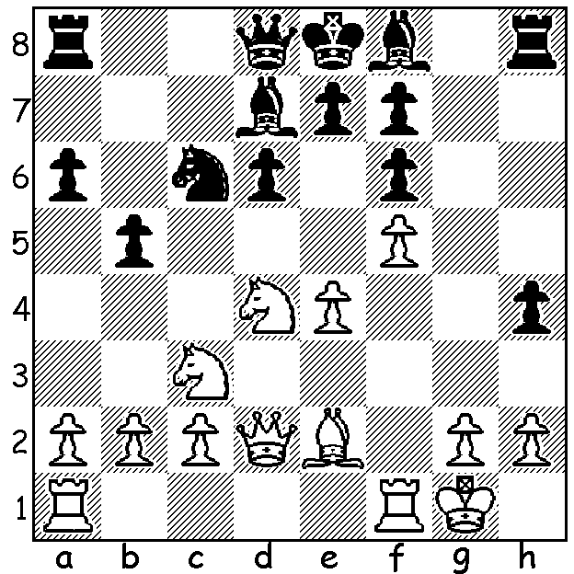
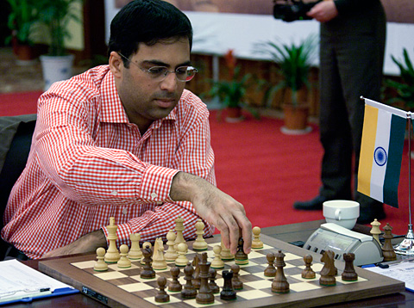

Eight of the world’s top players are at present competing in the World Chess Championship Candidates Tournament in London to determine a challenger to Viswanathan Anand. Favourite in London will be Norwegian Magnus Carlsen who recently attained the highest rating ever. Other contestants are Vladimir Kramnik, Alexander Grischuk, Peter Svidler (all Russia), Boris Gelfand (Israel), Levon Aronian (Armenia), Teimour Radjabov (Azebaijan), Vassily Ivanchuk (Ukraine). Anand became world champion in 2007 when he won a similar tournament in Mexico City with 9/14, a point ahead of former world champion Kramnik. He has successfully defended his title three times – 6.5 - 4.5 against Kramnik in 2008, 6.5 – 5.5 against Veselin Topolov in 2010 and in 2012, after tying 6-6 with Boris Gelfand, winning a rapid-play play-off 2.5 – 1.5. While successfully warding off challengers in matches Anand has failed to dominate in tournaments and his victory at Baden Baden earlier this year was his first tournament success since 2008. Here is one of his wins from that event:
Can you name the eight challengers? (answers in Solution)

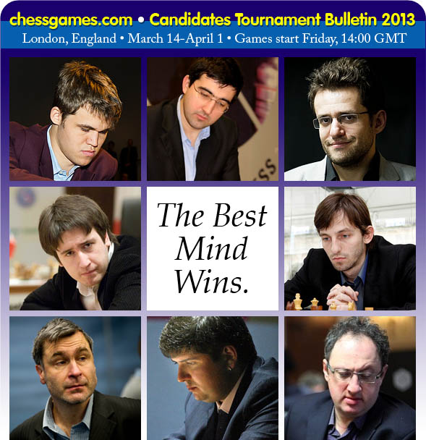

Arkadij Naiditch - Viswanathan Anand
2013 Baden Baden
Sicilian Defence: Rossilimo Attack
1.e4 c5 2.Nf3 d6 3.Bb5+ Bd7
4.Bxd7+ Qxd7 5.c4 Nf6 6.Nc3 g6
7.d4 cxd 8.Nxd4 Bg7 9.0-0 Nc6
10.Nde2 Qe6(a) 11.Nd5 Qxe4 12.Nc7+ Kd7
13.Nxa8 Qxc4 14.Nc3(b) Rxa8 15.Bg5 e6
16.Re1 Nd5(c) 17.Nxd5 Qxd5 18.Qxd5 exd5
19.Rad1 h6 20.Bc1 d4 21.Rd3 Rc8
22.Rb3 b6 23.Kf1 Ne5 24.Ra3 a5(d)
25.b4! Rc2(e) 26.bxa bxa 27.Rxa5 Nd3
28.Ra7+ Kc6 29.Rxf7 Nxe1 30.Kxe1 Rxc1+
31.Kd2 Rg1 32.Rxg7 Rxg2 33.Ke1?(f) Rxh2 34.Rxg6 Rh1+ 35.Kd2 h5 36.Rh6 h4
37.a4 h3 38.a5 h2 39.a6 Kc7
40.Rh7+ Kb8 41.Ke2 d3+ 42.Kd2 Ka8
43.Rh5 Ka7 44.Rh6 d5 45.Rh8(g) Kxa6 46.Rh6+ Kb5 47.Rh8 Kc4 48.Rc8+ Kd4
49.Rh8 Ke4 White resigns(h)

a) Anand researched this line before the event to see if anyone had played this move before only to discover it had been used in the famous Internet game, Gary Kasparov v The World, 1999.
b) At the cost of a tempo Black could, as Kasparov did, double and isolate Black’s queenside pawns with 14.Nb6+.
c) An ugly move allowing the doubling of his centre pawns but nevertheless effective .
d) Anand was very critical of this move preferring 24…Rc7.
e) After 25…axb 26.Ra7+ Rc7 27.Rxc7+ Kxc7 28.Bd2 Nc6 29.Rb1 with the exchange of rooks easing White’s position.
f) ‘A horrible blunder’ (Anand): this move loses a vital tempo in allowing a back row check – 33.Ke2 would likely draw.
g) If 45.Rh6 d4 and the a pawn goes.
h) While White keeps checking, Black’s king will capture the f pawn, find shelter at d4 or c5 and then win by …Ra1 Rxh2 Ra2+.

SOLUTION: 1…Bh6 2.Qd3 Qb6 3.Rd1 Nxd4 4.Qxd4 Be3+. (Moves 1 & 2 can be interchanged and Black could also win by 4…Qxd4 5.Rxd4 Be3+)
Pictures: from top, L – R: Carlsen, Kramnik, Aronian / Radjabov, Grischuk / Ivanchuk, Svidler, Gelfand

