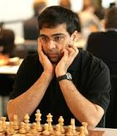
Diagram 481: Anand – Ivanchuk 2004:
White wins (3 moves):
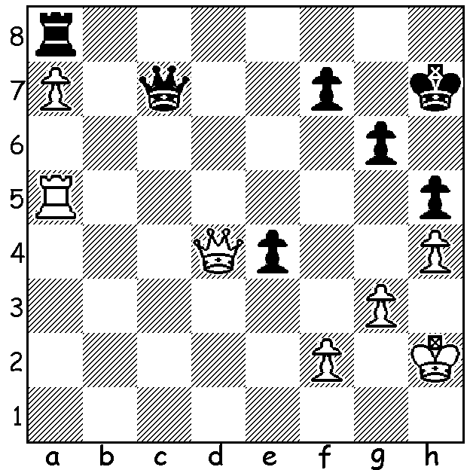

Viswanathan Anand

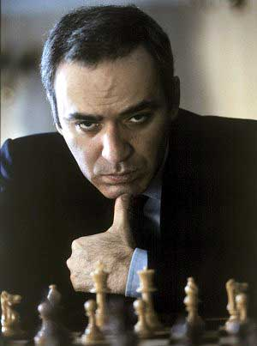
My previous article analysed a 2013 win by world champion Viswanathan Anand in which he followed
a defence played in the famous four month long 1999
internet game Kasparov v The World. Today we look
at that historic encounter. Play was at the rate of one
move per day with The World team comprising four
young chess stars, Etienne Bacrot, Florin Felecan, Irina
Krush and Elisabeth Paehtz assisted by computers(which
however were not then advanced enough to deal with the
complexities of the endgame). These four players made
suggestions which were voted on by the general public
with over 50,000 individuals from 75 countries participating.
Gary Kasparov
Gary Kasparov - The World
Sicilian Defence: Rossolimo Attack
Internet 1999
1.e4 c5 2.Nf3 d6 3.Bb5+ Bd7
4.Bxd7 Qxd7 5.c4 Nc6 6.Nc3 Nf6
7.0-0 g6 8.d4 cxd 9.Nxd4 Bg7
10.Nde2 Qe6!?(a) 11.Nd5 Qxe4 12.Nc7+ Kd7
13.Nxa8 Qxc4 14.Nb6+ axb6 15.Nc3 Ra8
16.a4!(b) Ne4 17.Nxe4 Qxe4 18.Qb3 f5!
19.Bg5(c) Qb4 20.Qf7 Be5! 21.h3 Rxa4
22.Rxa4 Qxa4 23.Qxh7 Bxb2 24.Qxg6(d) Qe4
25.Qf7 Bd4 26.Qb3 f4!(e) 27.Qf7 Be5
28.h4 b5 29.h5 Qc4 30.Qf5+ Qe6
31.Qxe6+ Kxe6 32.g3! fxg 33.fxg b4(f)
34.Bf4 Bd4+ 35.Kh1 b3 36.g4 Kd5!
37.g5 e6(g) 38.h6 Ne7 39.Rd1 e5
40.Be3 Kc4 41.Bxd4 exd4 42.Kg2 b2
43.Kf3 Kc3 44.h7 Ng6 45.Ke4 Kc2
46.Rh1 d3 47.Kf5 b1=Q(h) 48.Rxb1 Kxb1.
49.Kxg6 d2 50.h8=Q d1=Q 51.Qh7 b5(i)
52.Kf6+ Kb2 53.Qh2+ Ka1! 54.Qf4 b4(j)
55.Qxb4 Qf3+ 56.Kg7 d5 57.Qd4+ Kb1
58.g6 Qe4 59.Qg1+ Kb2 60.Qf2+ Kc1
61.Kf6 d4 62.g7 resigns

a) An innovation discovered by Krush, the most dedicated member of the Black team whose recommendations were chosen every single move 10 to 50.
b) Preventing the rook from attacking White’s king (…Ra5, Nb5).
c) 19.Qxb6 is met by 19…Nd4 with the initiative.
d) The players have now entered the early stages of a difficult ending with both sides possessing a passed pawn.
e) Preventing 27.Be3.
f) 33.Bxg3 loses time – 34.h6 Be5 35.h7 Bg7 (else 36.Bf6!) 36.Rf8 b4 37.h8=Q Bxh8 38.Rxh8 although Black is still fighting with N + 4p v R + B.
g) Allowing the knight to defend against the pawns’ advance via e7.
h) If 47…Nh8 – 48.g6 d2 49.g7 d1=Q 50.Rxd1 Kxd1 51.gxh8=Q b1=Q+ when White’s advanced g pawn gives him the advantage as in the game.
i) Krush’s sugestion 51…Ka1 was better as was her 52…Kc1.
j) Bacrot’s 54…Qd5 gives a theoretical draw.

GRAND PRIX
THE GUFELD CUP this Sat & Sun, 6th & 7th April, at Moresby St. Centre: details cawa.org.au: contact Haydn Barber today for discount on entry fee (93984242 or 0401473031).
PERTH OPEN next weekend, April 13 & 14, at Woodvale Primary: contact Norbert Muller 9409 9579.

TRAGIC ACCIDENT IN VICTORIA
Six members of the Melbourne Chess Club were returning from the Doeberl Cup in Canberra on Easter Monday when their car rolled off the Hume freeway in NE Victoria. Andrew Saint & Hannibal Swartz, both in their 30s, were killed, James Morris & Dimitri Partsi were seriously injured while Anthony Hain & Paul Cavezza were less seriously injured. Speed, drugs & alcohol have all been ruled out and it is thought a mechanical fault, perhaps a burst tyre, was the cause.
To the families involved and to the Victorian chess community WA sends its sympathies and the hope for a speedy recovery for those injured.

SOLUTION: 1.Rxh5+ Kxh5 2.Qxd5+ / 3.Qxa8.

