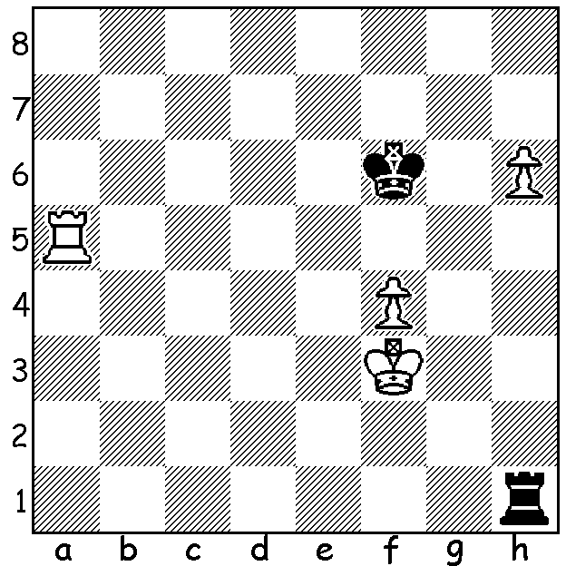
Diagram 482:
Radjabov – Grischuk
(Candidates 2013):
White has just played 1.h6.
Can Black safely capture the pawn

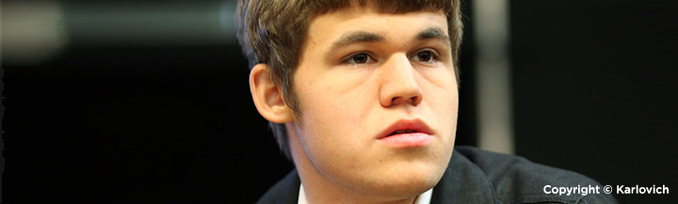
The eight player Candidates Tournament held in
London from March 15 to April 1 was, as expected, a
struggle between the world’s top three rated players,
Magnus Carlsen (Norway), Levon Aronian (Armenia) and former world champion Vladimir Kramnik (Russia). Aronian made the early running, leading from Rd 2 to Rd
8, neck and neck with Carlsen from Rd 4, but fell behind with losses in Rds 9 and 11. Kramnik drew all his games
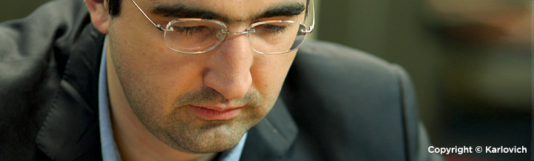
in the first half and trailed by 1.5 pts, but went on a surge,
winning 4 of 5 games in Rds 8 to 12 to take the lead after
Carlsen fell to Vassily Ivanchuk (Ukraine). However
after drawing with Boris Gelfand (Israel) in Rd 13 Kramnik by Carlsen was caught who ground out a win against
Teimour Radjabov (Azerbaijan).The final round was
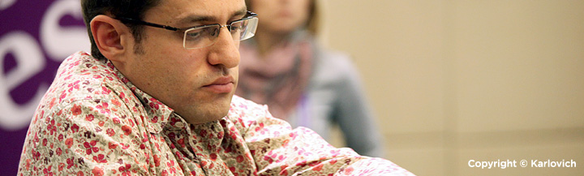
incredibly tense with the two leaders both striving to win. Surprisingly both lost, Carlsen to Peter Svidler (Russia) and
Kramnik to Gelfand, leaving a tie with both Carlsen and Kramnik scoring 8.5/14. The 22 year old Carlsen was
awarded 1st place by virtue of gaining more wins, 5 to
Kramnik’s 4, and will later in the year play a match with
defending champion Viswanathan Anand for the world
title. Other scores: Aronian and Svidler 8, Gelfand and
Alexander Grischuk (Russia) 6.5, Ivanchuk 6, Radjabov 4.

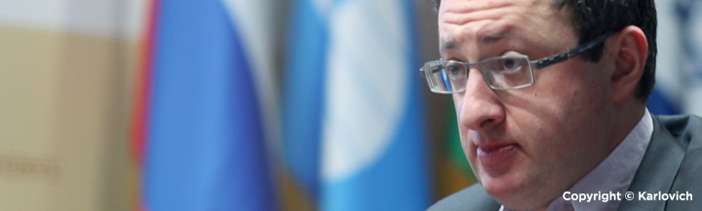
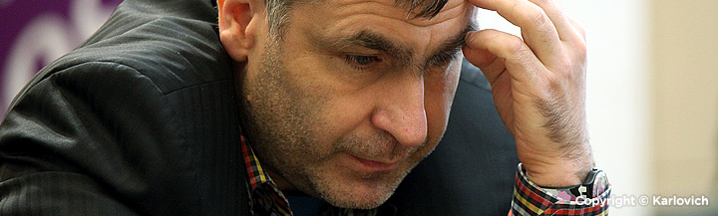

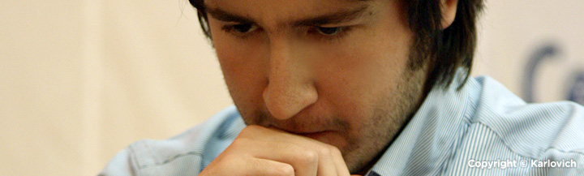

(from top, left to right) Carlsen, Kramnik,
Aronian, Ivanchuk. Gelfand, Radjabov:,
(page 2) Svidler, Grischuk,

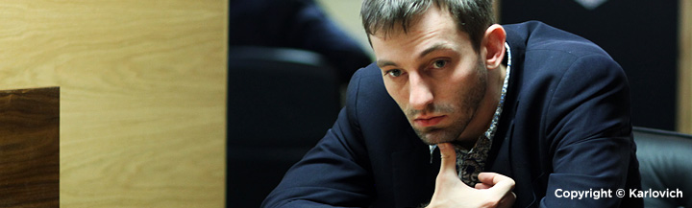
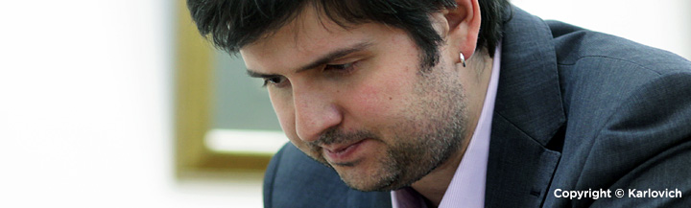

Here is an exciting game between two of the Russian contestants:
Peter Svidler - Alexander Grischuk
Candidates Tournament, London 2013, Rd 9
Kings Indian Defence, Saemisch Variation
1.d4 Nf6 2.c4 g6 3.Nc3 Bg7
4.e4 d6 5.f3 0-0 6.Be3 c5(a)
7.Nge2 Nc6 8.d5 Ne5 9.Ng3 h5
10.Be2 h4 11.Nf1 e6 12.f4 Nxc4!?(b)
13.Bxc4 b5! 14.Bxb5 exd5 15.e5 dxe5
16.fxe5 Bg4 17.exf6!(c) Bxd1 18.fxg7 Kxg7
19.Bxc5 h3! 20.Rxd1(d) hxg2 21.Rg1 gxf1=Q+
22.Kxf1 Qh4 23.Rg2! Rfd8 24.Rd4 Qh5(e)
25.Rf4 d4!(f) 26.Bxd4+ Rxd4 27.Rxd4 Rb8
28.a4 a6 29.Bxa6? Qf3+?(g) 30.Rf2 Qh1+
31.Ke2 Rxb2+ 32.Rd2 Qc1 33.Kd3 Rb6
34.Bc4 Rd6+ 35.Bd5 Rd7 36.Rf4 f5
37.Rd4 Kh6 38.h4 Rc7 39.Bc4 Qf1+
40.Re2 f4 41.Kc2 f3 DRAW AGREED (h)

a) Analysis has shown Black obtains sufficient compensation for the pawn after 7.dxc dxc 8.Bxc5 Nc6 or 8.Qxd8 Rxd8 9.Bxc5 Nc6.
b) An amazingly risky piece sacrifice attempting to take advantage of Black’s better development.
c) A move not considered by Grischuk in his preparation.
d) If 20…Bg5 21.Bd4+! Kg8 22.Ne3 with advantage.
e) Some detailed analysis after 24…Qf6+: 25,Rf2 Qe5 26.Rdf4 d4 27.Rxf7+ Kh6 28.R2f2 dxc3 29.Rh3+ Kg5 30.Be7+ Qxe7 31.Rg3+ Kh6 32.Rxe7 c2! 33.Rc3 Rd1 34.Re1 Rf8+ 35.Ke2 Rf5 36.Rxc2 Rxe1+ 37.Kxe1 Rxb5 38.Kd2 with some winning chances.
f) If Black allows 26.Bd4+ he is soon mated.
g) Black misses 29…Qe5! 30.Rd5 Qf6+ 31.Ke1 Qxa6.
h) There is still so much play: 42.Ree4 Qg2+ 43.Kb3 Rb7+ (43…f2 44.Rf4 Rxc4 45.Rxc4 f1=Q 46.Rxf1 Qxf1 and White is in no danger of losing) 44.Nb5 Qg1 45.Kc2 f2 46.Rf4 Qa1 47.Bd3 …

PERTH OPEN this weekend, April 13 & 14, at Woodvale Primary: contact Norbert Muller 9409 9579.

SOLUTION: 1.h6 Rxh6 2.Ra6+ Kg7 3.Rxh6 Kxh6 4.Ke4 Kg6 5.Ke5 Kf7 6.Kf5 Kg7 7.Ke6 wins. However
Black does not need to guard his rook and plays 2…Kf5! when 3.Rxh6 is stalemate and if the rook is not captured
the R+P v R is drawn.

