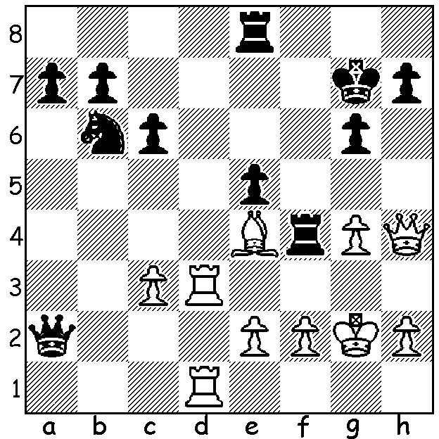

Diagram 483: Another position from the
recent Candidates tournament in London
(Aronian-Ivanchuk): Black has just
played …Rf4? How does White take
advantage of this error (think obstruction
sacrifice)?

Over the past five weeks three Open Championships have been held in Perth.
The WA Open concluded in March with a tie between Marc Vliestra and Akef Saleh (5.5/7) with Gabriel Nhial, David Ellis & junior George Carolin-Unkovich =3rd (4.5). Marc forfeited his final game but Akef only managed a draw against George, leaving Marc WA Open champion on tie-break. Aileen Fisher won the WA Women’s title and David Ellis the Senior title.
The Gufeld Cup was won by WA champion Yita Choong with a clean score of 6/6. George Carolin-Uncovich had another excellent result, 2nd with 4.5 while Marc Vliestra and David Ellis shared 3rd place. However the outstanding result was that of Gary Donaldson who scored 3.5 despite having the toughest draw and being outrated on an average by nearly 450 points each game.
The Perth Open, run by the Perth Club at their base in Whitfords and bolstered by a strong membership turnout, attracted 39 entries. Winner was leading WA player Tristan Boyd with 5.5 with Eddy Seah (5) 2nd and Gordon Dunlop and Natalie Maris (who beat husband Robert in the final round) =3rd on 4.5. The outstanding result was achieved by a lowly rated
ten year old, Sri Krishna Dharmapuri with 3.5. His scores included a draw with a three times WA champion (your columnist) and a win against one of WA’s most famous players and eight times WA champion Wolfgang Leonhardt.
Here is a win by WA champion Yita Choong against his main rival in the Gufeld Cup, Marc Vliestra, who had beaten Yita in the Kinsley Open in February:

Yita Choong - Marc Vliestra
Gufeld Cup, March 2013
Ruy Lopez: Chigorin Defence
1.e4 e5 2.Nf3 Nc6
3.Bb5 a6 4.Ba4 Nf6
5.0-0 b5 6.Bb3 Be7
7.Re1 0-0 8.h3 d6
9.c3 Na5 10.Bc2 c5
11.d4 Qc7 12.Nbd2 Bb7
13.d5 Bc8 14.Nf1 Nc4
15.b3 Nb6 16.Ne3 a5
17.a4 bxa 18.bxa Ba6
19.Nf5 Rfc8 20.Bg5 Bd8
21.Nh2 g6 22.Nh6+ Kg7
23.Qc1 Ng8 24.Nxg8 Kxg8
25.Ng4 Nd7 26.h4 h5
27.Nh6+ Kg7 28.g4 hxg
29.Nxg4 f6 30.Bd2 c4
31.Re3 Be7 32.Rg3 Rh8
33.Nh6 Nf8 34.Be3 Rb8
35.Kg2 Rh7 36.Qd2 Kh8
37.Rg1 Bd8 38.Kf1 Bc8
39.Qd1 Bd7 40.Rxg6! Bh3+
41.Ke1 Nxg6 42.Rxg6 Be7(a)
43.Qh5 Rf8 44.Rg3 Qc8
45.Qg6 Bd7 46.Rg1 Qe8
47.Qg3 f5?(b) 48.exf Bf6?(c)
49.Bg5(d) Re7 50.Bxf6+ Rxf6
51.Ng8 Rf8 52.Nxe7 Qxe7
53.Qg6 Be8(e) 54.Qh6+ resigns

a) 42…Rg7 leads to a losing ending after 43.Qh5 Rxg6 44.Qxg6 Qg7 45.Nf7+ Kg8 46.Qxg7+ Kxg7 47.Nxd6.
b) Better …Bd8.
c) Again …Bd8.
d) Threat 50.Bxf6 Qxf6 51.Qg8+ mating.
e) If 53.Qh7 54.Qxd6 Rg8 55.Qf6+ Rg7 56.h5 wins.

SOLUTION: 1.Bf5!! (an obstruction sacrifice cutting off the rook on f4 from defending the king): if 1…gxf4 2.Rd7+! Nxd7 3.Rxd7+ wins (3…Kf8 4.Qh6+ Kg8 5.Qg7# or 3…Qf7 4.Rxf7+ Kxf7 5.Qxh7+ Kf8 (5…Kf6 6.g5+! Ke6 – 6…Kxg5 loses the rook on e8 – 7.g6) 6.Qh6+ Kf7 7.g5 and Black is too uncoordinated to prevent the continued advance of the passed pawn (the rook on f4 can be imprisoned by f3).

