AUSSIE WINS THAILAND OPEN

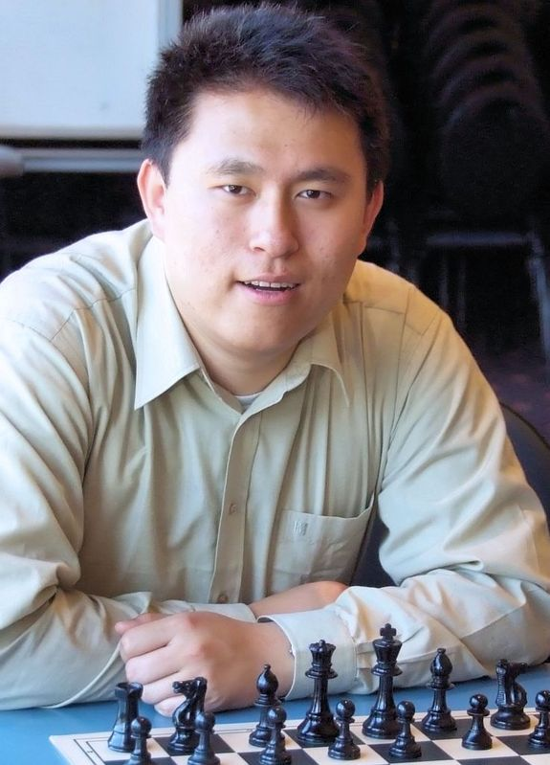
Australia’s top player Zhao Zong-Yuan has won the
150 player Thailand Open (Bangkok, April 14-21) with 7.5/9 (+6 =3). Zhao becomes the 3rd Australian after Ian Rogers and David Smerdon to win the
tournament which has been held annually since 2002.
Zhao, born in 1986 in Beijing and at 14, the youngest
Australian IM (International Master) became a GM
(Grandmaster) in 2008. He has represented Australia
in 3 Olympiads, two on top board.
Other Australian scores: Max Illingworth 5,
Tim Reilly & Fedja Zulfic 4.5.

Zhao Zong-Yuan

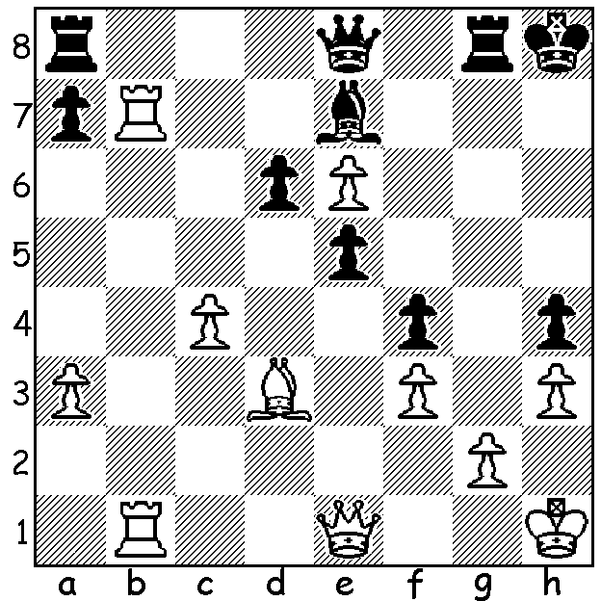

Diagram 484:
Rogers – Kerridge
(Southport, UK, 1983):
A spectacular finish by Australia’s greatest:

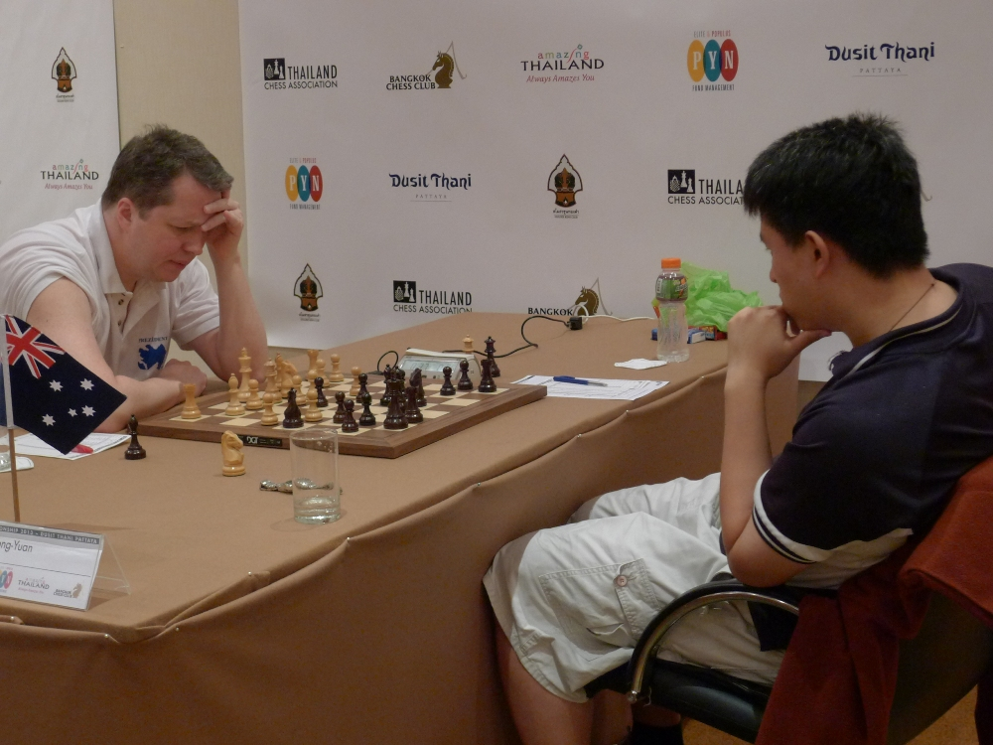

Zhao’s defeat of tournament favourite
and defending champion UK GM Nigel
Short in Rd 8 put paid to the Englishman’s
chances. Zhao’s play is a classic example
of how to counter a premature attack
against the castled king as he sacrifices 3
pawns to break open the centre:

Nigel Short in trouble v Zhao Zong-Yuan

Nigel Short - Zhao Zong-Yuan
2013 Thailand Open, Rd 8
Reti Opening
1.Nf3 d5 2.g3 Nf6 3.Bg2 c6
4.d3 Bg4 5.Nbd2 Nbd7 6.h3 Bh4
7.g4 Bg6 8.Nh4 e5 9.e3(a) Bd6
10.Qe2 0-0 11.Nxg6 fxg6 12.h4(b) Qe7
13.g5 Nh5 14.c4? e4! 15.dxe d4!
16.exd(c) Nf4 17.Qf1 c5 18.d5 Ne5
19.Kd1 b5 ! 20.cxb c4 21.f3 Rac8
22.Bh3 Rc7 23.Nb1 Nfd3 24.Be6+ Kh8
25.Rh3 Bc5 26.Nc3(d) Nf2+ 27.Ke2 Nxh3
28.Qxh3 Rxf3 29.Qxf3(e) Nxf3 30.Kxf3 Qf8+
31.Bf4 Bd6 32.Ne2 c3! 33.bxc Bxf4
34.Nxf4 Rxc3+ 35.Kg4 Qa3(f) 36.Rg1 Re3
37.e5! Rxe5 38.Rg3 Qb4(g) 39.Rb3 Qc4
40.Kg3(h) Qc5 41.Rf3 Re1 42.Kh3 Re3(i)

a) 9.e4 seems logical, gaining a hold in the centre and securing the f5 square.
b) 12. The start of White’s problems with the further advance on move 13 enabling the Black knight to take up a dangerous position on h5.
c) With an inferior position White takes whatever is offered and hopes to defend against the coming attack
d) If 26.Rg3 Black can break through with 26…Nxc1 27.Qxc1 Nxf3.
e) The only move to keep the game alive.
f) Threatening 36…Rg3#.
g) With his rook cut off Black has to take care not to allow White’s rook to check mate.
h) Threatening 41.b6! axb 42.Ra3! h5 43.Ra8+ Kh7 44.Bg8+ Kg8 45.Be6+ drawing: if the immediate 40.b6 axb 41.Ra3 Black wins with 41…h5+.
i) The exchange of rooks deprives White of his chances of attacking Black’s king. Now Black only needs to bring his king into play to watch White’s passed d pawn. 43.Rxe3 Qxe3+ 44.Kg4 h5+ 45.gxh6 gxh 46.Nxg6+ Kg7 47.Ne7 h5+ 48.Kf5 Qf3+ 49.Ke5 Qg3+ 50.Kf5 Qxh4 51.Nc6 Qa4 52.Ke5 Qxb5 53.Kd6 h5 54.Kc7 Qb6+ 55.Kc8 Kf6 56.a4 a5 57.Kd7 Qe3 58.Kc7 Qg3+ 59.Kb6 h3 60.Bxh3 Qxh3 61.Kxa5 Qb3 62.d6 Qc3+ 63.Kb6 Ke6 64.Nd8+ Kd7 65.Nb7 & resigns (65...Qb4+ not 65...Qc6+ 66.Ka5 Qxb7?? stalemate)

The popular South West Open (WA Grand Prix) will again be held in Bridgetown followed by a Lightning tournament. Dates are 15 & 16 June. Intending competitors are advised to book accommodation early. Details cawa.org.au and enquiries to Norbert Muller 9409 9579.

SOLUTION: 1.Qxh4+! (deflection sacrifice): if 1…Bxh4 2.Rh7#: if 1…Kg7 2.Rxe7+.

