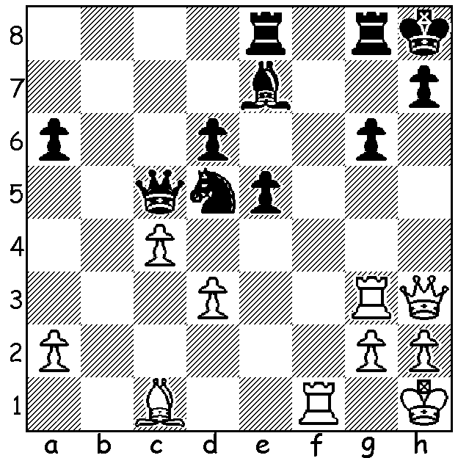

Diagram 485:
Nigel Short – Ye Jianchuan 2004:
White mates in 5:


Last week I reported on Australia’s Zhao Zong-Yuan’s success in winning the Thailand Open and published his win against tournament favourite Nigel Short. Short, now 47, was considered the second best player in the world in 1993 after defeating ex-world champion Anatoly Karpov and Jan Timman in Candidates matches to decide the challenger for Gary Kasparov’s world crown. His tilt at the title ended in a disappointing 7.5 – 12.5 loss in a match full of wonderful chess. A child prodigy, Short became an International Master at 14 and a Grandmaster at 19. He first qualified for the British Championship at the age of 11 and in 1980 was runner up to Gary Kasparov in the World Junior Championship. He has been British champion three times and has represented England with success in the last 15 Olympiads. His greatest tournament success was in Amsterdam in 1991 when he tied 1st ahead of Kasparov and Karpov. Always an adventurous player, his play in recent years has been marked by increasingly eccentric opening play in a search for unusual and complicated positions. Here is one of his wins from Bangkok:

Nigel Short - Per Andreassen
Hippopotamus Defence
1.d4 g6 2.e4 Bg7
3.Nf3 d6 4.Bc4 e6
5.Bb3 b6 6.0-0 Nd7
7.c4 Ne7 8.Re1 a6
9.Nc3 0-0 10 Be3 Nc6
11.a3 e5 12.d5 Ne7
13.Bc2 h6 14.Qd2 Kh7
15.b4 f5 16.exf gxf
17.Nh4 e4 18.Nxe4!(a) Ne5
19.Ng3 Nxc4 20.Qd1 Nxd3
21.Rxe3 Bxa1 22.Qxa1 Nxd5(b)
23.Ngxf5 Bxf5 24.Rg3 Bxc2??(c)
25.Qg7#

a) White is prepared to invest considerable material to expose Black’s king. If now 18…Bxa1? 19.Bxh6! fxe4 (20.Ng5+! was threatened) 20.Rxe4! Nf5 (20…Kh8 21.Rxe7! wins) 21.Nxf5 Rxf5 22.Re6 with a winning attack. And if 18…fxe4 19.Bxe4+ Kh8 20.Bxh6 Rf7 21.Qg5 Nf6 22.Ng6+ with a continuing attack
b) Best seems 22…Rf7 (23.Qb1 Kg8 24.Bxf5 Bxf5 25.Ngxf5 Nxf5 26.Nxf5 Qf6 27.g4 and not now 27.Qg5? h4!).
c) If 24…Qf6 25.Bxf5+ Kh8 26.Ng6+ Kg8 27.Qd1! wins.

And here’s another Short win from Bangkok where he is seen dicing with death:

Nigel Short – Attila Szebe
English Opening
1.c4 e5 2.Nc3 Nf6
3.g3 Bb4 4.Bg2 0-0
5.Qb3 Bxc3 6.Qxc3 Nc6
7.b4 d5 8.b5 Nd4
9.f4 Bf5 10.d3 dxc
11.fxe cxd 12.exf6 dxe
13.Nf3 Nc2+ 14.Kf2 Nxa1
15.Qxa1 Re8 16.Re1 Qd5
17.a4 Rad8 18.Qc3 Qe6
19.fxg Bd3 20.Qc5 a6
21.Ng5 Qf6 22.Nf3 axb
23.axb Qe6 24.Bf4 Rd5
25.Qxc7 Rxb5 26.Nd4 Qb6
27.Qc3 Rb3 28.Qa1 Ra3
29.Qxa3 Qxd4+ 30.Kf3 Be4+
31.Kxe2 Bxg2+ 32.Be3 Qg4+
33.Kf2 Be4 34.Bh6 Qf5+
35.Kg1 Black resigns (36.Qf8+ wins)

SOLUTION: 1.Qxh7+!! Kxh7 2.Rh3+ Bh4 3.Rxh4+ Kg7 4.Bh6+ Kh8 5.Bf8#.

