The Alekhine Memorial, played from April 20 to May 1, included 10 of the world’s top
Grandmasters. The tournament was divided between France and Russia, the two countries
Alekhine was a citizen of, with the first 5 rounds played in a specially erected luxury tent
in the Tuileries Gardens in Paris and the final

4 rounds at the Russian State Museum in St
Petersburg. Scores: Levon Aronian (Armenia)
& Boris Gelfand (Israel) 5.5/9, Viswanathan
Anand (India) 5, Michael Adams (England),
Nikita Vitiugov & Vladimir Kramnik (Russia),
Laurent Fressinet & Maxine Vachier-Lagrave
(France) 4.5, Liren Ding (China) 3.5, Peter
Svidler (Russia) 3. In the final round Aronian
defeated Vachier-Lagrave to draw level with
Gelfand and take the title on count-back (winning
more games). Aronian, ranked 2nd in the world,
suffered his only defeat at the hands of Ding in
the first round. Born in 1992, Ding, became a
GM and won the Chinese championship, both
at the age of 16. Front: Aronian & Gelfand
Back: Svidler & Kramnik

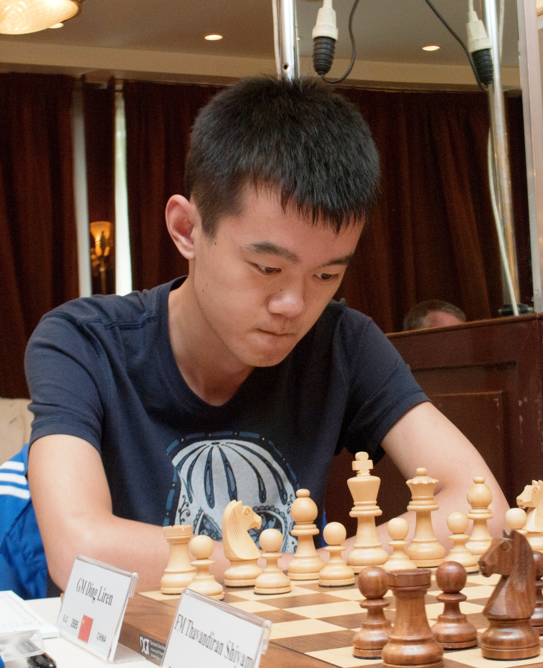
Diagram 486: Ding – Aronian (Alekhine Memorial, Rd 1, 2013): with Black severely cramped White’s advantage is clear but Black looks like winning the exchange. Find the move which increases White’s advantage and follow the
moves to the end of the game in Solution to see
why Ding won the Best Combination prize:

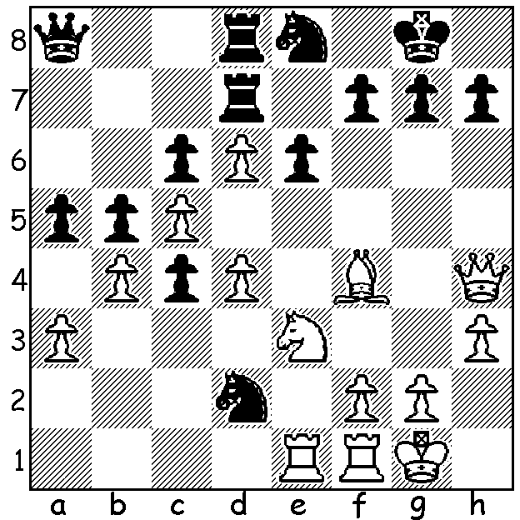
Ding in 2012

The following game, played between the current and an ex-world champion involves Black surrendering his queen for rook, bishop and pawn:

Vladimir Kramnik - Viswanathan Anand
2013 Alekhine Memorial, Rd 6
Queens Ganbit, Semi-Slav Defence
1.d4 Nf6 2.c4 e6
3.Nf3 d5 4.Nc3 c6
5.Bg5 h6 6.Bxf6 Qxf6
7.e3 g6 8.Be2 Bg7
9.e4 0-0 10.e5 Qd8
11.0-0 c5 12.dxc dxc
13.Bxc4 Nd7 14.Ne4 Nxe5
15.Nxe5 Bxe5 16.Qe2 Qc7
17.g3 b6 18.Rac1 bxc
19.Bd3 Qb6 20.Nxc5 Bd4(a)
21.b4!? Qxb4(b) 22.Be4 Rb8
23.Rb1 Qxb1(c) 24.Rxb1 Rxb1+
25.Bxb1 Bxc5 26.Qe5 Bb6
27.Be4 Bd7 28.h4 Rc8
29.h5 gxh 30.Qf6 Bc6(d)
31.Bd3 Rd8 32.Bc2 Rd2
33.Bh7+(e) Kxh7 34.Qxf7+ Kh8
35.Qf8+ & draws by perpetual check.

a) If 20…Qxb2? 21.Rc2 Qd4 22.Be4 Rb8 23.Rd1 Qb4 24.Bxg6!
b) A move leading to intense complications: 20…e5 was the safer alternative.
c) Giving up his queen this way is better than 23…Bxc5? 24.Rxb4 Rxb4 25.Rc1 Bb6 26.Bxg6! fxg6 27.Rxc8! Bxf2+ 28.Kg2 winning. Black could try 23…Bb2 24.Nd3 (or 24.Qc2) 24…Ba6 25.Bxg6 (25.Nxb4 Bxe2 26.Rxb2 Bxf1 27.Kxf1 a5 28.Nd3 Rxb2 29.Nxb2 Rb8=) 25…Qd6 (or 25…Qa3) 26.Rfd1 fxg6 27.Nxb2 Qxg3+ 28.fxg3 Bxe2 29.Rd2.
d) Black starts to create dangerous counter-play to meet the threats against his king.
e) White is forced to bail out to a draw.

The METRO OPEN will be played on 7 successive Thursday evenings from May 23 to July 4.
Entries and information Kelvin Taylor 9381 7854.

SOLUTION: 1.Nd5! Nxf1 (if 1…c/exd5 2.Bxd2 when White has united passed pawns on c5 & d6 or control of the e file, in either case combined with attractive attacking opportunities against Black’s king) 2.Nb6 Qa7 3.Rxf1 (even better 3.Kxf1) Nf6 4.Be5 Nd5 5.Nxd5 exd5 6.Bxg7! Kxg7 7.Qg5+ Kf8 8.Qf6 Kg8 … 11.Re1! axb 12.Re5 h6 13.Rh5 Qxa3 14.Qxh6 f6 15.Qxf6 Black resigns.

