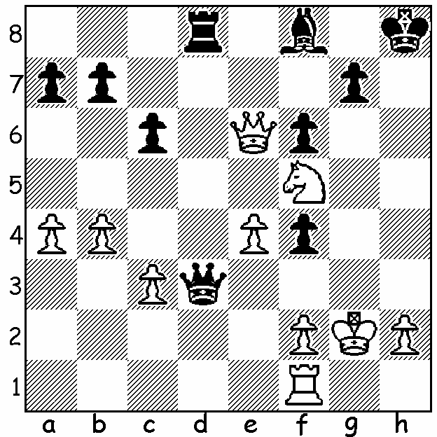

Diagram 487: Blumenfeld – Alekhine 1908:
Black wins quickly:

Last week I reported on the Alekhine Memorial played in both Paris and St Petersburg and won in a count-back by Levon Aronian from Boris Gelfand. Special prizes awarded: Best Technical Win to Boris Gelfand for his game against Michael Adams in Rd 3: Best Combination to Liren Ding for his Rd 1 win against Aronian (last week’s puzzle): Best Game Played in the Style of Alekhine to Laurent Fressinet for his Rd 5 win against ex-world champion Vladimir Kramnik and which is today’s selected game:
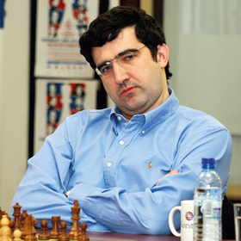
Vladimir Kramnik - Laurent Fressinet
2013 Alekhine Memorial, Rd 5
Irregular Queens Pawn Opening
1.Nf3 d5 2.g3 Nc6
3.d4 Bg4 4.Nbd2 Qd7
5.h3 Bf5 6.c3 e5
7.dxe 0-0-0 8.e3(a) Nge7
9.g4(b) Bg6 10.b4 h5
11.b5(c) hxg! 12.bxc6 Nxc6
13.e6(d) Qxe6 14.Nd4 Nxd4
15.cxd4 Be7 16.Bg2 gxh
17.Bf3 Bf5(e) 18.Qa4 Kb8
19.Ba3 Bh4(f) 20.Nf1 g5 Vladimir Kramnik
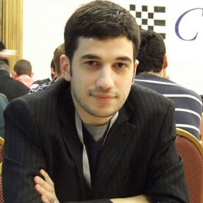
21.Rh2 g4 22.Be2 Be4
23.Rc1 Bg2 24.Qa5 Rc8
25.Rc3 Bxf2+! 26.Kxf2 Bxf1
27.Kxf1 g3 28.Bf3 gxh2
29.Ke2 Rhg8 30.Bc5 a6
31.Bh1 Rg2+ 32.Bxg2 & resigns

a) 8.Nb3 is better.
b) Very weakening.
c) If 11.Rg1 hxg 12.hxg f6 with compensation for the pawn.
d) The best move: if 13.Nd4 Nxe5 is good.
e) Planning the advance of the g pawn to g4.
f) Threatening 20…Qxe3+.
Laurent Fressinet

And here’s a win by the great Alekhine, a 19 move miniature with Black with a delightful queen sacrifice:
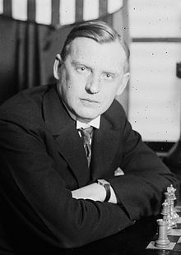
Peter Potemkin - Alexander Alekhine
Russia 1912: Sicilian Defence
1.e4 c5 2.g3 g6
3.Bg2 Bg7 4.Ne2 Nc6
5.c3 Nf6 6.Na3 d5
7.exd Nxd5 8.Nc2 0-0
9.d4 cxd 10.cxd Bg4
11.f3 Bf5 12.Ne3 Qa5+
13.Kf2 Ndb4 14.Nxf5 Qxf5
15.g4 Nd3+ 16.Kg3 Nxd4 !!
17.gxf5 Nxf5+ 18.Kg4 h5+
19.Kh3 Nf2#

The WORLD CHAMPIONSHIP match
between defending champion Viswanathan
Anand and Magnus Carlsen is scheduled
for November 6 – 26 in Chennai, India. Alexander Alekhine

The METRO CHAMPIONSHIP
will be played over 7 successive Thursday evenings from May 23
to July 4. Information and entry to Kelvin Taylor 9381 7854.

SOLUTION: 1…f3+ 2.Kg1 Qxf1+! 3.Kxf1 Rd1#.

