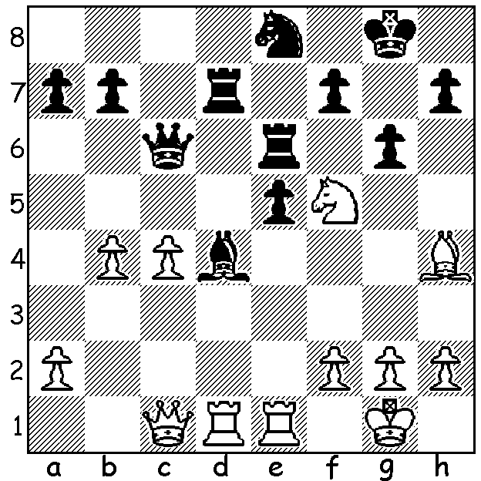

Diagram 488:
Ferozkohi – Lilly (Metro Ch. 2013):
how does White gain a small material
advantage (4 moves)?

The METROPOLITAN CLUB CHAMPIONSHIPS have recently concluded with WA champion Yita Choong winning his fourth club title in a row. Leading scores: A Division: 1st Yita Choong 7/9 (loss to Viswanath, draws with Ferozkohi & Ellis), =2nd Ihsan Ferozkohi & David Ellis 6.5, 4th Ganesh Viswanath 6: B Division: =1st Gordon Dunlop, Gavin Adam & George Carolin-Unkovich 5.5/9: C Division: 1st Mike McGregor 7/9, =2nd Evan Yeung & Alex de Heer 6: D Division: Garry Taylor 6/8, Steve Milovanovic & John Summerfield 5.5: E Division: Eugene Cheong, Ivan Johnson & Luke Sandells 6.5/9. The Metro Championship has been held continually since 1959 and has regularly attracted many of WA’s leading players. Twelve WA champions have won the club championship a total of 31 times in its 55 year history, Dick Lilly (8 times between 1962 & 1995), Mike Partis, Craig Kinsman & Yita Choong (all 4 times), Tristan Boyd (3), Jim Simpson (2), Robert di Renzo, Ron Cooper, John Finkelstein, Stuart Byrne, Wolfgang Leonhardt & David Ellis (all once).
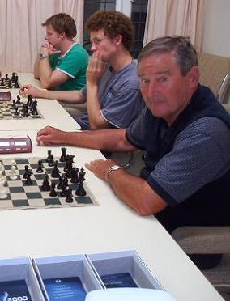



Yita Choong with good reason to smile Dick Lilly (foreground) with
with 3 WA and 4 Metro championships Mark Vliestra (centre) and
in the past four year. Leon Taylor at Metro.

Today’s game is Yita’s only loss from this year’s event:

Yita Choong - Ganesh Viswanath
2013 Metro Championship
Sicilian Defence: Morra Gambit Declined
1.e4 c5 2.d4 cxd
3.c3 Nf6 4.e5 Nd5
5.Qxd4 e6 6.Nf3 Nc6
7.Qe4 d6 8.Bb5 Bd7
9.c4 Nb6 10.exd Bxd6
11.0-0 a6 12.Rd1 Qe7
13.Bg5 f6 14.Be3 Bc5
15.b4(a) Bxe3 16.Qxe3 axb5
17.Qxb6 bxc 18.b5 Nb4
19.Qxb7 0-0!!(b) 20.Rxd7?(c) Rad8!
21.Nc3(d) Qxd7 22.Qe4 Qd3
23.Qxe6+(e) Kh8 24.Qe3 Nc2!(f)
25.Qxd3 Rxd3 26.Rc1 Rxc3
27.h3 Ra8 28.b6 Rb3
29.Rd1 Ra1 White resigns (g)

a) Enlivening the position: 15.Bxc5 Qxc5 16.Bxc6 Qxc6 is equal.
b) Very clever escaping from his difficulties and leaving White behind in development.
c) An uncharacteristic blunder by White: 20.Nc3 Nd3 21.a4 and White is fine.
d) An equally uninviting alternative is 21.Rxd8 Qxb7 22.Rxf8+ Kxf8 23.Nf3 (of course if 21.Rxe7?? Rd1+ mates).
e) Losing a tempo: the immediate 23.Qxd6 allows White to fight on longer.
f) Ensuring the win.
g) Lessons from the game:
1. Beware threats of a back-row mate.
2. Be wary of falling behind in development in open positions.

The FOUNDATION DAY OPEN (Australian, Oceanic & WA Grand Prix event) Sat June 1 (1pm – 8.30pm), Sun 2 & Mon 3 June (11am – 7pm), 2 rounds a day, 90 min + 30 sec on clock. Contact Haydn Barber hadix @vianet.net.au 93984242 or 040147031,

SOLUTION: 1.Ne7+ (either)Rxe7 2.Bxe7 3.Rxd5! exd5 4.Rxe7. Black played 2…Bxf2+ but with R v N + P advantage White went on to win.

APOLOGY: In last week’s diagram a White pawn was omitted from e4. The position has since been corrected.

