The FOUNDATION DAY OPEN (Grand Prix event) will be held over this WA Day weekend,
Sat 1 June (1 -8.30pm) Sun 2 & Mon 3 June (11am -7pm), 2 rounds a day.
Entries Haydn Barber at hadix@vianet.net.au or 9398 4242.

Today we feature the two players who will be competing for the world title in November, world champion Viswanathan Anand and Magnus Carlsen, ranked best player in the world.
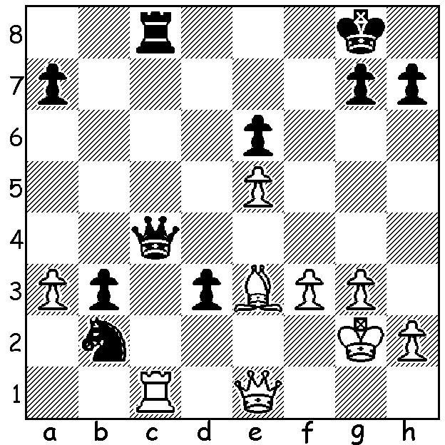
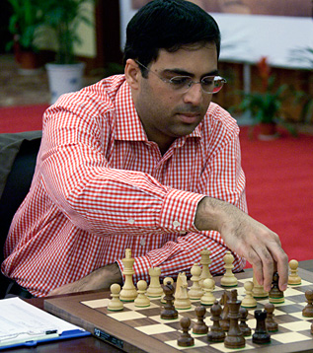

Diagram 489:
Radjabov – Anand
(Norway 2013):
Black brings off a
wonderful finish
(4 moves):

Nine of the world’s top 16 players recently completed a 10 player tournament spread over four venues in Norway. The Norwegian fans would have hoped for another victory from local hero Magnus Carlsen but after four rounds all players were trailing well behind Sergey Karjakin (Russia) who had started with four successive wins. Carlsen was able recover some ground by beating Karjakin in round 5 but was never able to catch up the Russian. Scores: Karjakin 6/9 (+5 =2 -2), Carlsen (+3 =5 -1) & Hikaru Nakamura (USA) 5.5, Peter Svidler (Russia), Levon Aronian (Armenia) & Anand (India) 5, Wang Hao (China) 4.5, Veselin Topolov (Bulgaria), the only player not to win a game, 4, Teimour Radjabov (Azerbaijan) 3, Jon Ludwig Hammer 1.5. Hammer, Norway’s number 2 player, is not rated in the world’s top 100 but did manage one win, against Wang. One pleasing aspect was that there were only 21 draws among the 45 games.



Players at Prizegiving L-R: Two officials, Karjakin, Carlsen, Nakamura,
Svidler, Aronian, Anand, Wang, Topolov, Radjabov, Hammer.
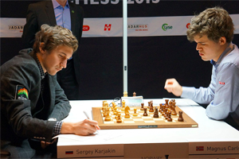
Here is the top clash of the tournament:

Sergey Karjakin - Magnus Carlsen
Norway Chess Super Tournament 2013
Ruy Lopez: Breyer Defence
1.e4 e5 2.Nf3 Nc6
5.0-0 Be7 6.Re1 b5
7.Bb3 d6 8.c3 0-0
9.h3 Nb8 10.d4 Nbd7

11.Nbd2 Bb7 12.Bc2 Re8
13.a4 Bf8 14.Bd3 c6
15.Qc2 Rc8 16.axb axb
17.b4 Qc7 18.Bb2 Ra8
19.Rad1 Nb6 20.c4 bxc
21.Nxc4 Nxc4 22.Bxc4 h6
23.dxe dxe 24.Bc3 Ba6
25.Bb3 c5 26.Qb2 c4
27.Ba4 Re6(a) 28.Nxe5 Bb7(b)
29.Bc2 Rae8 30.f4 Bd6
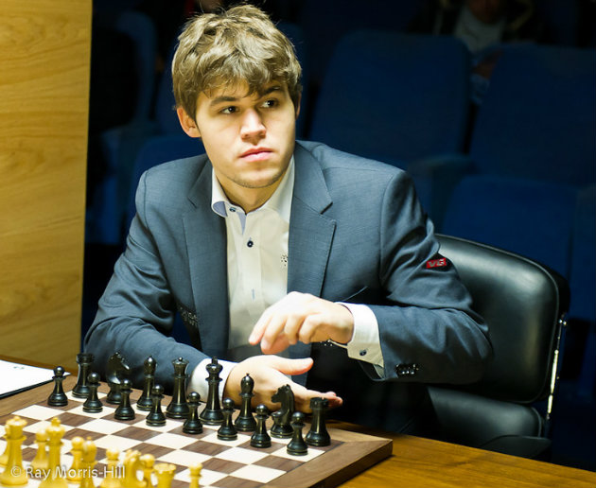
31.Kh2(c) Nh5 32.g3 f6
33.Ng6(d) Nxf4!!(e) 34.Rxd6 Nxg6
35.Rxe6 Rxe6 36.Bd4(f) f5!(g)
37.e5 Nxe5! 38.Bxe5 Qc6
39.Rg1(h) Qd5 40.Bxf5 Rxe5
41.Bg4 h5 42.Bd1(i) c3!
43.Qf2(j) Rf5 44.Qe3 Qf7
45.g4 Re5! 46.Qd4 Qc7
White resigns(k)

a) With a far superior position (compare the bishops on each side) White now wins a pawn.
b) The pawn loss has freed Black’s game, enabling him to attack White’s e pawn. However
White could maintain his advantage with 29.Bb5! (29…Bxe4 30.Bxc4! Rxe5 31.Bxe5 Qxc4 32.Rd4 Qc2 33.Qxc2 Bxc2 34.b5 and the passed pawn will cost Black a piece).
c) Dangerous, placing the king in line with the Black QB battery, but White feels the need to play 32.g3 after Black’s next move.
d) White must have felt he had consolidated and was now winning.
e) A bolt from the blue: if now 34.gxf4 Bxf4+ 35.Nxf4 Qxf4+ 36.Kh1 (36.Kg2 f5 threatening 36…Rg6+) 36…Qg3 37.Re2 Rxe4! winning.
f) Better 36.Bb1 to enable the queen to come to the defence of the king – 36…h5 37.Qf2 h4 38.Re3.
g) Opening up the long white diagonal.
h) 39.Be4! fxe4 40.Re3 is the only move to stave off a speedy end.
i) Black hoped for 42.Rd1? Qxd1! 43 Bxd1 Re1 44.g4 h4 & wins.
j) If 43.Qxc3? Qa2+ wins.
k) If 47.Rg3 h4 or 47…Re1.

SOLUTION: 1…d2!! if 2.Rxc4 dxe1=N+! 3.Kf1 Nxc4: if 2.Bxd2 Nd3! 3.Rxc4 Nxe1+ 4.Bxe1 Rxc4: if 2.Qxd2 Qxc1 3.Qxc1 Rxc1 4.Bxc1 Nd3 and the b pawn queens.

