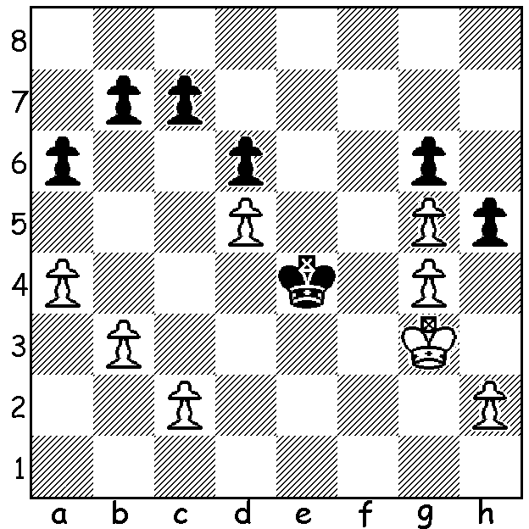

Diagram 490: Ivanchuk –Wang Yue 2009.
Looking at this position you notice White is
a pawn up and has seemingly mobilised his
kingside pawn majority. ‘Should Black resign?’
you might ask. However Black now surprises
White and turns the tables. Find this move and
Black’s winning plan.

The 2013 USA Championship was won by Gara Kamsky, defeating Alejandro Ramirez 2-1 in a play-off after both finished with 6.5/9. Kamsky had previously won in 2011, 2010 and 1991 (then 19 years). Born in the Soviet Union in 1974, Kamsky learnt to play aged 7. He became the youngest player to beat a GM in tournament chess when he defeated Mark Taimanov when 12. His junior successes included USSR Under 20 champion 1987 & 1988. He defected to the USA in 1989 and publicised his intention of becoming world champion. In 1996 he qualified to play Anatoly Karpov in Russia for the title but lost 7.5 – 10.5 (+3 =9 -6). Either through disappointment or as a protest against perceived cheating by the Russians he retired and only took up the game again in 2004. Here is one of his best games:

Vladimir Kramnik – Gata Kamsky
World Championship Quarter-Final 1994
English Opening
1.Nf3 Nf6 2.c4 e6
3.Nc3 Bb4 4.g3 0-0
5.Bg2 c5 6.0-0 Nc6
7.d4 cxd 8.Nxd4 Qe7
9.Nc2(a) Bxc3 10.bxc3 Rd8
11.Ba3 d6 12.Rb1 Qc7
13.Nd4 Nxd4 14.cxd4 Qxc4
15.Qd2 Qa6 16.Rb3 Rb8
17.e4 Bd7 18.Rf3(b) Ba4!(c)
19.Re1 Rbc8 20.Bf1 Bb5
21.Bh3 Qa4 22.d5 Rc2
23.Qe3 exd 24.e5(d) d4!
25.Qg5 Re2! 26.exf6(e) Rxe1+
27.Bf1(f) Rxf1! 28.Kg2 Rg1+!
29.Kh3(g) Bd7+ 30.Kh4 g6
31.Qh6 d3+ 32.Rf4 Qxf4!+
33.Qxf4(h) Rh1 34.g4 h6!
35.Kh3 g5! 36.Qd4 Rg1
37.f3 d2! 38.Qxd2(i) Bb5
White resigns

a) Prepared to accept double isolated pawns to gain the two bishops, better development and open lines.
b) Intending a kingside attack but leaving Black a free hand on the queenside.
c) 18…Nxe4 19.Qf4 f5 20.g4 would fall in with White’s plan.
d) If 24.exd? Re8 wins.
e) Sacrificing for a seemingly mating attack.
f) Not 27.Kg2? Bf1+ 28.Kg1 Bxh3#.
g) Not 29.Kxg1? Qd1+ 30.Kg2 Qf1#.
h) White is forced to release the mate threat as 33.gxf4 loses to 33…Rg4+ 34.Kh3 Rg5+ 35.Kh4 Rh5+.
i) If 38.Qxg1 Bb5 and the d pawn queens.

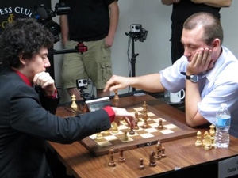

Kamsky (rt) v Ramirez in their US championship Armageddon decider.

SOUTH WEST OPEN Sat 15 & Sun 16 June at Bridgetown. Time is running out to enter and arrange accommodation. Details cawa.org.au & inquiries to Norbert Muller 9409 9579

SOLUTION: 1…h4+!! (a pawn down, Black sacrifices a second to gain Zugzwang (note the appropriate name of the winner): 2.Kxh4 (forced) Kf3. Now White’s pawn majority is completely immobilised and he will be forced to shed pawns on the queenside (Black can stop the White king shuffle between h3 & h4 by playing …Kg2). Attempts to engineer pawn sacrifice breaks to queen on the queenside fail (3.a5 – planning to place pawns on a5, b4, c4, d5 – is met by 3…c6!). The game concluded 1…h4+ 2.Kxh4 Kf3 3.b4 b5 4.a5 Kg2 5.h3 Kh2 White resigns.
.

