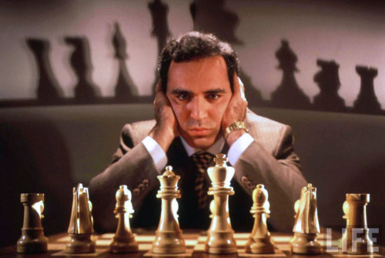
Diagram 491: Kasparov – Ivanchuk 1988:
White to play and win (4 moves):

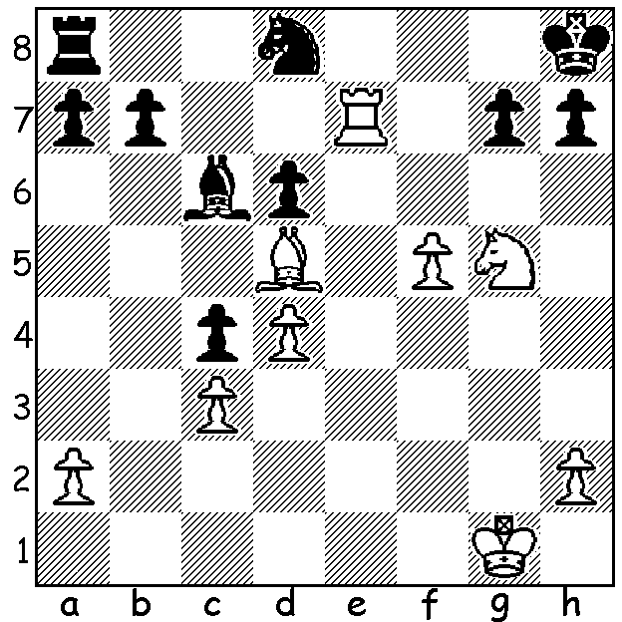

GARY KASPAROV RECEIVES HUMAN RIGHTS AWARD

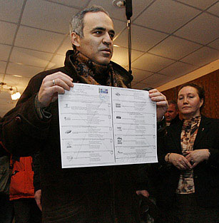
Former world champion Gary Kasparov retired from
chess in 2005 and since then his activities have been
divided between two passions, the advancement of chess
through the worldwide promotion of the game within the
education system and the struggle for human rights within
Russia. On June 5th in Geneva he received the UN Watch’s
annual human rights prize, the Morris B. Abraham Human
Rights Award for his political campaigning. At one time a
potential challenger to Vladimir Putin for the presidency,
Kasparov has been arrested more than once and has spent
time in prison. Up to late February he paid frequent visits
to Russia but at an interview after receiving the award he
stated he would not return to Russia because of the likelihood
of criminal prosecution for his political activities in view of
the present increasing crackdown on dissidents. However he
declared, “Russia is my home even if I am not able
to live there.” So here is a game from his earlier time
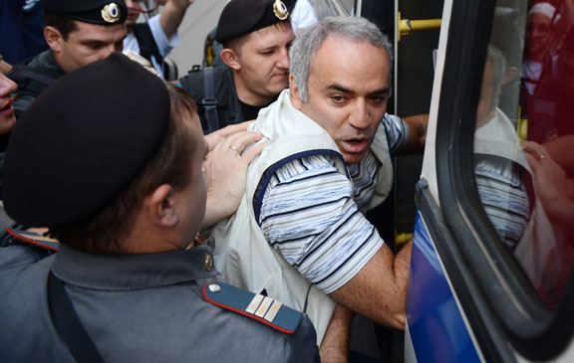
in Russia, a win aged 18 in the USSR Championship
in which he came =1st. Let’s marvel at Kasparov’s
superb positional play and the concluding brilliant
combinations.

Gary Kasparov receiving
UN Human Rights award 2013

Kasparov arrested in 2012
at pop group Pussy Riot’s trial

G. Kasparov - V. Gavrikov
1981 USSR Championship
Queens Gambit, Tarrasch Defence
1.d4 d5 2.c4 e6
3.Nf3 c5 4.cxd exd
5.g3 Nc6 6.Bg2 Nf6
7.0-0 Be7 8.dxc Bxc5
9.Bg5 0-0 10.Nc3 d4(a)
11.Bxf6 Qxf6 12.Nd5 Qd8
13.Nd2(b) a6(c) 14.Rc1 Ba7
15.Nc4 Rb8(d) 16.Nf4 b5?
17.Nd6! Qxd6(e) 18.Rxc6 Qd8
19.Qc2 Re8(f) 20.Rc1 a5
21.Bd5! Bb6 22.Qb3 Re7
23.Bf3 Re5 24.Bh5! g6
25.Bxg6! hxg6 26.Rxg6 Kf8
27.Rh6 Ke7(h) 28.Rcc6 Rf5(i)
29.Qf3!(j) Bc7 30.Qe4+ Re5
31.Ng6+! fxg6 32.Rh7+ Kf8
33.Qxg6 Black resigns

a) 10…Be6 is a playable alternative.
b) The start of a long series of moves which gains control of the c file and so many of the key white squares.
c) Securing a retreat for the bishop but better was 13…Bg4 14.Nf4 (14.Rc1? d3!) or 13…Bh3!
d) Again better was 15…Bh3!
e) 17…Ne5 was a little better.
f) 19…Bb7 would force White into winning positionally – 20.Rc7 Bxg2 21.Kxg2 Bb6 22.Rc6.
g) The tempting skewer 21…Bb7 loses to 22.Bxf7+! Kxf7 23.Rc7+ Re7 (23…Kg8 24.Qb3+ Kh8 25.Qf7 wins) 24.Qb3+ Kf8 25.Ne6+ Rxe6 26.Qxe6 Qf6 27.Qxf6 gxf6 28.Rxh7 winning.
h) If 27…Kg7 28.Rh7+! wins.
i) f7 must be defended – if 28…Bd7 29.Ng6+! fxg6 30.Rh7+ wins.
j) Not 29.Ng6+ fxg6 30.Rh7+ Kf8 31.Rh8+ Kg7 32.Rxd8 Bxd8 with more than ample material for the queen.

SOLUTION: 1.f6! Black resigns – 1…Bxd5 (1…gxf 2.Rxh7#) 2.Re8+ Bg8 27.f7 Nxf7 28.Nxf7#.

