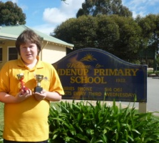
Bridgetown, for the second year running, was last weekend venue for the South West Open (WA GP event), giving non-metropolitan players an opportunity to compete seriously in competition, with 11 of the 26 entrants coming from outside Perth. The tournament, organised by Norbert Muller from the Perth Club was a great success (certainly on a personal level, as I gained my first top place in any event since 2011). Scores: 1st= David Ellis, Marc Vliestra, Robert Maris, Gordon Dunlop (4.5/6), 3rd= Gavin Adam, Steven Wood, Jayden Williams (4.5), with Steven and Jayden becoming joint champions of Country WA.

Readers may remember that Jayden was
featured in this column last year as top
board of the Kendenup Primary School
which won the ChessKids WA Primary
schools championship and then went on
to be runners-up in the Australian-New
Zealand competition in Melbourne.

Jayden with trophies
won in Melbourne 2012

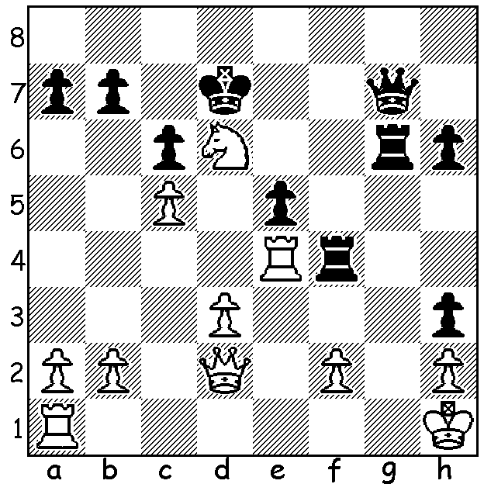

Our position, Marc Vliestra – Steven Wood,
(Diagram 492) comes from the Bridgetown event. White, a piece up, plays 1.Rxf4 but is visibly shocked by Black’s reply. Can you find Black’s move?

Over the years particular defences have periods of popularity among the leading players. At present Semi-Slav defences against 1.d4 and various defences against the Ruy Lopez (a move away from the Sicilian) are the most common. Occasionally however one sees a game stand out through its unusual opening play:
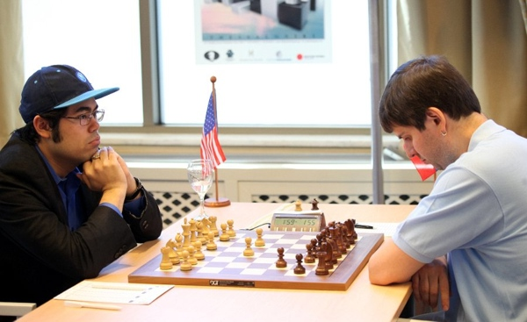

Hikaru Nakamura - Peter Svidler
GP Thessaloniki, May 2013
English Opening (Irregular)

1.c4 g6 2.e4 e5
3.d4 Nf6 4.Nf3 exd
5.e5 Ne4 6.Qxd4 Bb4+
7.Nbd2 Ng5 8.a3 Nxf3+
9.gxf3 Nc6 10.Qe3 Bf8
11.b4 Bg7 12.Bb2 0-0
13.f4 d6 14.0-0-0 dxe
15.fxe Qh4 16.b5 Ne7
17.Qg3 Qh5 18.f4 a6
19.a4 axb 20.axb Bg4
21.Re1 Rfd8 22.Rg1 Be6
23.Be2 Qf5 24.Bg4 Qxg4
25.Qxg4 Bxg4 26.Rxg4 Nf5
27.Rg2 Rd3 28.Ne4 Ra4
29.Rc2 Re3 30.Kd1 Rd3+
31.Kc1 Ne3 32.Nc5 Nxc2
33.Kxc2 Rxc4+ 34.Kxd3 Rxc5
35.Ra1 Rxb5? 36.Ra8+ Bf8
37.Bd4 h6 38.Rc8 c6
39.Bc3 Rd5+ 40.Ke4 Rc5
41.Kd3 Rb5 42.h4 h5
43.Bd2 Rd5+ 44.Kc2 Rc5+
45.Kd3 Rd5+ 46.Kc2 g5
47.f5! gxh 48.Bc3 Kg7
49.e6+ f6 50.Rc7+ Kg8
51.Rc8 Kg7 52.Rc7+ Kg8
53.Bxf6 Rxf5 54.Rc8 Rf2+
55.Kd3 Rf3+ 56.Kd4 resigns

The previous GP event, the Foundation Day (WA Day) Open was won jointly by WA champion Yita Choong and Ganesh Viswanath (5/6) with Eddy Seah and Akef Salah (4/6) equal third.

A new chess club is opening in Mandurah with its first meeting planned for 7pm Monday 24 June at Assumption Catholic Primary. Players of all standards welcome including beginners. For more information see mandurahchess@gmail.com or phone John on 0421930437.

SOLUTION: 1.Rxf4 Rxd6!! 2.Rg1 (2.cxd6?? Qg2# or 2.Rf7+ Qxf7 33.cxd6?? Qf3+ wins) 2…Rg6 3.Rg3 and after the exchange of both pairs of rooks White went on to win a hard fought queen ending.

