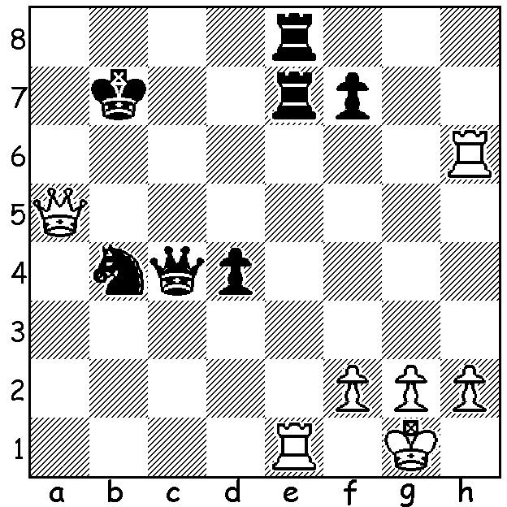

Diagram 493:
Gelfand – Kramnik 1994:
White mates quickly:

The 8th Tal Memorial, held in Moscow 12 to 24 June was won by Israeli Boris Gelfand who one year ago just failed to dethrone world champion Viswanathan Anand. At Moscow Gelfand went through undefeated in scoring 6/9, a half point ahead of Magnus Carlsen, Anand’s next challenger in November. The four Russians would have disappointed their supporters winning only two games and only one in 24 games against non-Russians with ex-world champion Vladimir Kramnik finishing in last place. American Hikaru Nakamura led after six rounds but lost his last three games to finish on 4.5/9. Here is the first of those three losses with Gelfand showing superb technique to obtain a winning minor piece endgame with only three pawns each, utilising the superiority of bishops in open positions, better king placement and the outside passed pawn. Published games tend to be those with brilliant sacrificial attacks but today let’s enjoy the artistry of the accumulation of small advantages to finally gain a win with sparse material remaining.

Hikaru Nakamura - Boris Gelfand
8th Tal Memorial, Rd 7
Sicilian, Sveshnikov Variation

1.e4 c5 2.Nf3 Nc6 3.d4 cxd
4.Nxd4 Nf6 5.Nc3 e5 6.Ndb5 d6
7.Bg5 a6 8.Na3 b5 9.Bxf6 gxf6
10.Nd5 f5(a) 11.c4 b4 12.Nc2 fxe
13.g3(b) Bg7 14.Bg2 0-0 15.Bxe4 Rb8
16.b3 f5 17.Bg2 e4 18.Rb1 Qa5
19.0-0 Qxa2 20.Nde3(c) Qa5 21.Qxd6 Rf6
22.Qf4 Qe5 23.Qxe5 Nxe5 24.Nd5 Rf7
25.Ncxb4 a5 26.Nc2 Rfb7 27.Nce3(d) Nc6(e)
28.c5 Rxb3 29.Nb6 Rxb1 30.Rxb1 Be6(f)
31.Bf1 Bd4 32.Rb5 Kf7 33.Nc4 Kg7
34.Nd6 Kf6(g) 35.Na4 e3(h) 36.fxe3 Bxe3+
37.Kg2 Bd5+ 38.Kh3 Rxb5 39.Bxb5 Ne5
40.Nc3 Bf3 41.Be2 Bxe2 42.Nd5+ Kg5
43.Nxe3 Ng4(i) 44.Kg2 Nxe3 45.Kf2 Nc4
White resigns(j)

a) While many top players have changed from 1…c5 to 1…e5, Gelfand retains faith in the Sicilian.
Needing a win, he chooses one of the most aggressive lines, accepting a broken kingside and a vulnerable backward d pawn on the half open file. In compensation Black has the two bishops and a central pawn majority.
b) Not 13.Ndxb4? Nxb4 14.Nxb4 Qa5 15.a3 d5!
c) Better might be 20.f3 exf 21.Bxf3 Be5.
d) Very complicated is 27.Nd4 (27…Nxc4 28.Nc6 Nd2 29.Nde7+ Rxe7 30.Nxe7+ Kf7 31.Nxc8 Nxb1 32.Nd6+ Ke6 33.Nxf5 Kxf5 34.Rxb1 Bc3 35.Rd1 =).
e) Not 27…Rxb3? 28.Rxb3 Rxb3 29.Ne7+.
f) Note the potential of the passed a pawn supported by the raking bishops.
g) 34…Bxc5 35.Rxc5 Rxb6 36.Nxf5+ Bxf5 37.Rxf5 is also to Black’s advantage with his distant passed a pawn difficult to stop.
h) Now White is in danger of being mated.
i) 43…Bf3 is also worrying to White threatening …Nd3 & …Nf2# (if 44.Ndxf5 Ng4! wins).
j) With his outside passed pawn it’s a simple won pawn ending after 45.Kxe2 Nxd6 46.cxd6 Kf6.




Nakamura & Gelfand after their game Gelfand with Tal Memorial trophy

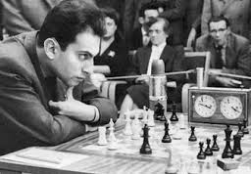

Mikhail Tal (1936-92) in 1982.
World Champion 1960-61.
Considered the greatest
attacking player of all time.

SOLUTION: 1.Rxe7+ (exposing Black’s back rank) 1…Rxe7 2.Qb6+ Kc8 3.Rh8+ …

