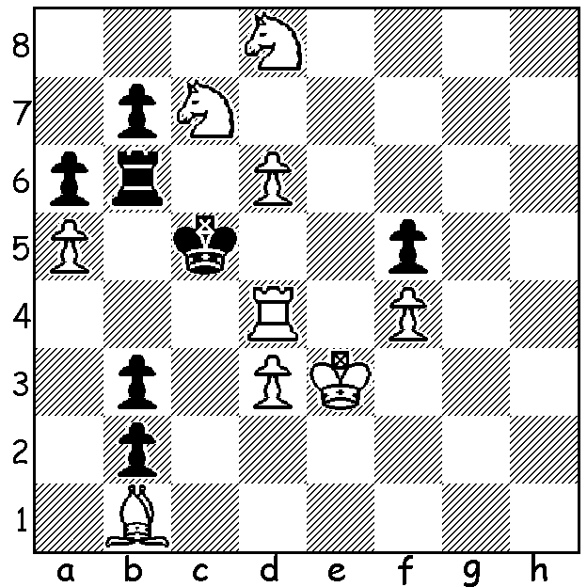

Diagram 495:
A surprise first move for a mate in two –
5 variations (J. P. Taylor):

Last week I asked, ‘Who was the most famous person to lose in a Man v Machine chess game?’
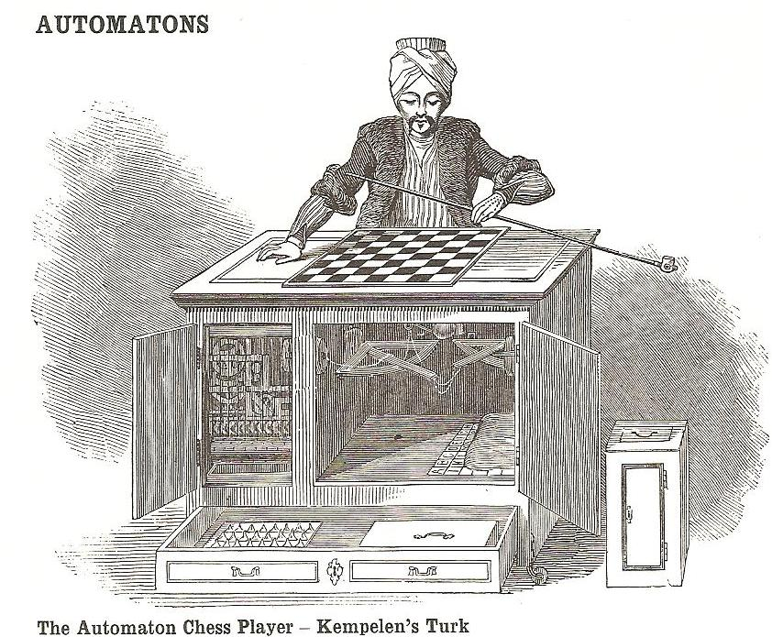
I first heard this question on Stephen Fry’s QI, a humorous quiz on ABC1. I’m afraid I would have got a -10 score with the answer, ‘Gary Kasparov’, thinking of his defeat in 1997 against Deep Blue. The answer is in fact Napoleon Bonaparte
in his game against The Turk, a name given
to a chess-playing ‘automaton’ designed in
1769 by Wolfgang von Kempelen as an
amusement for the court of the Austrian
Empress Maria Theresa. The device consisted
of a life-size figure clad in Turkish robes attached
to a sizeable cabinet which had an inlaid chess
board with pieces on top. Spectators were
invited to look into the cabinet with its array
of machinery to ensure it did not contain a
person (which, of course, it did during the
actual game, a prominent player who was able
to see the moves thanks to a magnetic system of
pieces and manipulate the mechanism). The Turk
continued its career for almost 85 years. Kempelen
took The Turk to several European cities including
Dresden, Leipzig, Paris and London. After his
death in 1804 the automaton was bought by
a Bavarian showman Johann Neponuk Melzel who had designed an automatic orchestra and persuaded Beethoven to compose for the machine. Melzel and The Turk also toured European cities and from 1826 to 1836 cities in USA. After Melzel’s death while returning from Cuba to USA the Turk ended its days at the Chinese Museum in Philadelphia where it perished in a fire in 1854.

Napoleon Bonaparte - The Turk (1809)
1.e4 e5 2.Qf3 Nc6
3.Bc4 Nf6 4.Ne2 Bc5
5.a3 d6 6.0-0 Bg4
7.Qd3 Nh5 8.h3 Bxe2
9.Qxe2 Nf4 10.Qe1? Nd5
11.Bb3 Nxh3+! 12.Kh2 Qh4
13.g3 Nf3+ 14.Kg2 Nxe1+
and Black soon wins.

Not impresses by the game? Here’s a better one by the purported player against Napoleon, Johann Baptist Allgaier (1763 – 1823), the leading player in Vienna whose treatise on the game, first published in 1795, was reprinted seven times up to 1843 and whose name is commemorated in the Allgaier Gambit, a variation in the Kings Gambit (1.e4 e5 2.f4 exf 3.Nf3 g5 4.h4 g4 5.Ng5 h6 6.Nxf7):

Anon – Johann Baptist Allgaier
Bishops Opening
1.e4 e5 2.Bc4 f5
3.Bxg8 Rxg8 4.exf d5
5.Qh5+ g6 6.fxg Rxg6
7.h3 Qf6 8.Nf3 Nc6
9.Nh4 Bc5 10.Nxg6 hxg6
11.Qf3 Bf5 12.g4 Nd4
13.Qxd5 Nxc2+ 14.Kd1 Rd8
15.Qxc5 Be4 16.Re1 Qf3+
17.Re2 Qh1+ 18.Re1 Qxe1#.

SOLUTION: 1.Kd2!! If 1.Kxd4 Nde6# and any rook move deprives the king of an escape square - if 1…Rb5 2.Nce6#; if 1…Rc6 2.Nxb7#; if 1…Rxd6 2.Rc4#: if 1…Rb4 2.Rd5#.

