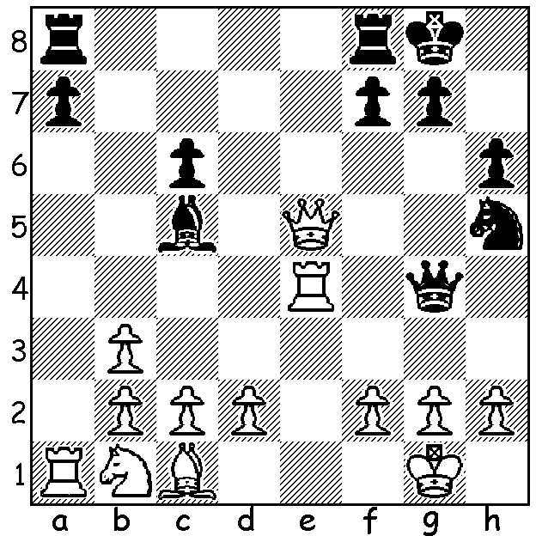

Diagram 496:
William Wayte – Elijah Williams 1835:
Black wins quickly:

Last week we answered the question, ‘Who was the most famous person to lose a Man v Machine game of chess?’ with the answer being ‘The Turk’, a fake automaton designed in 1769 by Wolfgang von Kempelen and whose most famous victim was Napoleon Bonaparte. One of players who had a stint concealed within The Turk’s cabinet was the Englishman Elijah Williams (1809-54). Williams was born in Bristol where he practiced as an apothecary before the lure of chess became too strong. He moved to London where Simpson’s Divan, a café/restaurant in The Strand, was the leading world centre of chess.

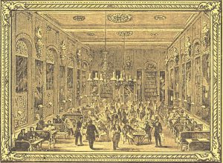

Simpsons Divan

Williams published a collection of 150 games of leading masters played mainly at the Divan entitled ‘Horae Divanianae’. He also wrote chess columns in both the Bath & Cheltenham Gazette and The Field for a number of years. Williams’ play revealed a sophisticated style, employing positional devices not common until about sixty years later. He participated in the first international tournament, London 1851, the year of the Great Exhibition in London, won by Adolf Anderssen, famous for his ‘Immortal’ and ‘Evergreen’ games. The event was a knock out tournament of 16 players with all the winners of Round 1 continuing to the end to determine minor placings. First round winners needed to win two games and in subsequent rounds winners needed to win four games. In the match to decide 3rd place Williams claimed a hard-fought 4.5-3.5 win against Howard Staunton, recognised as the leading player in Europe in the 1840s and the pioneer of the event. Staunton was a fierce critic of Williams’ slow play, a justifiable complaint as Williams was recorded as taking 2hr 30min on just one move during the event. It’s reported that Staunton said, “Elijah, you not supposed to just sit there – you’re expected to sit there AND THINK!” Williams was also the subject of a song using his unflattering nickname, ‘The Bristol Sloth’. It’s no wonder that time restrictions were introduced at London 1862, 20 moves in 2 hrs using sand glasses.

Elijah Williams – Howard Staunton
London 1851
Sicilian Defence
1. e4 c5 2.f4 Nc6 3.Nf3 e6
4.Bb5 g6 5.Bxc6 bxc6 6.c4 Bg7
7.Qe2 Qb6 8.e5 Nh6 9.Nc3 Nf5
10.Ne4 0-0 11.d3 Rb8 12.0-0 d5
13.Nc3 Ba6 14.b3 Qc7(a) 15.Ba3 Rfd8
16.Bxc5 Bf8 17.Bf2 Qa5 18.Rac1 Rd7
19.g4 Ng7 20.Nd1(b) h5 . 21.h3 Be7
22.Ne3 d4(c) 23.Ng2 c5 24.Ng5! Bxg5
25.fxg5 Bb7 26.Nf4 hxg4 27.hxg4 Qb6
28.Bg3 Qc6 29.Qh2 Ne8 30.Rc2 f5
31.gxf6! Rh7 32.Nxg6! Nxf6(d) 33.exf6 Rxh2
34.Rxh2 Re8 and Black resigns(e)

a) Losing a pawn: 14…Nd4 15.Qf2 Nxf3+ 16.Qxf3 f6 17.exf Bxf6 is equal.
b) Heading for the kingside. A similar idea was used in the famous game Botvinnik-Tshechover 1935
c) Black is now planning to take advantage of White’s lack of a white-square bishop by a concentrated attack along the long diagonal a8-h1 and the h file.
d) 32…Qh1+ 33.Qxh1 Rxh1+ 34.Kf2 Kf7 35.Rxh1 Bxh1 leads to a clearly lost ending.
e) 35.Rh8+ Kf7 36.Ne5#: nor would 34…Rf8 have been better – 35.Rh8+ Kf7 36.Ne5+ Ke8 37.f7+ Kd8 38.Nxc6+.

SOLUTION: 1…Nf4! (a sacrifice taking advantage of White’s vulnerable back rank): if 2.Q/Rxf4 3.Qd1+ mates. White played 2.g3 but resigned after 2…Bd6! (if 3.Qxd6 or 3.Rxf4 3…Qd1+).

