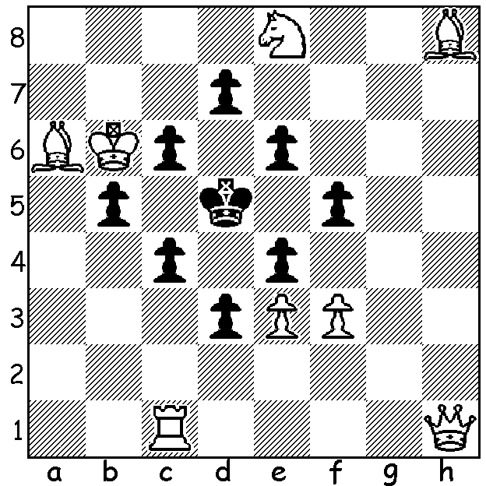

Diagram 497:
White to play and mate in two
(J. Keeble):

Readers may remember mention last week of the Victorian Elijah Williams recorded as taking 2hr 30min on one move. This is the slowest move ever made although with chess clocks Francisco Trois took 2hr 20min on his 7th move against Luis Santos at Vigo, Spain, in 1980.
Some other random records and statistics:
The largest Chess Tournament was the 1935-6 USSR Trade Union Chess Championship with over 700,000 entrants.
In 2004 the annual Chess Challenge for Schools in the UK had over 71,000 competitors from over 2000 schools.
1985 US Scholastic Championship 1572 players.
1973 New York Chess Congress 1487 players.
Most successive captures – 17 from Blodig–Wimmer, Germany 1988 and Rudd – Robertson, Swansea, Wales, 2006.
Longest game without a capture 72 moves – Meijfroidt–Lenoir 1972 with White losing on time.
It’s estimated there are 700 million players in the world with 7,500,000 in 160 countries registered with FIDE (Fédération Internationale des Échecs). There are also 200 million who have played online.

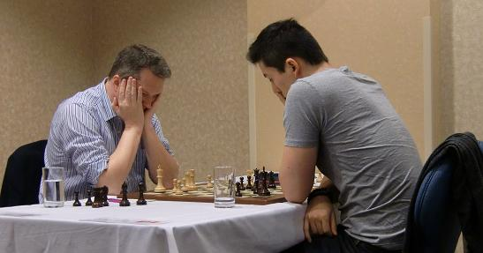

Nigel Short (L) and Eric Hansen in their draw at Canadian Open
Our game today comes from the 2013 Canadian Open (181 players) which was won by Nigel Short (UK) on tie-break from Canadian Eric Hansen with 7.5/9. The game is noteworthy for the positional exchange sacrifice which takes 12 moves to bear fruit.

Leonid Gerzhoy - Nigel Short
2013 Canadian Championship
Queens Gambit Declined: Orthodox Defence
1.d4 Nf6 2.Nf3 d5
3.c4 e6 4.Nc3 Nbd7
5.Bg5 h6 6.Bh4 Be7
7.e3 0-0 8.Rc1 Re8
9.Bd3 dxc 10.Bxc4 a6
11.a4 c5 12.0-0 cxd
13.exd Nb6 14.Bb3 Bd7
15.Ne5 Bc6 16.a5 Nbd5
17.Nxd5 Bxd5 18.Ba4 Qxa5!?
19.Bxe8 Rxe8(a) 20.Bxf6 Bxf6
21.Qh5 Bxe5 22.dxe5 Qd2
23.Rc3(b) Qxb2 24.Rg3 Kf8
25.f4(c) Rc8 26.Qg4 Rc1!
27.Qxg7+(d) Ke8 28.Rgf3(e) Qd4+
29.Kh1 Qa1 30.Qh8+ Kd7
White resigns

a) Black has a pawn for the exchange and his queen’s bishop, usually the problem child in this defence, takes up a dominating position.
b) White gives up a second pawn to swing the rook over to the kingside but leaves his own back rank vulnerable despite the presence of the other rook on f1.
c) Preparing his next move but weakening, enabling a later queen check.
d) ‘But when she got there, the cupboard was bare’ – White’s attack has come to nothing and the queen is now out of play.
e) If 28.Rxc1 Qxc1+ 29.Kf2 Qd2+ 30.Kf3 (30.Kg1 Qe1#) 30…Qe2#.

SOLUTION: With Black’s king unable to move there is only one move to mate after each of Black’s pawn moves – 1.Qg2: if 1…d6 2.Nc7#; if 1…c5 2.Bb7#; if 1…e5 2.Qg8#; if 1…b4 2.Bxc4#; if 1…f4 2.fxe#; if 1…c3 2.Qa2#; if 1…exf 2.Qxf3#; if 1…d2 2.Qxd2#.

