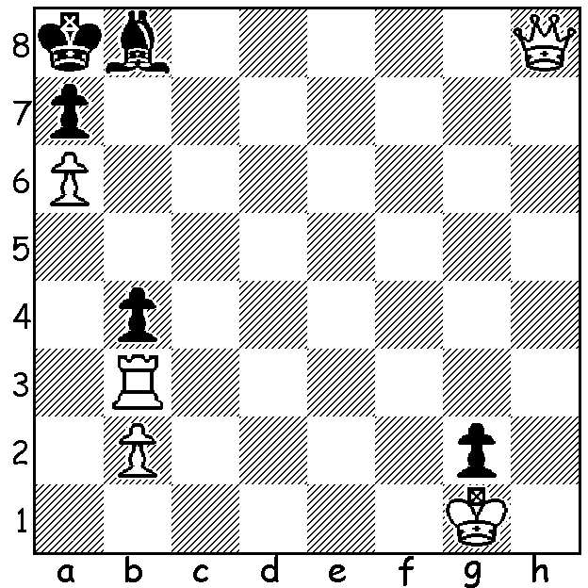

Diagram 498:
P. Daley
White to play and mate in 3
(only one line):

The Metropolitan Chess Club has held a mid-year Open Championship since 1999, the year it celebrated its 40th anniversary. This year’s event attracted 36 players and, as is often the case, there were a number of upsets. Looking through the games, two in particular attracted my attention, Doug McLean’s win against a twice winner and two times state champion Richard Lilly and Brian Gale’s win against another Open winner Gordon Dunlop. Brian also came very close to defeating the top ranked player Marc Vliestra. In those two games Brian was rated 359 and 507 points respectively below his opponent.

Brian Gale - Gordon Dunlop
Metro Open Championship 2013
Queens Indian Defence
1.d4 Nf6 2.Nf3 e6
3.c4 b6 4.e3 Bb7
5.Bd3 d5 6.cxd Nxd5
7.0-0 Be7 8.Qa4+ c6
9.Nc3 0-0 10.Nxd5 Qxd5(a)
11.Qc2 Qh5 12.Be2 f5
13.Ne5 Qh6 14.Bf3 Bd6
15.g3 Bxe5 16.dxe5 Nd7
17.e4 Qg6 18.Bf4 Nc5
19.exf exf 20.Rfe1 Kh8
21.Rad1 Rad8 22.Rxd8(b) Rxd8
23.Bg2 Ne6 24.Be3 h5
25.f4 h4 26.Bf2 hxg
27.hxg Qg4 28.Qe2(c) Qxe2
29.Rxe2 Ba6 30.Rc2 c5
31.Bh3(d) Rd1+ 32.Kh2 Bd3
33.Rc3 Rd2(e) 34.Kg1 g5.
35.Be1 Rd1 36.Rxd3!!(f) Rxd3
37.Bxf5 Rd1 38.Bxe6 Rxe1+
39.Kf2 Rb1 40.f5 Rxb2+
41.Kf3 Kg7 42.Kg4 Re2(g)
43.f6+ Kf8 44.Kf5 b5
45.Bd7 a6 46.e6 c4

47.Kg6 b4 48.e7+ Rxe7
49.fxe7+ Kxe7 50.Ba4 g4
51.Kf5 Kd6 52.Kxg4 Kc5
53.Kf5 b3(h) 54.Bxb3! cxb3
55.axb Kb4 56.g4 Kxb3
57.g5 resigns

a) Black intends to pressure White’s kingside with the queen and fianchettoed bishop on b7.
b) Giving up the d file gives Black chances of equalizing or even seizing the initiative.
c) Worried about the possibility of 28…g5 29.fxg f4! White wisely seeks the queen exchange.
d) Underestimating Black’s threats on his 1st & 2nd ranks: 31.Be3 would eliminate danger.
e) 33...Be4 34.Bg2 Bxg2 leaves Black, whose rook and knight are strongly placed, with no worries despite White’s passed pawn
f) Very imaginative play! Despite finishing the exchange down White’s advance united passed pawns give him the advantage.
g) If 42…c4! 43.f6+ (43…Bxc4? 44.Rb4 winning) 43…Kf8 44.Bf5 maintains the win.
h) Hoping for 54.axb c3 55.g4+ Kxg4

If readers would like to check out further games from the event I would suggest Vliestra - Gale,
Seah - Vliestra, Lilly - McLean, R. Bailye – G. Taylor, Gale – Lilly, Seah - Ellis, Vliestra - Ellis, Gilmetdinov - Seah.
Results: 1.David Ellis 6/7 (following wins in 2000, 2004, 2005), =2nd Eddy Seah, Leon Taylor 5.5, 3rd Marc Vliestra 5: Rating winners – Under 1750 Mohammad Jahangirian, Sakib Ahmed 4.5, Under 1350 Ben Motu 4.

SOLUTION: White’s problem is to avoid stalemate. The key move is 1…Rh3 and after 1..b3 2.Rh1! gxh1=Q+ 3.Qxh1#.

