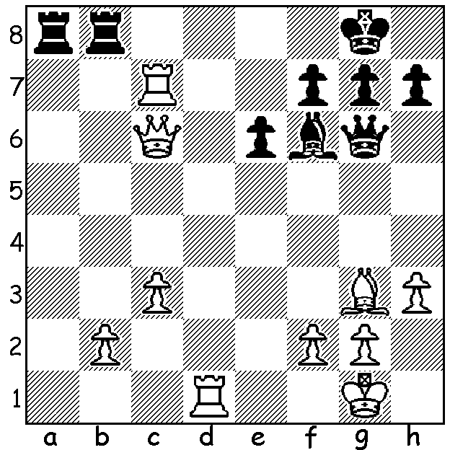

Diagram 489:
Lane – Menacher 2003:
White to play and win:

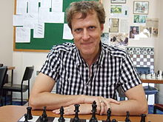
Looking at the news on the British
Championship being played at the
seaside resort of Torquay in Devon,
I saw the name Gary Lane (Australia).
Born in 1964 Gary was, I believe,
originally from Torquay and came to
live in Sydney in 2000. An IM
(International Master), Gary is a past
Australian champion, 2004, and
Commonwealth champion, 1998, and
has represented Australia in three
Olympiads. He has written over 20
books and also writes for a number
of chess publications both here and
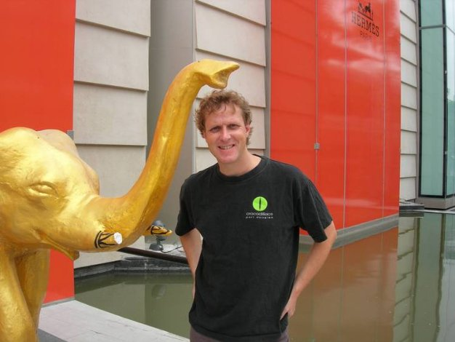
the UK besides having coached
representatives from both countries in
international junior events. I met Gary
at last year’s Oceanic Seniors
Championship where he had a bookstall.
He was anxious to pass on the email
address of English chess writer Bob Jones
who was researching for a book on the
West of England Championships as I
had been a winner in 1966. Despite
being from different generations we
were able to spend time reminiscing on
chess in England, particularly the South
West.

Simon Warman - Gary Lane
2013 British Championship, Rd 1
Ruy Lopez
1.e4 e5 2.Nf3 Nc6 3.Bb5 a6
4.Ba4 Nf6 5.0-0 b5 6.Bb3 Bb7
7.Nc3 Be7 8.Nd5 d6 9.Nxf6+ Bxf6
10.Bd5 Rb8 11.c3 0-0 12.d4 Re8
13.Re1 exd 14.cxd Nxd4! 15.Bxf7+!(a) Kxf7
16.Nxd4 Kg8(b) 17.Bf4 Qd7 18.f3 Qf7
19.Bg3 g6 20.Re2 Rbd8 21.Nb3 Qg7
22.Na5 Ba8 23.Qb3+ Kh8 24.Rd1 d5
25.Rc2 Bd4+ 26.Kf1 dxe 27.Rxc7 Qf6
28.Rf7 Qb6 29.Bc7 exf!!(c) 30.gxf Bd5!(d)
31.Qxd5! Qxc7! 32.Rxc7 Rxd5 33.Nc6 Bb6
34.Rxh7+! Kxh7 35.Rxd5 Rc8 36.Rd6 g5
37.Ke2 Re8+ 38.Kd2 Be3+ 39.Kd3 Bf4
40.Rd7+ Kg6 41.Ra7 Re3+ 42.Kd4 Rxf3
43.Rxa6 Kh5 44.Ra5 Bxh2 45.Rxb5(e) Kh4
46.Ne7 g4 47.Ng6+ Kh3 48.Rh5+ Kg3
49.a4 Rf6 50.Rg5 Kh3 51.a5 Bc7
52.Rh5+ Kg3 53.Ne7 Rf4+ 54.Kc3 Kf2
55.a6 g3 56.Nd5?(f) Rf3+ 57.Kc4 g2
58.a7 g1=Q 59.Rh8(g) Qf1+ 60.Kd4 Qd3+
White resigns

a) The ‘desperado’- see also move 31 & 34. If 15.Nxd4? Bxd5 16.exd5? Rxe1+ wins a piece.
b) Black declines the pawn here and on next move: 16…Bxe4 17.Qb3+ d5 18.Nc6 or 16…Rxe4 17.Rxe4 Bxd4 18.Qb3+ Kg6 19.Ne6.
c) Brilliant move! 30.Bxb6?? fxg# (could also have been played on previous two moves).
d) Such a complicated position with every piece attacking or under attack or both.
e) White has united passed pawns to Black’s solitary passed pawn but the winning factor is often who can advance quicker.
f) Push that passed pawn! 56.a7 Ra4 57.Rf5+ Ke2 58.Nc6=.
g) 59.a8=Q loses the rook to 60.Qg4+

SOLUTION: Did you immediately see Black’s unmoved 3 pawns around his king and think, ‘Back Row Mate’? 1.Ra7!! (deflection and discovered attack): if 1…Rxa7 2.Bxb8 threatening 3.Qe8# and 3.Bxa7. Black played 1…Qc2 but after 3.Rf1 resigned as the threats remained.

