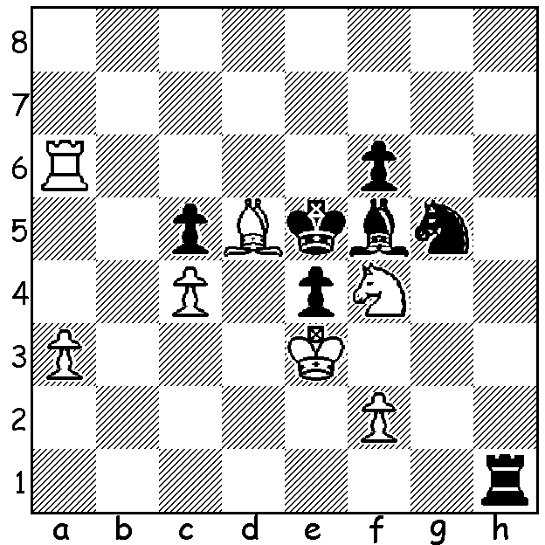

Diagram 490:
Zhou – Barnett
(British Championship 2013)
White to play has a quick win:

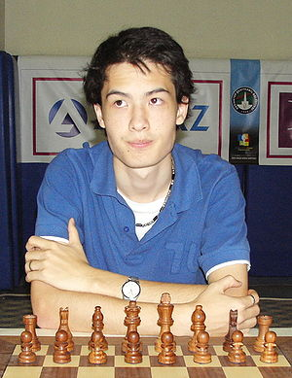
The British Championship was won with a
round to spare by David Howell with a final
unbeaten score of 9.5/11. Born in 1990 to
an English father and a Singaporean mother,
Howell also won the title in 2009 after a
meteoric rise, having qualified for the British
Championship in 2000 aged only 9. He was
a runner-up in both the European and World
Under 12 Championships, became a GM aged
16 and gained 3rd place in the World Junior
Championship in 2008. Equal second at
Torquay were 2012 champion Garwain Jones, David Howell
Mark Hebden and Stephen Gordon on 8/11.
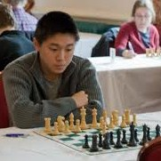
In following the news on the championship
held at the seaside resort of Torquay in Devon,
I found IM Andrew Martin’s daily video of his
‘Game of the Day’ particularly helpful in finding
entertaining games from the tournament and I
have selected his choice from Rd 2. The winner,
the UK’s most promising young player Zhou
Yang-Fan, born in 1994 and ranked 18th among
active English players, came =5th with 7.5.
Zhou Yang-Fan

Shawn Tavares - Zhou Yang-Fan
2013 British Championship Rd 2
Kings Indian Defence
1.d4 Nf6 2.c4 g6
3.Nc3 Bg7 4.e4 0-0
5.f3(a) Nc6(b) 6.Nge2 e5
7.d5 Nd4! 8.Be3(c) c5
9.dxc6 dxc6 10.Nxd4 exd4
11.Qxd4(d) Nd5! 12.Qd2 Nxe3.
13.Qxe3 Be6 14.Rd1 Qa5(e)
15.Be2 Qb4 16.0-0 Qxb2
17.e5 Qb4 18.f4 Rfd8
19.Rxd8 Rxd8 20.Rb1 Qa3
21.Rb3 Qa6 22.Ne4 Qxa2(f)
23.Rxb7 Bxc4 24.Bf3 a5
25.Nd6 Bf8 26.Ne4(g) Qa1+
27.Kf2 Qf1+ 28.Kg3 Rd3
29.Nf6+ Kg7 30.Ne8+?(h) Kh6
31.Qb6 Bb4 32.h3 c5(i)
33.Qf6 Rxf3+ 34.Kh2 Rxh3+!
35.Kxh3 Qh1+ 36.Kg3 Be1+
37.Kf3 Qf1+ White resigns

a) Fischer’s brilliant win in 1960 v Letelier showed the chances available for Black after 5.e5.
b) Turning upside down the common held theory of the need to move central pawns in the opening: if now 6.d5 Nb4.
c) White cannot win a pawn by 8.Nxd4 exd4 9.Qxd4? as 9…Nxe4! 10.Qxe4? Re8 winning the queen.
d) Seemingly a novelty as 11.Bxd4 is usually played – 11…Nxe4! 12.Bxg7 Qh4+ 13.g3 Nxg3 14.Bf6! (14.hxg3 Re8+ is strong) 14…Re8+ 15.Be2 Qxf6 16.hxg3 Qxf3 with a strong attack for the piece
e) Martin suggested 14…Qb6! here (if 15.Qxb6 axb6 16.Rd2 Ra3!! Or 15.Qf2 Qa5 in both cases with strong queenside play.
f) If 22…Bf8 23.Nd6! Bxd6 24.exd6 c5 (not 24…Rxd6 25.c5 winning) 25.Qxc5 Qxa2 26.Rxb2 Qxc5=.
g) 26.h3 is a good alternative (Martin gives the possible wild continuation 26…a4 27.Qb6 Qa1+ 28.Kh2 Qc1! 29.Qxd8 Qxf4+ 30.g3 Qd2+! 31.Bg2 Bf1 32.Qxf8+!! Kxf8 33.Rxf7+ Kg8 34.Rxf1 Qc3 with White’s with the better chances).
h) White has the excellent retort 30.e6!! Bxe6 (30..Rxe3? 32.Rxf7+ Kh6 33.Ng8+ Kg4 34.h4#) 31.Qxe6 Rxf3+ 32.gxf3 Qg1+ with a draw.
i) Cutting off the queen.

SOLUTION: Did you immediately see Black’s king without a move and look for a quick mate? 1.Nd3+! (a combined clearance and deflection sacrifice) forces 1…exd3 permitting 2.f4#.

