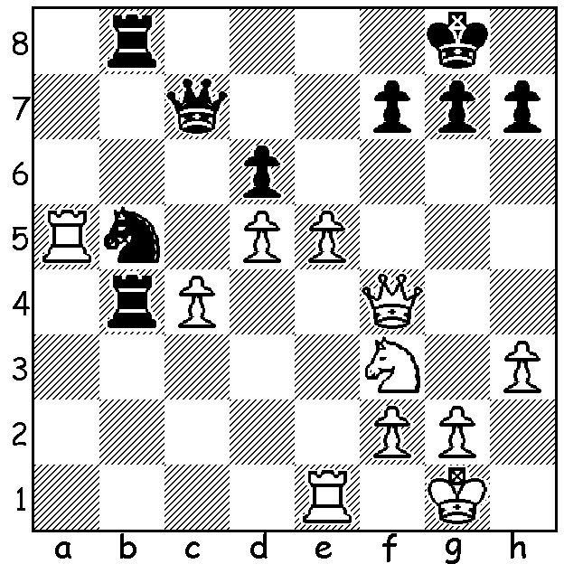

Diagram 491: Adams – Westerin 1988:
White to play and win (a number of combinative
ideas are involved, principally back row mate plus
deflection sacrifices and breaking of pin – 5 moves)

While David Howell was winning the British Championship, the UK’s top player Michael Adams was securing one of the best results of his career on winning the Dortmund (Germany) International. Up against 9 GM opponents including 10 times winner and ex-world champion Vladimir Kramnik, 2012 winner Fabiano Caruana, Russian champion Dmitry Andreikin and the number 1 players from China and Hungary, Wang Ho and Peter Leko, Adams scored 7.5/9, half a point ahead of Kramnik, while no other player achieved a +50% score. Born in 1971 Adams started playing at the age of six although his then non-playing father was initially somewhat discouraging of Michael’s wish to learn the game imagining, as he said, that chess was ‘a game for pipe smoking gentlemen of retirement age and not the sort of thing for a youngster’. He told his son, “You are too young to play chess. Chess is for grown-ups. Perhaps when you are 18 you might learn to play.” In fact by the time Michael was 17 he was already a Grandmaster and British champion. There is quite an Australian connection, with Adams from Cornwall a younger rival to Australian International Gary Lane from Devon who had been one of Michael’s coaches and who was also West of England champion on a number of occasions; he played against Haydn Barber in a county match and secured a vital last round tournament draw against Ian Rogers to secure a GM norm. He also went to the same secondary school as I did in Truro, Cornwall, and I share with Michael the satisfaction of being Cornish Junior champion, Cornish champion and West of England champion. Michael has played once in Australia, the 1988 World Junior Championship.

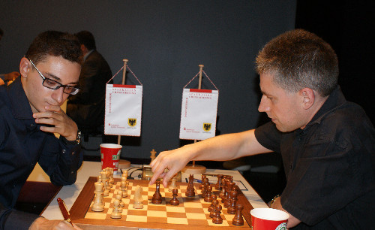

Adams (R) v Caruana at Dortmund

Fabiano Caruana - Michael Adams
2013 Dortmund, Rd 3
Ruy Lopez, Berlin Defence
1.e4 e5 2.Nf3 Nc6
3.Bb5 Nf6 4.0-0 Nxe4
5.d4 Nd6 6.Bxc6 dxc6
7.dxe Nf5 8.Qxd8+ Kxd8
9.h3 Bd7 10.Rd1 Kc8
11.g4 Ne7 12.Ng5 Be8
13.f4 h5 14.Kf2 b6
15.f5 Kb7 16.Nc3 hxg
17.hxg Rh2+!(a) 18.Kg3 Rxc2!
19.Nh7 c5 20.Nxf8 Bc6
21.f6(b) Rg2+ 22.Kf4(c) gxf
23.exf Rf2+ 24.Ke3(d) Rxf6
25.Nh7 Rf3+ 26.Kd2 Rd8+
27.Kc2 Rxc3+! 28.bxc3 Ba4+
29.Kb2 Rxd1 30.Bg5 Nc6
31.Rxd1 Bxd1(e)

a) Black’s plan involves the sacrifice of his entrapped black-squared bishop.
b) 21.Bg5 would probably result in a draw after 21…Rg2+ 22.Kf4 Rf2+ 23.Kg3 Rg2+ while 21.Nh7? Rh8 would expose White to a devastating attack from the two rooks and raking bishop
c) 22.Kh3 gxf 23.Bh6 f5 would be good for Black.
d) Alternatives are no better: 24.Kg5 Rxf8 25.fxe7 Rg8+ 26.Kh4 Rg2 or 24.Ke5 Re8!
e) The game is now an easy win to Black - 32.Bf4 Bxg4 33.Nf6 Bf3 34.Ne8 Na5 35.Nxc7 Bc6 36.Kc2 Kc8 37.Kd3 Kd7 38.Kc2 Nc4 39.Na6 Bb7 40.Nb8+ Kc8 41.Kd3 b5 White resigns (the knight is lost after …f6 & …Ne5)

England’s number 2 player Nigel Short had also had recent success, winning the Canadian Open on tie-break after tying with Eric Hansen on 7.5/9.

Last Friday I went searching for a novelty chess set for my grandson who was five at the weekend and knows the rudiments of the game. At Myers I found the Board Games section but no chess sets. Same with David Jones. Fancy, Perth’s two principal stores not stocking sets of the most popular board game in the world! Fortunately I found what I was looking for at Toys R Us, purchasing a board and set which could both be illuminated. Pleased to say grandson was delighted with set and DVD of Room on the Broom, a children’s play he had seen in Mandurah recently.

SOLUTION: 1.Rxb5! R8xb5 (1…R4xb5? 2.cxb5) 2.exd Qd8 3.d7! (threat 4.Re8+) Qxd7 4.Qf5! (breaking the pin on the c pawn - 4…Qxf5 5.Re8# or 4…Qd8 5.cxb5). Not a bad combination for a 16 year old!

