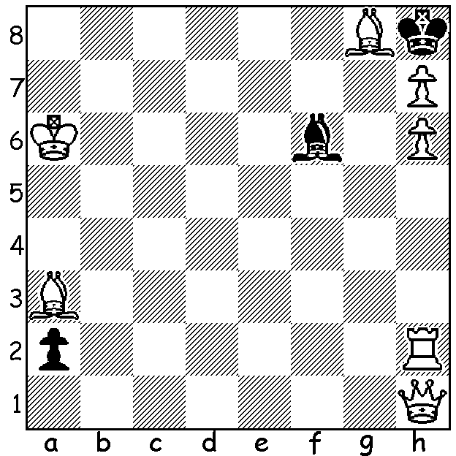

Diagram 502:
White to play and mate in 3
only one line, a delightful combination!
(H. S. Horton):

W. A. RESERVES CHAMPIONSHIP (Under 1950 rating) will be played Wednesdays, Saturdays and Sundays at N. Woodvale Primary (Wed 7.30pm, Sat & Sun 1pm) starting Wed 11 Sept, concluding Sun 29 Sept. See cawa.org.au or contact Norbert Muller 9409 9579.

On receiving the latest ACF newsletter I was saddened to hear of the death of Peter Parr (1946-2013), an immensely dedicated chess worker and recipient of the Order of Australia medal for his work over many years. The son of well known English player Frank Parr, a runner-up in the British Championship, Peter moved to Australia in 1968. A former NSW
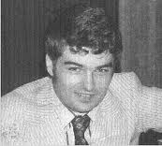
champion, he was asuccessful player but will be
remembered more for his support and promotion
of chess in Australia and NSW in particular. He
was Chief Arbiter at the Easter Doerberl Cup in
Canberra 21 times, besides running state and
Australian Championships. He served as president
of NSWCA, was editor and publisher of the Chess
in Australia magazine 1983-98, wrote a weekly
column for the Sydney Herald for many years right
up to his death, was non-playing captain of Australia’s Olympiad team six times and served on a number of FIDE committees He ran a chess centre in Sydney which was open 11 to 11 seven days a week and which ran almost every NSW
event for five years. He set up and for 40 years ran the Chess Discount store which also served
as a chess club. Whenever in Sydney I would visit Peter’s shop, spending pleasant hours chatting with him and making a few purchases. We played twice, an inter-state telephone match in 1996 and in the last round of my first Australian Championship, Cooma 1973-4, which lasted 14 hours. Here is an entertaining game from Peter at that event:

Abraham Sztern - Peter Parr
Australian Championship, Cooma 1973-4
Kings Indian Defence
1d4 Nf6 2.c4 g6
3.Nc3 Bg7 4.e4 0-0
5.e5 Ne8 6.f4 d6
7.Nf3 c5(a) 8.dxc Qa5
9.Bd2 Qxc5(b) 10.Nd5 Kh8(c)
11.Bb4(d) Qc6(e) 12.Nxe7 Qe4+
13.Qe2 Bf5 14.Rd1(f) Qxf4
15.Rd4(g) Qc1+ 16.Kf2 Nd7
17.g4 Nxe5!?(h) 18.gxf5 Nxf3
19.Rd1 Qg5 20.Kxf3 Be5
21.Nd5 Qxf5+ 22.Kg2 Ng7
23.Bc3 Rae8 24.Qf3 Qg5+
25.Kf2 Qh4+ 26.Kg2 Bxc3
27.bxc3(i) Re5 28.h3 Nf5
29.Rd4?(j) Qg5+ 30.Kh2 Nxd4
31.cxd4 Rf5 32.Qe4?(k) Rf2+
33.Bg2 Kg7(l) 34.Rb1 Re8
35.Qg4 Qxg4+ 36.hxg4 Ree2
37.Rg1 Rxa2 38.Nc3 Rac2
39.Nb5 Rf4 40 Nxd6 Rxd4
41.Nxb7 Rdxc4 White resigns

a) Sounder is 7…dxe 8.dxe=.
b) Better 9…dxe 10.Nd5 Qd8=.
c) Not 10…Nc6?? 11.b4 winning.
d) 11.Nxe7 dxe 12.Nd5 Nc6 13.fxe Bg4=.
e) 12…Qb6 13.Bc3 Nc6 14.Nxc6 Qxc6 15.Be2 with slight White advantage
f) White could try 14.Qxe4 Bxe4 15.0-0-0.
g) 15.g3 Qe4 16.exd, again slight White advantage.
h) An enterprising sacrifice to attack White’s king
i) Or 27.Nxc3 (not 27.Qxf3? Qg4+) 27…Nf5 28.Nd5 Qg5+ 29.Kf2 Qh4+ 30.Kg1 Qg5+ 31.Bg2 f6.
j) There is no need to give up the rook: 29.Rg1 was best
k) 32.Qe2 was better.
l) Planning a rook sacrifice but 33…f5 wins very quickly (34.h4 Qd2).

SOLUTION: 1.Qa1!! Bxa1 2.Rb2! Bxb2 3.Bxb2#.

