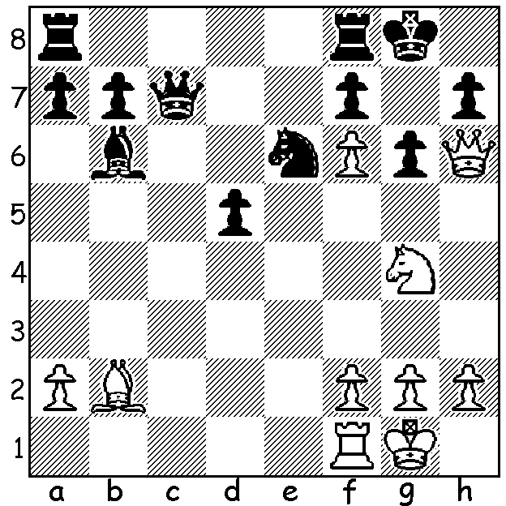

Diagram 504:
Bird – Pinkerley 1850:
with a considerable material deficit
and Black threatening …Qf4,
White must find a quick win (3 moves):

Continuing our alphabet series on players who have given their name to openings we stay with B as we look at Henry Bird (1829 – 1908). Bird was never a chess professional but worked as an accountant, specialising in railway accountancy. His expertise was in demand in the USA which was undertaking extensive rail development although Bird was critical of investment schemes and wrote a polemic entitled A Caution to Investors. This disapproval may have led to his resignation from the firm where he worked and the setting up of his own business. He began visiting chess haunts in London in his teens including the famous Simpsons Divan. He played matches against many of the top players in England, including world champion Wilhelm Steinitz. Bird’s match against Steinitz was played in evenings at the Westminster Club after, for Bird, a full day’s work and it seems remarkable that the score was so close, +7 =7 -6, to Steinitz before a work commitment in America forced Bird to abandon the match. Bird’s style was aggressive and his opening play original (eccentric?) leading to comparison with Nimzovitsch and Larsen. His two opening legacies are the Birds Opening, 1.f4, and the Birds Defence to the Ruy Lopez with its 3…Nd4 which we see in today’s game:

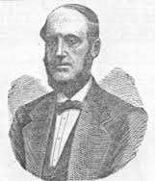
Georg Marco - Henry Bird
Hastings 1895
Ruy Lopez, Birds Defence
1.e4 e5 2.Nf3 Nc6
3.Bb5 Nd4 4.Nxd4 exd4
5.Bc4 h5(a) 6.d3 Bc5
7.0-0 d6 8.f4 c6
9.f5 d5 10.exd cxd
11.Bb3 f6 12.Qf3 Ne7
13.h3 a5(b) 14.a4 Kf8
15.g4 hxg 16.hxg Ra6
17.Bf4 g6!(c) 18.fxg Kg7
19.Nd2 Rh4 20.g5 Rg4+
21.Kh1 Qh8+ 22.Bh2 Rxg5
23.Rf2 Bg4 24.Qf4 Rf5
25.Qg3 Bd6 26.Qg1 Rxf2
27.Qxf2 f5?(d) 28.Qxd4+ Kg8
29.Bxd5+ Nxd5 30.Qxd5+ Kg7 Henry Bird
31.Qd4+ Kg8 32.Qc4+ Kg7
33.Qc3+(e)

a) Making 6…Bc4 possible (5…Bc5? 6.Bxf7+! Kxf7 7.Qh5+).
b) Black gains time in preparing to develop a rook via a6. Not 13…Bxf5 14.Re1 winning the d pawn and opening an attack through the developed bishop.
c) An excellent move enabling Black to attack White’s king.
d) A careless oversight: 27…Qxh2+ would give him winning chances.
e) White now, in attempting to gain time on his clock, repeated moves allowing Black to claim a draw by threefold repetition of position. He should play 33.Qf7+ Kh6 34.Bxd6 Rxd6 35.Qh7+(f) Qxh7 36.gxh7 Kxh7 37.Re1 with prospects of an endgame victory.
f) Teichmann in his tournament book recommended 35.Kg2 not seeing 35…Rxg6! 36.Rh1+ Bh5!+ 37.Kf1 Rg8+! 38.Kxg8 Qd4+ with a perpetual check.

Readers may have heard of the recent death of renowned interviewer David Frost. Try chessvibes.com if you would like to watch Frost’s interview with Gary Kasparov which deals not only with Kasparov’s chess career but his life after chess and his political views about Russia.

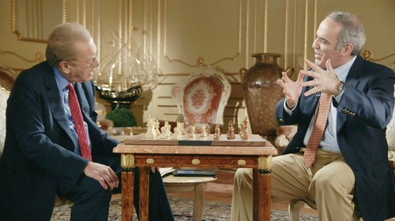

David Frost interviewing Gary Kasparov

SOLUTION: 1.Qg7+!! Nxg7 2.Nh6+! Kh8 3.fxg7#.

