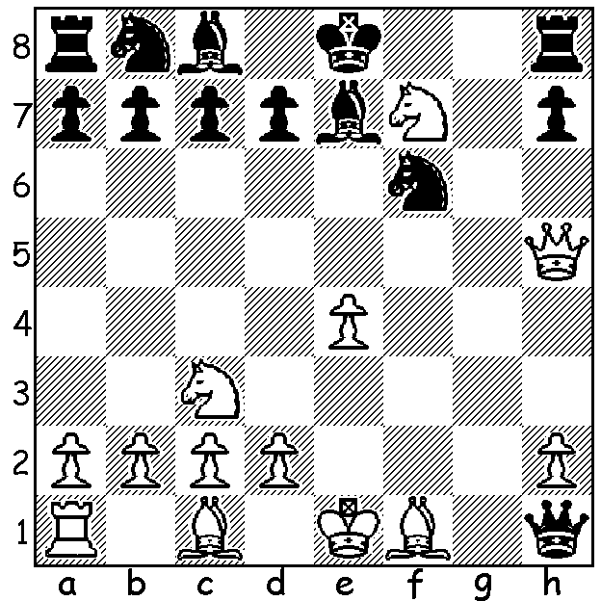

Diagram 505:
Henry Bird wins in 3 moves:

Last week we looked at Henry Bird (1830-1908), an accountant by profession who was one of the strongest players in Victorian times when London was the principal chess centre in the world. His main legacy to the chess world is Birds Opening, 1.f4. Ideally White fianchettos his queen’s bishop (Bb2), occupies e5 with a knight (often by exchanging his king’s bishop for Black’s queen’s knight, Bb5 / Bxc6) and launches a kingside attack with the king’s rook often going to h3 via f3. Birds Opening is certainly a sound system but has never been very popular with Larsen and Tartakower being the only really strong player of the past 100 years or so to use it. Here is the most famous Birds Opening game won by Emanuel Lasker while he was world champion.

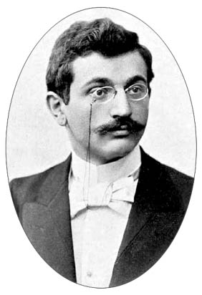
Emanuel Lasker - Johann Bauer
Amsterdam 1889
1.f4 d5 2.e3 Nf6
3.b3 e6 4.Bb2 Be7
5.Bd3 b6 6.Nc3(a) Bb7
7.Nf3 Nbd7 8.0-0 0-0
9.Ne2 c5 10.Ng3 Qc7
11.Ne5 Nxe5 12.Bxe5 Qc6
13.Qe2 a6(a) 14.Nh5 Nxh5
15.Bxh7+!! Kxh7 16.Qxh5+ Kg8
17.Bxg7! Kxg7(b) 18.Qg4+ Kh7
19.Rf3(c) e5 20.Rh3+ Qh6
21.Rxh6+ Kxh6 22.Qd7(d) Emanuel Lasker

a) Planning an advance on the queenside, Bauer would have been shocked by White’s coming sacrifices. 13…g6 preventing 14.Nh5 would have avoided the coming catastrophe.
b) Refusing the second bishop does not save Black -17…f5 18.Be5 Rf6 19 Rf3 / Rg3 or 17.f6… 18.Bh6.
c) Black must give up the queen to avoid mate.
d) Without this fork of the two bishops Black would have near adequate material for the queen and pawns. Now Black could resign but continued to move 38.

And now an impressive game by the originator:

Henry Bird - Daniel Mills (1885)
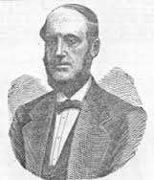
1.f4 d5 2.Nf3 e6
3.e3 Nf6 4.b3 Be7
5.Bb2 c5 6.Bd3 Nc6
7.0-0 b6 8.Ne5 Bb7
9.Bb5 Qc7 10.d3 0-0
11.Bxc6 Bxc6 12.Qf3 Rac8
13.Nd2 Bb7 14.Qg3 Ne8
15.Ndf3 f6 16.Ng4 Kh8
17.Qh3 Bd6 18.Nh4 Qf7
19.f5 exf5 20.Nxf5 Rc7
21.Nxd6 Nxd6 22.Be5 Qe7
23.Qh4! Kg8 24.Nxf6! Rxf6
25.Bxf6 gxf6 26.Rxf6 Ne8
27.Qg4+ Ng7 28.Raf1 Bc8
29.Qf3 h5 30 Qxd5+ Kh7 Henry Bird
31.Qg5 Be6 32.e4 Rd7
33.Rh6+ Kg8 34.Qg6 resigns.

WILLETTON OPEN (WA Grand Prix event) Sat 5 & Sun 6 October at Moresby St. Centre, Kensington. See cawa.org.au and contact Haydn Barber 9398 4242 or 0401473031.

SOLUTION: 1.Nd6+ Kd8 2.Qe8+! Rxd8 3.Nf7#.

