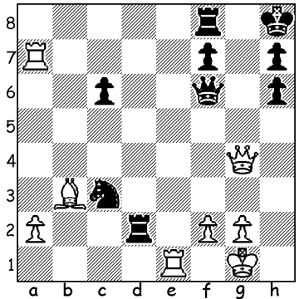

Diagram 506:
Colle – Fairhurst (London 1927):
White to play and win
(4 moves – move 3 is a cracker)

Coming to C in our series of players who have given their names to openings or defences we find the Belgian master Edgar Colle (1897-1932). Colle was a player of enormous combinational ability but plagued throughout his life by poor health. Nevertheless he enjoyed considerable tournament success against the leading players of his day. The opening named after him, the Colle System is a flexible opening which can be played against almost anything and is typically characterized by the moves d4, Nf3, e3, Nbd2, c3, Bd3. A common idea is the eventual move e4 to increase the potential of White’s pieces. Here are two games showing White’s scheme working brilliantly:

Edgar Colle - Victor Berger
Hastings 1928/29
1.d4 Nf6 2.Nf3 d5
3.e3 e6 4.Bd3 Be7
5.Nbd2 0-0 6.0-0 Nbd7
7.e4 dxe 8.Nxe4 Nxe4
9.Bxe4 Nf6 10.Bd3 c5
11.dxc Bxc5 12.Bg5 Be7
13,Qe2 Qc7 14.Rad1 Rd8
15.Ne5 Bd7 16.Bxh7+! Kxh7
17.Bxf6 Bxf6 18.Qh5+ Kg8
19.Qxf7+ Kh7 20.Rd3 resigns

Edgar Colle - John O’Hanlon
Nice 1930
1.d4 d5 2.Nf3 Nf6
3.e3 c5 4.c3 e6
5.Bd3 Bd6 6.Nbd2 Nbd7
7.0-0 0-0 8.Re1 Re8
9.e4 dxe 10.Nxe4 Nxe4
11.Bxe4 cxd 12.Bxh7+!?(a) Kxh7
13.Ng5+(b) Kg6 14.h4 Rh8
15.Rxe6! Nf6(c) 16.h5+ Kh6
17.Rxd6! Qa5 18.Nxf7+ Kh7
19.Ng5+ Kg8 20.Qb3+ resigns

a) Black’s failure to play 11…Nf6 gives White the opportunity to make this speculative sacrifice.
b) This position has for many years given rise to speculation on the soundness of White’s sacrifice if Black now plays 13…Kg8. After 14.Qh5 Black has two possibilities:
i) 14…Ne5 15.Rxe5! Bxe5 16.Qxf7+ Kh8 17.b3 planning Ba3 (17…Re7 18.Ba3!).
ii) 14…Qf6 15.Qh7+ Kf8 16.Ne4 Qe5 17.f4 Qd5 18.c4 Qc6 19.Qh8+ Ke7 20.Qxg7 with a continuing attack.
c) If 15…fxe6 not 16.Nxe6 but 16.Qd3+ Kf6 (16…Kh5 17.g4!+)17.Qf3+ Bf4 18.Qxf4+ Ke7
19.Qf7+ Kd6 20.Qxe6+ Kc5 21.b4+ Kb5 22.a4#.

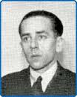
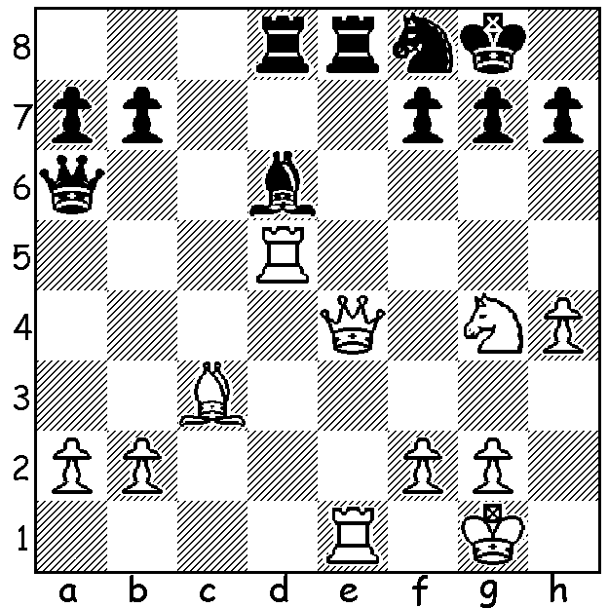

Colle – Euwe (Hastings 1923/24)
1.Rg5!! Rxe5 2.Nh6+ Kh8 3.Nxf7# Edgar Colle 1931

WILLETTON OPEN (WA Grand Prix) at Moresby St. Centre, Kensington. See cawa.org.au & contact Haydn Barber 93984242 or 0401473031.

SOLUTION: 1.Rxf7!! Rxf7 2.Re8+ Rf8 3.Qg8!! resigns (3…Rxg8 4.Rxg8#)

