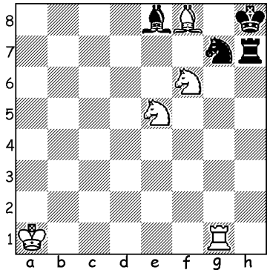

Diagram 507:
A problem by the legendary Adolf Anderssen:
White to play and mate in three:


The World Junior Championships (Under 20) were held in
Turkey between 12 and 27 September in Turkey with 117 in the
Boys’ Championship (10 GMs & 26 IMs) and 75 in the Girls’
Championship. The venue was changed from Hatay, which is
close to the Syrian border, to Kocadin and home hopes were high
for victory to Alexander Ipatov who was the previous winner in
Greece. However Ipatov (10.5/13) was beaten into second place
by top seed Yu Yangyi (11/13), the first player from China to win
the title. Previous winners have included world champions Boris
Spassky 1955, Anatoly Karpov 1969, Gary Kasparov 1980,
Vishwanathan Anand 1987. The Girls’ Championship was won
by Russian Alexsandra Goryadinka with 10.5/13. Here is a well
played game by the winner against a GM opponent from the Yu Yangyi
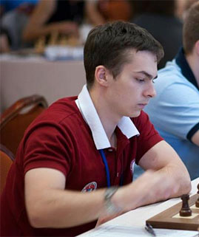
United Arab Emirates, Saleh Salem:

Yu Yangyi - Saleh Salem
2013 World Junior Championship, Rd 4
Scotch Opening
1.e4 e5 2.Nf3 Nc6
3.d4 exd 4.Nxd4 Bb4+
5.c3 Bc5 6.Be3 Bb6
7.Nf5 g6 8.Bxb6 axb6
9.Ne3 Nf6 10.f3 Qe7
11.c4 Qb4+ 12.Qd2 Qxd2+ Alexander Ipatov
13.Kxd2 d6 14.Nc3 Kd8

15.Be2 Re8 16.Rac1 Nd4
17.Rhd1(a) c6 18.Bf1 Kc7
19.Ke1 Ne6 20.b4 Nd7
21.Kf2 Ng7 22.Rd4 f5!
23.a4(b) Nf6 24.Rcd1 Re6
25.g3 fxe 26.Bh3 Re7
27.Rxd6 Nge8 28.Rd8 exf
29.b5 Rb8(c) 30.a5! Nd7
31.Rxc8+!(d) Kxc8 32.Ned5! cxd5
33.Nxd5(e) Rg7 34.Nxb6+ Kc7
35.Nxd7 Ra8 36.b6+ Kc6
37.Rd5(f) Rxa5 38.Rxa5 Rxd7
39.Bxd7 Kxd7 40 Kxf3 resigns Alexsandra Goryadinka

a) White has more space which he now uses to apply pressure on the d file and advance on the queenside.
b) If 23.exf Rxe3! 24.Kxe3 Nxf5+ and Black’s position is considerably eased.
c) Rather than this logical move giving the rook protection Black has a better chance with an unlikely piece sacrifice – 29…Re5! And if 37.a5! bxa 31.b6+! Kxb6 32.Rxc8 Rxc8 33.Bxc8 Kc7 34.Bh3 Rh5 35.Bf1 Rxh2+.
d) The start of brilliant combinative play: the ensuing pin on the knight at d7 will prove decisive.
e) White is a rook down but will recover the material with interest.
f) Threat 38.Ne5#.

The 2013 WA CHAMPIONSHIP was won by WA’s top player Tristan Boyd (8.5/9) who won his crucial game against defending champion Yita Choong (8/9) in the penultimate round. Tristan also
won the title in 2007, 2008 & 2009 while Yita won in 2011 & 2012. The Reserves Championship resulted in a tie between Gordon Dunlop and Natalie Maris (both 8/9) with Ned Tomic 3rd on 7/9. Natalie was defending champion while Gordon has won the title five times previously dating back
to 1989.

WILLETTON OPEN (WA Grand Prix) at Moresby St. Centre, Kensington, Sat 5th Oct (1 – 8pm) and Sun 6th (11.30am – 7.30pm). See cawa.org.au for details & submit entry to Haydn Barber (hadix2vianet.net.au or 93984242 or 0401473031) before Sat for $10 discount.

SOLUTION: Black has to defend against mates on f7, g6, g7 & g8 so a waiting move is required - 1.Kb1. Black’s only move is 1…Bh5 which blocks Black rook enabling White to play the obstruction sacrifice 2.Rg6! with mate on g6, f7 or g7 to follow.

