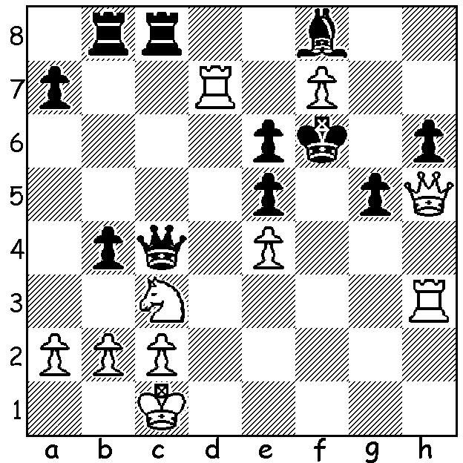
Diagram 508:
Hou Yifan – Marie Sebag 2011:
faced with the loss of the knight
White could draw with
1.Rf3+ Kg7 2.Rh3 Kf6 3.Rf3+:
however White finds a 4 move mate:

The recent Womens World Championship Match in China was won convincingly by 19 year old Chinese medical student Hou Yifan who regained the title she won in 2011. Her opponent Anna Ushenina (born 1985) of Ukraine won the title in a Knock-Out tournament last year when Hou Yifan was defeated in the second of five rounds. Hou’s winning score of 5.5 – 1.5 (+4 =3) included wins in all three games as Black (2 Nimzoindians and 1 Queens Indian) and concluded with Hou Yifan’s only win in 4 Sicilians. Hou learnt to play at the age of three and competed in her first World Womens Championship when only 12. She became the youngest ever female to become a GM aged 14 and was also the youngest World and Chinese Womens Champion. She is the 12th highest ranked junior in the world (including boys) and competes with success in open events, her beat result being =1st at the 2012 Gibraltar Chess Festival with 8/10. This event included 55 GMs and her performance rating for the event was 2800+. Here is the penultimate game of her match with Ushenina:

Anna Ushinina – Hou Yifan
2013 Womens World Championship, Game 6
Queens Indian Defence
1.d4 Nf3 2.c4 e6
3.Nf3(a) b6 4.g3 Bb7
5.Bg2 Be7 6.Nc3 0-0
7.Qc2 c5 8.d5 exd
9.Nh4 Nc6 10.cxd Nd4
11.Qd1 Ne8 12.Nf3 Nxf3+
13.Bxf3 d6 14.0-0 Nc7(b)
15.a4 a6 16.Rb1 Bf6
17.Bd2 b5 18.axb Nxb5(c)
19.Bg2 Bc8 20.Ne4 Re8
21 Nxf6+ Qxf6 22.e4 a5
23.Ra1 Bd7 24.Ra2 a4
25.Re1 h6 26.Be3 a3
27.Qd2 axb 28.Rxb2 Nc3
29.f3 Ra3 30.Bf2 Nb5
31.Reb1 c4!(d) 32.Rxb5 Bxb5
33.Bd4?(e) c3! 34.Qf2 Qg5
35.f4 Qg4 36.Re1 Rea8
37.h3 Qc8 38.e5 Ra1
39.exd6 c2 40.Bxa1 c1=Q
41.Rxc1 Qxc1+ 42.Kh2 Rxa1
White resigns

a) Having lost her previous two Whites after 3.Nc3 Bb4 (Nimzodian Defence) Anna selects the alternative 3.Nf3.
b) The game now resembles the Benoni Defence in which White’s central domination with prospects of a kingside attack is balanced by Black’s queenside pressure.
c) Also good is 18…axb (19.e4 b4 20.Ne2 Nb5).
d) An aggressive offer of 2 pieces for a rook when White was suffering considerable time trouble to get to move 40.
e) A losing move: also losing was 33.Rxb5 Ra1+ 34.Bf1 Qxf3 but 33.Qb4! Ra2 34.Qxb5 Rxe4! leaves the result uncertain.

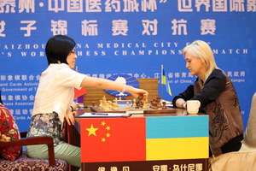

WEST AUSTRALIAN LIGHTNING CHAMPIONSHIP (5 mins per player) Sunday 12 October at Moresby St. Centre starting 11am. Submit entries to Haydn Barber hadix@vianet.net.au or 93984242 or 0401473031. Entries also accepted on day before 10.45.

SOLUTION: 1.Qxh6+!! Bxh6 2.Rxh6+ Kg7 3.f8=Q! Kxf8 4.Rh8#

