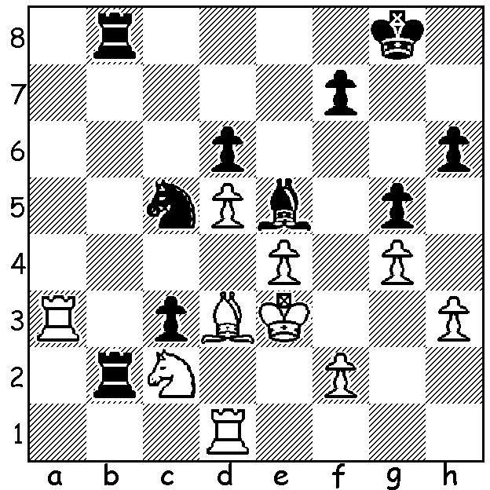

Diagram 509:
Ponomariov – Bacrot (Paris GP 2013):
Black to play (4/5 moves)

While there are still nearly three weeks to go before the 12 game World Championship match between champion Viswanathan Anand (India) and challenger Magnus Carlsen (Norway), other aspiring contestants have been vying throughout the year to win selection to the 2014 Candidates tournament to find the next challenger. Two of final places were decided at the recent Paris Grand Prix event which was won on countback by Fabiano Caruana
(Italy) over Anand’s previous challenger Boris Gelfand (Israel), after both finished on 7/11.
The win proved bitter sweet for Caruana who needed an outright first place to be 2nd in the
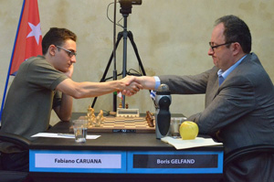
GP standings to gain entry to the
Candidates. The two GP places went to Veselin Topalov (Bulgaria) and Shakhriyar Mamedyarov (Azerbaijan).
Other 2014 candidates will be the loser of the Anand/Carlsen match, Levon Aronian
(Armenia) and Sergey Karjakin (Russia) by rating and winner and runner-up from the 2013 World Cup, ex-champion Vladimir Kramnik and Dmitry Andrekin (both Russia). This leaves one vacancy with the player to be selected by
FIDE.
Caruana & Gelfand at Paris

In 1989 Boris Gelfand was described by Gary Kasparov as ‘one of the most talented players of his generation’. At 45 Gelfand remains one of the top players, rated 7th in the world.

Boris Gelfand - Hikaru Nakamura
Paris Grand Prix 2013
Sicilian Najdorf
1.e4 c5 2.Nf3 d6 3.d4 cxd 4.Nxd4 Nf6 5.Nc3 a6 6.Be3 Ng4
7.Bc1 Nf6 8.Be3 Ng4 9.Bg5 h6
10.Bh4 g5 11.Bg3 Bg7 12.h3 Ne5
13.f3 Nbc6 14.Bf2 Be6 15.Qd2 Rc8
16.0-0-0 Nxd4 17.Bxd4 Qa5 18.a3 0-0
19.h4 g4 20.Qf2 Rc6 21.f4 Rfc8!
22.Qg3(a) Nd7 23.Bxg7 Kxg7 24.f5 Rxc3!(b)
25.bxc3 Qxa3+ 26.Kd2 Nf6! 27.Qd3 Bc4
28.Qd4 d5! 29.exd Bxd5 30.Rg1 Be4
31.Bd3 Qa5! 32.Qb4(c) Qc7 33.Bxe4?(d) a5
34.Qxb7 Qf4+ 35.Ke2 Rc7 36.Qb6 Nxe4
37.Qd4+ Kh7 38.c4?(e) Rd7! 39.Qe3(f) Ng3+
40.Qxg3 Qxg3 41.Rxd7 Qe5+ 42.Kd2 Qxf5
White resigns (f)

a) If 22.fxe5 Black wins with 22…dxe5 23.Be3 Rxc3! 24.bxc3 Qxa3+ 25.Kd2 Qxc3+ 26.Ke2 Bc4+ 27.Rd3 Qxc2+ 28.Ke1 Bxd3. At the post mortem both players agreed 22.f5 should be played.
b) 24…Ne5! is also good (25.fxe6 Rxc3! 26.bxc3 Rxc3).
c) 32.Bxe4? Rd8.
d) 33.Kc1 keeps White alive.
e) Some chances remained with 38.Rgf1 Nxc3+ 39.Qxc3 Qxf1+ 40.Rxf1 Rxc3 41.Kd2.
f) 39.Qxd7 Qf2+ 40.Kd3 Nc5+ 41.Kc3 Nxd7.
g) One of the rooks is lost.
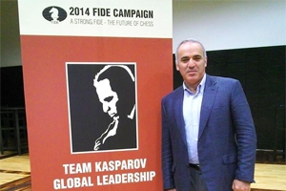
GARY KASPAROV has announced his candidacy
for the 2014 FIDE presidential election saying, “We
have to bring the chess world and the outside world
together.” He has put together a strong team with
representatives from USA, Europe, Africa, the Middle
East and Asia. He will oppose former president of
Kalmykia and multi millionaire Kirsan Ilyumzhinov
who has been FIDE president since 1995 and has
seen off three challengers including ex-world champion
Anatoly Karpov.
Kasparov launches his bid for FIDE presidency
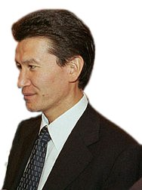
SOLUTION:
1…Rxc2! 2.Bxc2 Rb2 3.Bb1 c2 4.Bxc2 Rxc2
and Black went on to win the ending B & N v R + p.
If 3.Bd3 c2 4.Rda1? Bf4+ or c1=Q+ wins.
The game was a typical win by the Black side in a Benoni.

Kirsan Ilyumzhinov

