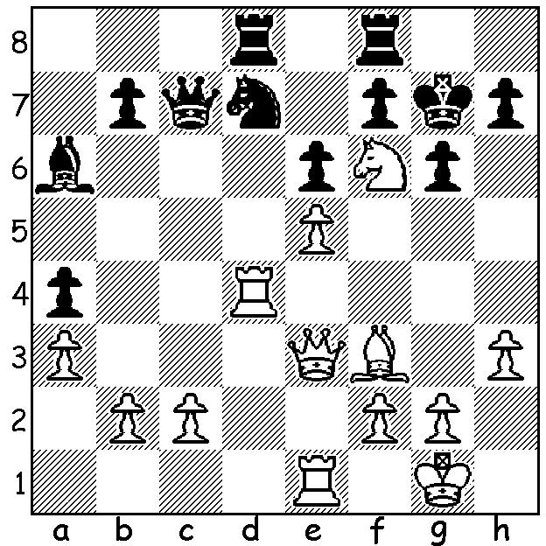

Diagram 510:
Andreikin – Kretov 2004:
White mates in 3, 4 or 5 moves
(3 variations):

The Soviet Union was justifiably considered the home of the world’s greatest players until its breakup in 1991 with all world champions since WWII, with the exception of Bobby Fischer, coming from the USSR. The Soviet Championship was the highest ranking of all national championships with its most consistent winners being world champions Mikhail Botvinnik (6 times), Tigran Petrosian and Mikhail Tal (each 4 times). Since the dissolution of the USSR the Russian Championship has remained the strongest national tournament in the world with Gary Kasparov among its winners. This year the championship was won for the 7th time by Peter Svidler who defeated 2010 winner Ian Nepomniachtchi in a play-off. The final round started with Svidler holding a half point lead over Nepomniachtchi and ex-world champion Vladimir Kramnik. After Svidler drew to finish with 6.5/9, Kramnik strove to beat Nepomniachtchi to share top spot, only to over-extend and lose in 70 moves. Here is one of the games from the event, won by the defending champion Dmitri Andreikin, who was runner-up in the 2013 World Cup and thereby a qualifier for the 2014 Candidates tournament to decide the next challenger for the world title:

Dmitri Andreikin - Aleksy Goganov
2013 Russian Chanpionship, Rd 6
Levitsky Attack
1.d4 d5 2.Bg5 Nf6(a)
3.e3 c5 4.Bxf6 gxf6
5.dxc e6 6.c4 dxc
7.Nd2 c3 8.bxc Bxc5
9.Qg4(b) Nd7 10.Bb5 f5
11.Qg3 Qf6 12.Rb1 Ke7
13.Ne2 Bd6 14.f4 Nc5(c)
15.Nd4 a6 16.Be2 Bd7
17.Qf3 b5 18.0-0 Rab8
19.e4(d) Nxe4 20.Nxe4 fxe4
21.Qxe4 Rhc8 22.Qd3 Rc7
23.Rbd1 Bc5 24.Kh1 Rbc8
25.f5 e5 26.Ne6! Ra7(e)
27.Bh5 fxe6 28.fxe6 Qxe6
29.Qxh7+ Kd8 30.h3 Be7
31.Bg4 Qc6 32.Rf7 Bd6
33.Qg6 Be7 34.Qg7 Qc5
35.Rf8+!(f) Kc7 36.Rxd7+ resigns
a) Black transposes into the Trampowsky Attack (1.d4 Nf6 2.Bg5 Nf6). There are so many alternative moves for Black. One I saw was 2…f6 3.Bh4 Nh6 4.f3 Nc6. Instead Black accepts the weakening of his kingside hoping his two bishops and half open g file will compensate.
b) While not threatening 10.Qg7 (10…Ke7) this does prevent …0-0 and keeps the king in the centre.
c) 14…Kf8 15…Rg8 would make his king safer.
d) White starts breaking down the defences to Black’s king.
e) Planning a queenside escape for the king. If 26…fxe6 27.fxe Qxe6 28.Qxh7+ Kd8 29.h3 planning 30.Bg4 wins.
f) A fine deflection sacrifice to finish a brilliant attacking game – 35…Bxf8 36.Rxd7+ mates.

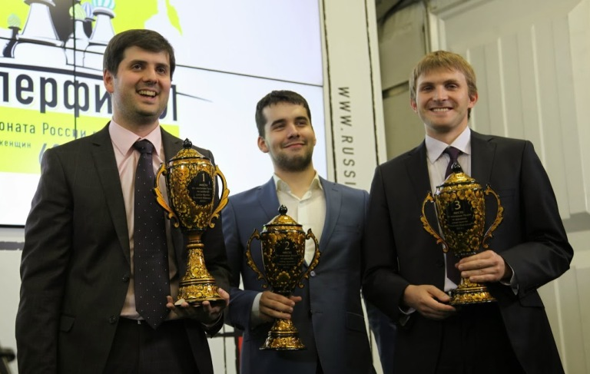
Prizewinners at Russian Championship (L-R):

1: Peter Svidle,

2: Ian Nepomniachtchi

3: Nikita Vitiugov

The Spring Allegro (WA Rapid Grand Prix event) Sunday 27 Oct, 11am – 5pm at Moresby St. Centre. Entries and enquiries to Haydn Barber (hadix@vianet.net.au, 0401473031 or 93984242. Entries also accepted on day before 11.45.

SOLUTION: 1.Qh6+!! Kxh6 2.Rh4+ Kg5 (2…Kg7 3.Rxh7#) 3.Nxh7+! Kf5 (3…Kxh4 4.Re4#) 4.Bg4+ Kf4 5.Bxe6# or Bh3#.

