HAYDN BARBER - RIP

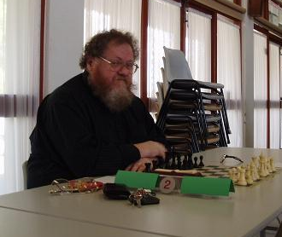
Sadly I announce the death of the CAWA
President and WA’s greatest player Haydn Barber who passed away early this week. I shall be preparing a commemorative article to honour the career of a 15 times winner of the WA Championship. The funeral will be held at Fremantle Cemetery at 4pm Wednesday
6 November. It is hoped many in the WA Chess
community will be able to attend to pay their respects.

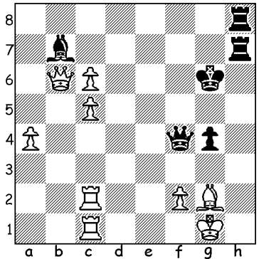
With the much anticipated World Championship
match between defending champion Viswanathan
Anand and challenger Magnus Carlsen due to start
on November 6, this and next week’s column will
be devoted to the two contestants. Firstly Anand,
starting with a sensational finish against Vladimir
Kramnik in a 2008 Rapid-Play game.
Diagram 511: Black to play and win (4 moves):

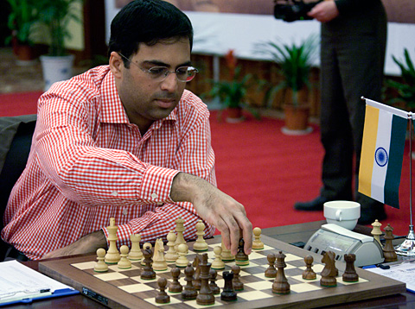
Viswanathan Anand was born December 1969, learning chess at the age of six from his mother. He became Indian champion at the age of 16 and in
he became India’s first GM, a year after winning the
1988 World Junior Championship. He was the FIDE
world champion in 2000 at a time when most of the
chess world still recognized Gary Kasparov as
champion. However Anand became undisputed world
champion in 2007 winning a double round robin
championship tournament with 9/14, a point ahead of
Kasparov’s conqueror Vladimir Kramnik and Boris Gelfand. He has since successfully defended the title threetimes, 6.5 - 4.5 against Kramnik (Russia) in 2008, 6.5 – 5.5 against Veselin Topalov (Bulgaria) in 2010 and 2.5 - 1.5 in a play-off against Boris Gelfand (Israel) in 2012 after the players were locked together on 6 each. With an unassuming personality, Anand refrains from psychological or political ploys and is immensely popular and respected throughout the world. He is the recipient of many awards in India including national Sports Star of the Year. He can be credited with popularising the game in India and inspiring the many Indians who have achieved success internationally.

Viswanathan Anand - Viktor Bologan
New Delhi 2000
Ruy Lopez: Breyer Defence
1.e4 e5 2.Nf3 Nc6 3.Bb5 a6
4.Ba4 Nf6 5.0-0 Be7 6.Re1 b5
7.Bb3 d6 8.c3 0-0 9.h3 Nb8(a)
10.d4 Nbd7 11.Nbd2 Bb7 12.Bc2 Re8
13.Nf1 Bf8 14.Ng3 c5 15.d5 c4
16.Bg5 Qc7 17.Nf5 Kh8 18.g4 Ng8
19.Qd2 Nc5 20.Be3 Bc8 21.Ng3 Rb8
22.Kg2 a5 23.a3 Ne7 24.Rh1 Ng6
25.g5 b4(b) 26.axb axb 27.cxb Na6
28.Ra4 Nf4+ 29.Bxf4 exf4 30.Nh5 Qb6
31.Qxf4 Nxb4 32.Bb1 Rb7 33.Ra3(c) Rc7
34.Rd1 Na6 35.Nd4 Qxb2 36.Rg3 c3
37.Nf6!! Re5(d) 38.g6! fxg 39.Nd7 Be7
40.Nxe5 dxe5 41.Qf7 h6 42.Qe8+ resigns

a) The Breyer Defence which repositions the queen’s knight. As the position becomes more and more blocked both sides, but especially Black, are involved in the repositioning of pieces.
b) A clever pawn sacrifice, opening up the queenside and enabling Black to build pressure there to counter White’s kingside attack.
c) Unfortunately for Black his queenside attack has given White’s queen’s rook the opportunity to switch over to the kingside.
d) 37…gxf6 38.gxf6 h6 39.Rg1! Qd2 40.Qh4 with a winning attack.

SOLUTION: 1…Qf3!!! (threat 2.Rh1+) 2.cxb7+ Kf5 and White resigned (3.Bxf3 gxf3 4.b8=Q or 4.Kf1 Rh1#) A marvellous finish, two queens down.

