Diagram 512: A piece down, 12 year-old Magnus Carlsen brings of a spectacular win: White to play (3 moves):
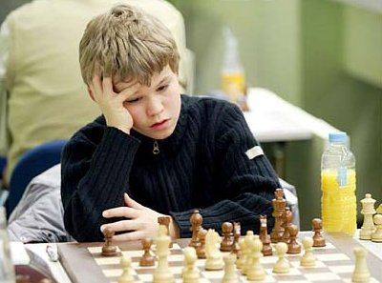
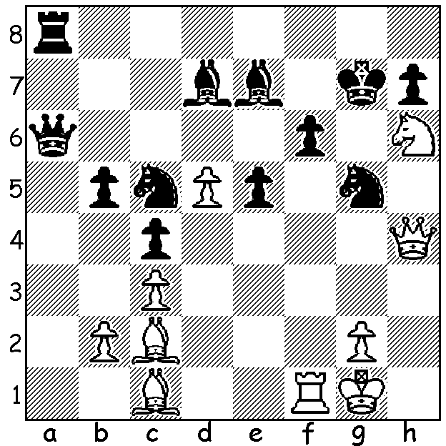

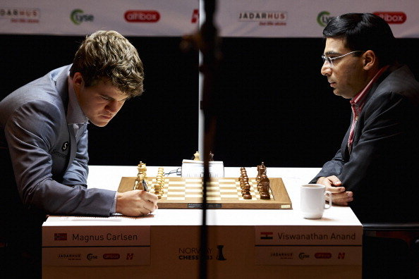
Tomorrow sees the start of the much
anticipated World Championship
match between defending champion
Viswanathan Anand and challenger
Magnus Carlsen in Chennai, India.
Last week we looked at the career of
the champion and today it’s the
challenger. Magnus Carlsen was
born in Norway in November 1990
making him at 22 a little over half
the age of Anand. He was taught to
play by his father when six and became
Carlsen and Anand about to begin a recent game a GM at 13 (then the second youngest
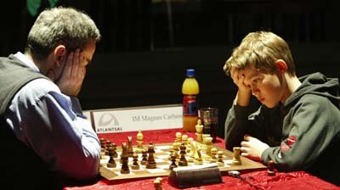
to gain the title – now third youngest).
At 19 he was the youngest player ever
to be ranked number 1 and has been the
top ranked player continuously since July
2011. In his teens he attracted the attention of Gary Kasparov who tutored
him in2009. He is known for his stamina,
able to play at virtually his best near the end of exhaustingly long games and
tournaments, and he has a superb
Kasparov struggles to a draw in a Rapid Play game endgame technique. In his spare time
against Carlsen before winning the second game. he models for the clothing company G-
Star and has expressed a wish to seek a
girlfriend after the match, win or lose. In choosing a game I’ve selected a win showing one
of his strengths, a readiness to play a large variety of openings and defences; against the US top player he essays a rarely played opening which is considered innocuous, the Giuoco Piano:

Magnus Carlsen - Hikara Nakamura
2011 London Classic
Giuoco Piano
1.e4 e5 2.Nf3 Nc6
3.Bc4 Nf6 4.d3(a) Bc5
5.c3 d6 6.Bb3 a6
7.Nbd2 Ba7 8.Nf1 h6
9.Ng3 0-0 10.0-0 Be6
11.h3 Qd7 12.Be3 Ne7
13.Nh4(b) Ng6 14.Nhf5 Ne7
15.Nxe7+ Qxe7 16.Bxa7(c) Rxa7
17.f4 c5 18.Bc2(d) b5
19.Qd2 Rb7 20.a3 a5
21.Rf2 b4 22.axb axb
23.Raf1 bxc 24.bxc exf
25.Rxf4 Nh7(e) 26.d4 cxd
27.cxd Qg5 28.Kh2 Nf6
29.Bd1(f) Rfb8(g) 30.h4 Qg6
31.Rxf6! gxf6 32.Qf4 Rb2(h)
33.Bh5 Qg7 34.Bf3 Ra8(i)
35.d5 Bc8 36.Nh5 Qf8
37.Nxf6+ Kh8 38.Rc1(j) Kg7
39.e5! dxe 40.Nh5+(k) Kh7(l)
41.Be4+ resigns(m)

a) White has varied from the almost universally played 3.Bb5 (the Ruy Lopez) and now avoids the Two Knights Defence with 4.d4 or Ng5.
b) If 13.d4 exd 14.cxd d5 equalises.
c) Both sides have avoided capturing the opposing bishop on the e file which, after fxe3 or …fxe6, would give the opponent attacking chances on the half-open f file.
d) As in the Ruy Lopez, the bishop seems ineffective, hemmed in by its own pawns.
e) White was threatening 25.Rxf6! gxf6 26.Qxh6.
f) Preventing 29…Nh5.
g) 29…Ra8 is preferable.
h) Seeking counterplay, pressurising g2, but defending with 32…Rb6 was better.
i) 34…Rd8 is preferable.
j) Threatens 39.Rxc8! (39…Rxc8 40.Qf5 winning)
k) 40.Qxe5 also wins (40…Rb4 41.Nd7+ f6 42.Qg3+).
l) If 40…Kg8 41.Qg3+ Kh7 42.Be4+ f5 43.Rc7+ Kg6 (43…Kg8 44.Qg3+ Kh8 45.Qxe5+ Kg8 46.Nf6+ mates) 44.Qg3+! Kxh5 45 .Bf3#.
m) 41…Kg8 42.Qg3+ Kh8 43.Qxe5+ or 41…f5 42.Rc7+ Kg8 43.Qg3+ mating.

SOLUTION: 1.Qxg5+!! fxg5 2.Rf7+ Kxh6/Kh8 3.Rxh7#.

