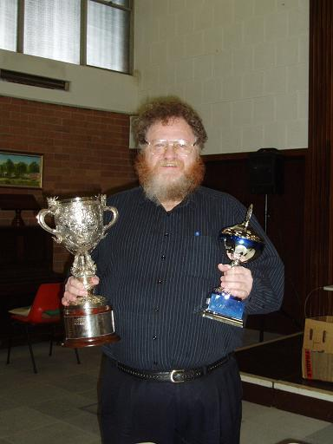
HAYDN BARBER (1950 – 2013)

Diagram 513
Adam Haasse – Haydn Barber
(WA Championship 1992)
Black to play and win (4 moves):
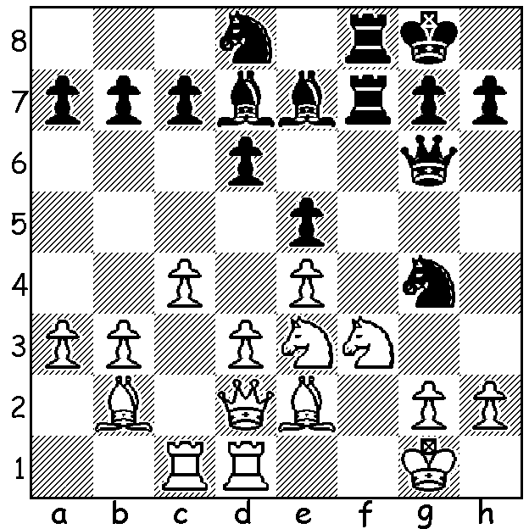

The funeral of CAWA President Haydn Barber took place on Wed. 6th November attended by family, friends and a large contingent of the chess community.* I was privileged to join ACF President Gary Wastell in paying tribute to WA’s most famous player who had been Association president since 2007. Born in the wheat belt town of Narrogin in 1950, Hayden became fascinated with the game at an early age and developed into one of Australia’s strongest players. He was WA champion 15 times, a record which would have been considerably more had he not lived away from WA, both over east and in England and Ireland, for about 15 years. A FIDE Master, he was NSW champion in 1987 and represented Australia at the 1988 Olympiad in Greece. However Haydn was also very much involved in administration, having been vice president of the ACF, Australian delegate to FIDE and captain of the Australian Women’s Olympiad team. For his services to chess he was awarded the Koshnitsky Medal in 1986. He set up chess rooms at his own house in Huntingdale, where he organised tournaments and, as an enthusiastic supporter of junior players, provided coaching classes. Truly Haydn can be described as the giant of WA Chess. Here is a game from the last year he won the state championship, defeating the higher ranked and much younger Tristan Boyd, WA champion 2007-9, 2013:

HAYDN BARBER - TRISTAN BOYD
2006 WA Championship, Round 6:
Sicilian Defence: Closed System
1.e4 c5 2.Nc3 Nc6 3.g3 g6
4.Bg2 Bg7 5.d3 d6 6.f4 e6
7.Nf3 Nge7 8.0-0 0-0 9.Be3 b6(a)
10.d4 d5 11.exd Nf5 12.Bf2 Ncxd4 13.Ne5 exd 14.Nxd5 Bb7(b) 15.Nf6+!? Qxf6 16.Bxb7 Rad8 17.c3 Qe7! 18.Bg2 Bxe5
19.fxe5 Nc6 20.Qe2 Qxe5(c) 21.Qb5 Nb8
22.g4 Nd6 23.Qa4 a6(d) 24.Rae1 Qg7
25.Bg3 b5 26.Qa3 Nc4 27.Qxc5 Nxb2(e) 28.Re7 Na4(f) 29.Qa7 resigns(g)

a) More usual is 9…Nd4 which can be met by the thematic 10.Qd2 preparing Nd1, c3 or (as Haydn intended) the aggressive 10.e5.
b) A risky move which gives White the opportunity at the cost of a pawn to gain 2 bishops v 2 knights in an open position.
c) Possibly better was 20…Nxe5 although White’s bishops will exert worrying pressure after 21.g4 Nd3! 22.Qxe7 Nxe7 23.Bh4.
d) Alternatives leave Black feeling the heat on the black squares: 23…Rd7 24.Rae1 Qg5
25. Be3 or 23…Qe2 24.Rae1 Qxb2 25.Bh4 Rd7 26.Be7.
e) Black’s knights have been forced out of play while White’s bishops will combine in a massive attack on Black’s king.
f) If 28…Rd7 29.Rxd7 (29 Bd5 is also strong) 29…Nxd7 30.Qc7 f6/5 31.Bd6 Re8 32.Bc6 wins or 28…Rd1 29.Rxd1 Nxd1 30.Qd6 followed by Bd5 or Be5 maintains White’s advantage.
g) Not 29…Nxc3? 30.Be5 nor 29…Qxc3 30.Rexf7. If 29…g5 (freeing g6 for the queen)
30.Bxb8 Rxb8 31.Rfxf7! Rxf7 32.Qxb8+ Qf8 33.Re8. A fine example of the power of the two bishops.

THE XMAS OPEN (final CAWA Grand Prix event of 2013) Sat 30 Nov, Sun 1 Dec at Moresby St Centre. Information cawa.org.au and entries David Ellis 0439798607.

SOLUTION: 1…Rxf3! 2.Bxf3 Rxf3! 3.gxf3 Nxe3+ 4.Kh1 Nxd1 and Black minor pieces were soon swarming around White’s king bringing resignation in 7 more moves.

CAN YOU HELP? I am putting together a collection of Haydn Barber’s WA Championship wins to put on this site. I have his games from the 1991, 92, 93, 95, 2005, 2006 championships. As he was champion 1970, 1985, 1986, 1989 – 1992, 1994 – 1996, 2002 – 2006 there are many games unaccounted for. Can you help in providing other game? I also intend collecting his wins from other events in WA, Australian Championships and other events in Australia and overseas.

* Those attending the funeral included
ACF President Garry Wastell:
WA champion Tristan Boyd: former WA champions, Yita Choong, David Ellis, Mike Partis:
Louise Bosnyak, Linda Carolin, George Carolin-Unkovich, KK Choong, Tom Donaldson, Gordon, Dunlop, John Fedec, Anthony Filose, Michael Horstmann, Mike McGregor, Fred, Robert and Natalie Maris, Norbert Muller, Peter Roza, John Sommerfield, Jack South, Andrew Tay, Mark Vliestra,

