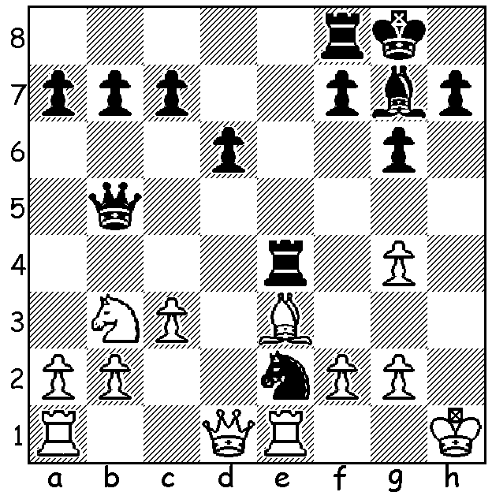

Diagram 514:
Carlsen (Black) wins very
quickly against fellow
Norwegian and one of his
seconds at Chennai:
(Jon Hammer – Magnus Carlsen 2003):

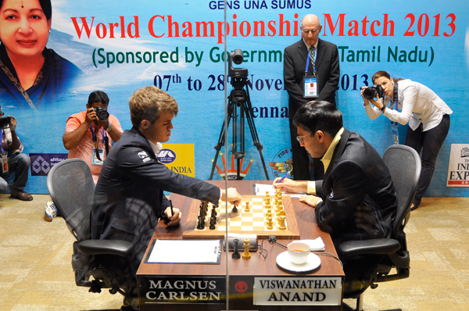
The World Championship match between
defending champion, 44 year old Viswanathan
Anand, and challenger, 22 year old Magnus
Carlsen has created extraordinary interest in
the countries of India and Norway. The Indian
public broadcaster is covering every playing
session in full on its sports station DD Sports
while in Norway the match has been described
as ‘perhaps the biggest sports event of the year’
with 100 hours of chess on TV being provided
by the Norwegian Broadcasting Company. At
the Hyatt Regency in Chennai about 30 rooms Start of Game 4:
are being occupied by the two teams, each on a
separate floor and with separate lifts. The actual
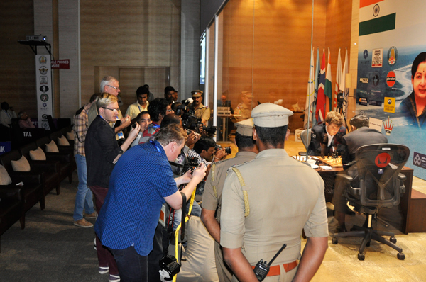
playing hall, with the players inside a glass booth,
can seat only 500 so many fans will have had to
watch the games being relayed via screens with the
world able to access the games live via numerous
chess sites. The winner will receive about $1.45
million with the loser getting just under $1 million.
After last weekend Carlsen, by winning games 5
and 6, took a two point lead after 4 successive
draws. In both these losses Anand, a pawn down
in each, failed to make the most of the defensive
chances in rook endgames. I have selected Game
4 as perhaps the most interesting of the first half: Photographers at Game 4

Viswanathan Anand - Magnus Carlsen
2013 World Championship, Game 4
Ruy Lopez: Berlin Defence
1.e4 e5 2.Nf3 Nc6 3.Bb5 Nf6(a)
4.0-0 Nxe4 5.d4 Nd6 6.Bxc6 dxc6
7.dxe Nf5 8.Qxd8+ Kxd8 9.h3 Bd7
10.Rd1 Be7 11.Nc3 Kc8 12.Bg5 h6
13.Bxe7 Nxe7 14.Rd2 c5 15.Rad1 Be6
16.Ne1 Ng6 17.Nd3 b6 18.Ne2 Bxa2(b)
19.b3 c4 20.Ndc1 cxb 21.cxb Bb1
22.f4 Kb7 23.Nc3 Bf5 24.g4 Bc8
25.Nd3 h5 26.f5 Ne7(c) 27.Nb5 hxg
28.hxg Rh4 29.Nf2 Nc6 30.Rc2 a5
31.Rc4 g6!(d) 32.Rdc1 Bd7 33.e6 fxe
34.fxe Be8 35.Ne4! Rxg4+ 36.Kf2 Rf4+
37.Ke3 Rf8 38.Nd4! Nxd4 39.Rxc7+ Ka6
40.Kxd4 Rd8+ 41.Kc3 Rf3+ 42.Kb2 Re3
43.Rc8! Rdd3 44.Ra8+ Kb7 45.Rxe8 Rxe4
46.e7 Rg3 47.Rc3 Re2+ 48.Rc2 Ree3
49.Ka2 g5(e) 50.Rd2 Re5 51.Rd7+ Kc6
52.Red8 Rge3 53.Rd6+ Kb7 54.R8d7+ Ka6
55.Rd5 Re2+ 56.Ka3 Re6! 57.Rd8(f) g4
58.Rg5 Rxe7 59.Ra8+ Kb7 60.Rag8 a4
61.Rxg4 axb 62.R8g7 Ka6 63.Rxe7 Rxe7
64.Kxb3 DRAW

a) After playing the reliable Caro-Kann in Game 2, Carlsen switches to defending the Ruy with the Berlin Defence which Vladimir Kramnik used very successfully in his victory over Gary Kasparov in 2000 (=4).
b) The pawn can safely be taken but White can now build up a threatening position.
c) 26…Nh4 27.Kf2 g6 28.Rc1! hxg 29.hxg gxf 30.Nb5! c5 31.b4!
d) 31…Bxf5!? 32.Rxc6!? Kxc6 33.Nd4+ Kb7 34.Nxf5 Rhh8=.
e) e) 49…Rxb3?? 50.Rb8+! wins
f) 57.Rxg5? allows 57…b5! winning.

HAYDN BARBER: Do readers have copies of any of their losses to Haydn? I have his games from WA Ch 1991, 1992, 1993, 1995, 2004, 2005, 2006 but little else.

XMAS OPEN: Sat 30 Nov (1 - 8pm), Sun 1 Dec (10.30am – 6pm) at Moresby St Centre. Enter by 29th for entry fee discount. Details cawa.org.au and entries to me at ellisd19@bigpond.com or 0439798607.

SOLUTION: 1…Qh5+!! 2.gxh5 Rh4#.

