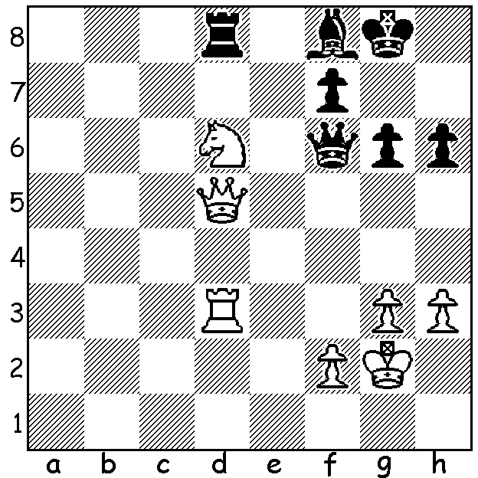

MAGNUS MAGIC:

We begin a series of positions
from the games of Magnus Carlsen:
Diagram 515: White to play and win
(Magnus Carlsen – Ruslan Ponamariov 2007):

CARLSEN NEW WORLD CHAMPION

Trailing 22 year old Magnus Carlsen by 3-5 (=6, -2) after 8 games in the 12 game Chennai match, defending champion Viswanathan Anand made the aggressive switch to 1.d4 in Game 9 enabling him to launch a frightening kingside attack while Carlsen sought victory on the queenside. See below how the game unfolded:
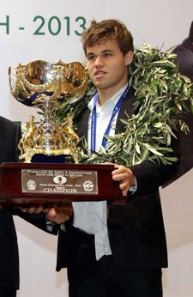
Viswanathan Anand - Magnus Carlsen
2013 World Championship, Game 9
Nimzoindian Defence
1.d4 Nf6 2.c4 e6
3.Nc3 Bb4 4.f3 d5
5.a3 Bxc3+ 6.bxc3 c5
7.cxd exd 8.e3 c4(a)
9.Ne2 Nc6 10.g4 0-0(b)
11.Bg2 Na5 12.0-0 Nb3
13.Ra2 b5 14.Ng3 a5
15.g5 Ne8 16.e4 Nxc1
17.Qxc1 Ra6 18.e5 Nc7
19.f4 b4 20.axb(c) axb
21.Rxa6 Nxa6 22.f5 b3
23.Qf4(d) Nc7 24.f6 g6(e)
25.Qh4 Ne8 26.Qh6 b2!
27.Rf4!(f) b8=Q+ 28.Nf1?? (g) Qe1
White resigns

a) A common pawn configuration gaining Black a potential winning queenside majority but giving White attacking kingside chances and an e4 break. Look up Botvinnik-Capablanca (AVRO 1938) for the definitive White victory.
b) A cool response: Carlsen is prepared to defend against a fierce attack.
c) This move has been criticized but is played to rid Black of the rook which defends along the 6th rank. The main alternatives are 21.a4 or f5.
d) Anand thought for 45 minutes on this move.
e) Carlsen, who admitted being scared of the power of White’s attack, rejected 24.gxf6 because of 25.Nh5 although 25…fxg (or 25…Ne8!) 26.Nf6+ Kh8 27.Qxg5 Rg8 seems to hold.
f) An amazing idea allowing Black to queen with check.
g) Played with little thought, Anand is probably guilty of failing to check his earlier analysis.
After his expected 28…Qd1 he planned to win with 29.Rh4 Qh5 30.Rxh5 gxh5 31.Ne3 Be6 32.Bxd5! Bxd5 33.Nf5 Be4 34.Ne7+ Kh8 35.Qxf8#. 28.Bf1 was correct when analysis judged the game equal after 28…Qd1 29.Rh4 Qh5 30.Nxh5 gxh5 31.Rxh5 Bf5 32.g6! Bxg6 33.Rg5 with Black a piece up but very constricted.

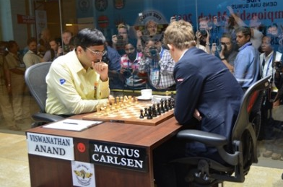
Many expected Game 10 to be a quick draw
but Anand continued to fight, playing the
Sicilian for the first time in the match. In the
final phase of the game Anand had knight for
3 pawns but the game liquidated to sole kings
after 65 moves giving the title to Carlsen 6.5 –
3.5. Interest in the match was unprecedented
with an estimated 100 – 200 million following
the game on line with some sites in danger of
crashing. Thank goodness for the internet
for there was a virtual complete lack of
Anand and Carlsen about to start Game 9 interest shown in WA from both print and
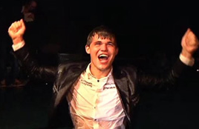
TV with SBS the only outlet I was aware of
giving space to the match.

XMAS OPEN:
Sat 30 Nov (1 - 8pm), Sun 1 Dec
(10.30am – 6pm) at Moresby St Centre.
Enter today for entry fee discount.
Details cawa.org.au and entries to me at
ellisd19@bigpond.com or 0439798607.

WA TEAMS LIGHTNING:
A happy Magnus after being Get some friends together to form a team dunked by his sponsors for Sunday 15 Dec. Info on cawa.org.au
and entries to Gordon Dunlop 93686412.

SOLUTION: 1.Ne4! wins the exchange: 1…Qe7 (1…Rxd5 2.Nxf6+ Kg7 3.Nxd5)
2.Qxd8 Qxe4+ 3.Rf3 and White won in another 38 moves.

