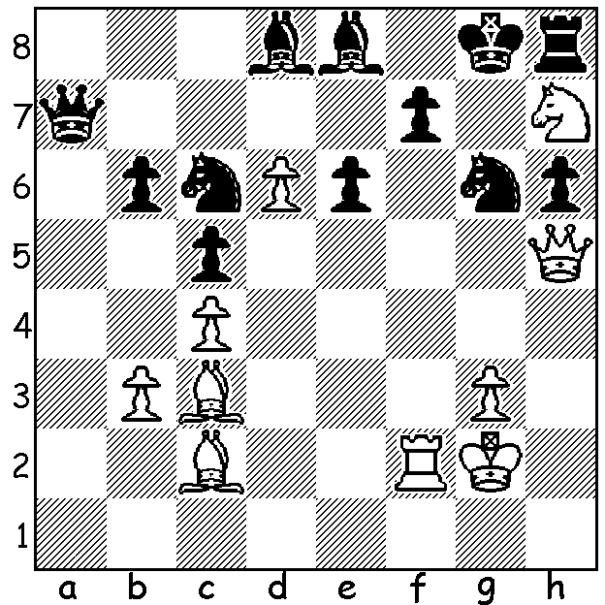
MORE MAGNUS MAGIC

Diagram 517:
Magnus Carlsen – Hans Harestad 2003:
White to play and win (3 moves)

WORLD TEAMS CHAMPIONSHIP (II)
The ten teams competing in the World Teams Championship held in Turkey comprised the previous winner, the top three teams in the previous Olympiad, four continent champion nations, the host country and one FIDE selection. After winning the first 5 rounds Ukraine lost 1.5–2.5 to Netherlands in Rd 6 and by a similar score to Russia in Rd 8. Russia, despite struggling to beat Egypt 2.5-1.5 in the final round, finished top with +7, =1, -1 (23/36 game points). China was second with +7, -2 (22) with Ukraine third with +7, -2 (21). These three teams were well ahead of USA & Armenia +4, =2, -3, Netherlands & Germany +4, =1, -4, Azerbaijan +3, =1, -5, Turkey +1, =1, -7 and Egypt -9. The top scores on Board 1 were Levon Aronian (Armenia) 6/8, Hikaru Nakamura (USA) 4.5/7, Vassily Ivanchuk (Ukraine) 5/8.

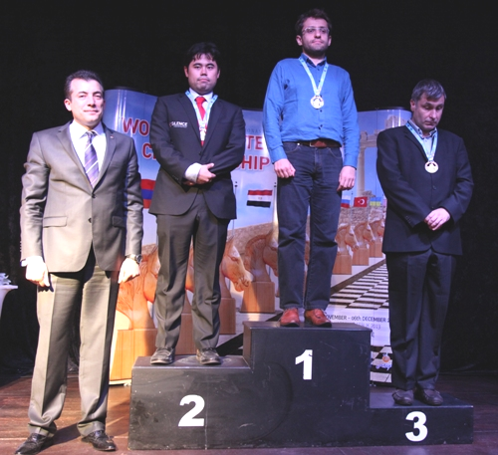
Alexander Ipatov (Turkey) –
Vladimir Kramnik (Russia)
2013 World Teams Championship, Rd 6
Queens Pawn: Torre Attack
1.d4 Nf6 2.Nf3 e6
3.Bg5 h6 4.Bh4 d6
5.e3 g5 6.Bg3 Nh5
7.Bd3 Bg7 8.Nbd2 Qe7
9.c3 Nd7 10.Qc2 a6
11.0-0-0 b5 12.Nb3 Rb8
13.Kb1 0-0 14.Nfd2 f5
15.f3 Nxg3 16.hxg3 c5
17.Na5 Rb6 18.f4 d5
19.b4 c4(a) 20.Be2 Nf6
21.Rdf1 Bd7 22.Qd1 g4
23.Kb2 Rf7 24.Qc1 Bf8
25.Kc2 Rh7 26.Rh2 Be8
27.Rfh1 Nd7 28.Qb2 h5
29.Kc1(b) e5!! 30.dxe Nxe5!
31.fxe5 Qxe5 32.Nf1 Bg7
33.a3(c) Qxc3+ 34.Qxc3 Bxc3
35.Bd1 Re6 36.Bc2 Bg6
37.Nd2(d) Rxe3 38.Rd1 Bf6
39Rhh1 d4 40.Rde1 Rhe7 Top Board prize winners:
White resigns Nakamura, Aronian, Ivanchuk.

a) Accepting the pawn gives White domination of the c file after 19…cxb 20.cxb Qxb4+ 21.Ndb3.
b) The blocked position leaves White with no constructive ideas. Black’s obvious plan would be to mass his heavy pieces on the h file in preparation for …h4 but Kramnik instead sacrifices a piece to open the centre, taking advantage of White’s disorganised position where his knight on a5 is trapped and his black-square pawns vulnerable.
c) If 33.Kd2 (33.Kc2 Bg6) 33….Bh6 34.Bd1 (else 34…Bxe3+! Nxe3 35.Re6) 34…Re6 with a decisive breakthrough.
d) Black threatened 37…d4!

WA TEAMS LIGHTNING: Get some friends together to form a team for this Sunday, starting 10.30. Info on cawa.org.au and entries to Gordon Dunlop 93686412. Games will be followed by the Christmas Wind-Up which includes prizegiving and refreshments. You are invited to bring a plate.

SOLUTION: 1.Qxg6+!! fxg6 2.Rf8+ Kxh7 3.Rxh8# (note the Harrwitz Bishops on adjacent diagonals raking Black’s kingside).

