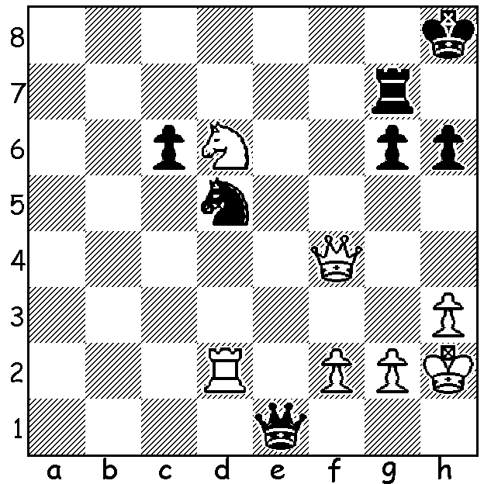
MAGNUS MAGIC

Diagram 518:
Magnus Carlsen – Alexander Morozevich (2006):
White to play and win (4-6 moves)

Over the past few years 14 year old George Carolin-Unkovich has become perhaps the most promising junior player in WA. Much of his experience has been obtained through the WA Grand Prix events, a series of up to seven six-round weekend tournaments at which many of the top state players compete. This year George, the 2013 WA Junior champion, was overall GP runner-up as well as topping the Major (Under 1850) and Junior sections. He is also a extremely talented musician and I recently enjoyed hearing him perform on piano at the UWA Summer School concert. George will join a number of other sandgropers, Yita Choong (WA champion 2011, 2012), Marc Vliestra and Dennis Holland, at the Australian Championships in Victoria on January 2nd. He recently returned from the Lidums Young Masters, an invitation event in Adelaide to which the most promising young players from Australia and NZ were invited. Playing in the Junior Masters section he came =3rd with 5/9 a score which included a win against the top rated player. Staring down the barrel George somehow found counterplay before playing an amazing rook sacrifice which enabled him to turn the tables:

Clive Ng - George Carolin-Unkovich
2013 Lidums Junior Masters, Rd 1
Sicilian Najdorf
1.e4 c5 2.Nf3 d6
3.d4 cxd 4.Nxd4 Nf6
5.Nc3 a6 6.Be3 e5
7.Nb3 Be6 8.f3 Be7
9.Qd2 Nbd7 10.0-0-0 b5
11.Kb1 b4 12.Nd5 Bxd5
13.exd5 Nb6 14.Na5 Nbxd5
15.Nc6 Qc7 16.Nxb4 Nxb4
17.Qxb4 0-0 18.Qb6 Qd7
19.Bc4 Rfb8 20.Qa5 Qb7
21.Bb3 Bd8 22.Qa4 d5?(a)
23.Rxd5!(b) Bc7 24.Rd2 a5
25.Rhd1 h6 26.Bc5 e4(c)
27.Bd4 Bf4 28.Rf2 e3
29.Re2 Rd8 30.Rd3 Bxh2(d)
31.Bxf6 Rxd3 32.cxd3 gxf6
33.Qg4+ Kh7 34.Bc2(e) Qb5!!(f)
35.Qe4+ f5 36.Qxa8 Be5
37.b3 Qc5 38.d4(g) Qxd4
39.Bxf5+ Kg7 40.Kc1 Qa1+
41.Bb1 Qc3+ 42.Bc2??(h) Qb2+
White resigns(i)

a) Too good to be true. Black should return the bishop to e7.
b) Black’s knight is overworked – 23…Nxd5?? 24.Qe8#.
c) Black refuses to be discouraged and searches for counterplay.
d) Black is prepared for a broken kingside, hoping for some attacking chances through the opposite coloured-squared bishops (his on black squares, his opponent’s on white).
e) 34.Qh5 is a good alternative (34…Qc7 35.Bxf7 Qg3).
f) Does White see this as a blunder?
g) The White win is now difficult to find – 38.Qe8 Qd4 39.Qxf7+ Kh8 40.Qf8+ Kh7 41.Qxf5+ Kh8 42.Qc8+ Kh7 43.Kc1 Qb2+ 44.Kd1 Qa1+ 45.Bb1 Qxb1+ 46.Qc1 Qxd3+ 47.Ke1 Bg3+ 48.Kf1 and Black’s attack fizzles out.
h) Now White loses: 42.Kd1 draws by repetition – 42…Qd4+ 43.Kc1 Qc3+ 44.Kd1 Qd4+ etc.
i) 43.Kd1 Qa1+ 44.Bb1 Qxb1#.

AUSTRALIAN JUNIOR CHAMPIONSHIPS Sydney 11 – 19 January. Details on CAWA and ACF web sites.

SOLUTION: 1.Rxd5! (Removing the Guard – protection of f6) 1.cxd5 2.Qf8+ Kh7 3.Ne8 with dual threats of 4.Qxg7# and 4.Nf6# (if 3…Qe5+ 4.f4 Qc3 5.Nf6+ wins queen).

